

**Module Code & Module Title**

**CS6P05NI Final Year Project**

**Assessment Weightage & Type**

**25% FYP Interim Report**

**Semester**

**2024-25 Autumn/Spring**

**Project Title: CS6P05NI**

**Student Name: Nischhal Shrestha**

**London Met ID: 22085857**

**College ID: np01ai4s230009**

**Internal Supervisor: Roshan Shrestha**

**External Supervisor: Shristi Shakya**

**Assignment Due Date:08/01/2025**

**Assignment Submission Date: 08/01/2025**

**Word Count (Where required): 3800**

*I confirm that I understand my coursework needs to be submitted online via MySecondTeacher under the relevant module page before the deadline in order for my assignment to be accepted and marked. I am fully aware that late submissions will be treated as non-submission and a mark of zero will be awarded.*

**Acknowledgement**

I would like to express my heartfelt gratitude to my university, Islington College, my supervisors and my friends for contributing to the successful completion of the Smart Banking System project.

Firstly, I would like to extend my sincere thanks to my college and the department of FYP department for providing me with the opportunity to work on this innovative project. Their support, resources, and encouragement played a significant role in bringing this idea to life.

I am deeply indebted to my project supervisors Shristi Shakya and Roshan Shrestha, for guiding me with their expertise and constructive feedback. They were invaluable throughout the development process of my project. Their insights greatly enhanced the scope and quality of this project.

I also acknowledge the contributions of my teachers and AI enthusiast friend, whose creative ideas enriched the project’s development. Their shared knowledge and dedication were instrumental in achieving our goals.

Finally, I’d like to express my gratitude to my family and friends for their constant motivation, support and understanding, they helped me with the moral support necessary to overcome challenges during the course of this project.

**Abstract**

The Smart Banking System integrates artificial intelligence (AI) and advanced security mechanisms to modernize banking operations. This web-based application features a user-friendly chatbot capable of addressing banking queries, facilitating fund transfers, and offering tailored financial advice. The system incorporates fraud detection algorithms to analyze transactions, promptly notifying users of potential fraudulent activities. By automating repetitive tasks such as FAQs and interest calculations, it significantly reduces operational costs while enhancing customer satisfaction. Built with a strong emphasis on data privacy, compliance, and usability, this project is designed to join the gap between traditional banking and modern digital solutions. The system demonstrates a practical approach to improving customer experience while addressing pressing concerns such as cybersecurity risks in the financial sector.

Table of Contents

1. Introduction: 1

1.1 Problem Statement 2

1.2 The project as a solution 2

1.3 Aims and Objectives: 2

1.3.1 Aim 2

1.3.2 Objective 3

1.4 Structure of the Report 4

1.4.1 Introduction 4

1.4.2 Background Study 4

1.4.2 Development to Date 4

1.4.3 Analysis of the progress 4

1.4.4 Future Work 4

1.4.5 References 4

1.4.6 Appendix 4

2. Background 5

2.1 About the client 6

2.2 Understanding the Project 6

2.3 Similar Projects 7

2.3.1 Review on Similar Projects 7

2.3.2 Comparison between the similarities of system 11

2.4 Software Development Methodology 11

2.4.1 Considered Methodology 12

2.4.2 Other methodology: 12

2.4.2 Selected Methodology 12

2.5 Technology Used 13

2.5.1 Programming Language 13

2.5.2 Frontend Framework 13

2.5.3 Backend Framework 14

2.5.4 APIs 14

3. Development to Date 15

3.1 Requirement Gathering 15

3.2 Data Flow Diagram (DFD) 24

3.2.1 Level 0 DFD(Context Diagram) 24

3.2.2 Level 1 DFD 25

3.2.3 Level 2 DFD 26

3.3 Use Case Diagram 28

3.5 Software Requirement Specification(SRS) 30

3.6 Sequence Diagram 30

3.7 Collaboration Diagram 35

3.8 Block Diagram 37

3.9 Wire Frame Design 39

3.10 Entity Relationship Diagram (ERD) 43

3.10 Class Diagram 44

3.11 Project Management: Trello 45

3.12 System Architecture Design 49

3.13 Database migrations 50

3.14 System Development 52

3.14.1 Front End Development 52

3.14.2 AI Development 56

3.14.3 Bank End Development 77

78

4. Progress Analysis 85

4.1 Progress Review 85

Sprint 1: Initiation and Planning 85

Sprint 2: System Design 85

Sprint 3: Data Collection 86

Sprint 4: Initiate Development 86

4.2 Progress Table 87

5. Future Work 88

11. Bibliography & References: 90

12. Appendix 93

12.1. Similar Projects 93

12.2.1 Use Case 94

3.4 High Level Use Case 94

12.2.2 High Level Use Case 96

12.1.1 Register User 96

12.1.2 Login 96

12.1.3 SIP Calculator 96

12.1.4 Deposit 96

12.1.5 Withdraw 97

12.1.6 Check Balance 97

12.1.7 View Statement 97

12.3 Future Development Plan: 98

12.4 Targeted Audiences: 98

12.5 Considered Methodology: 99

12.5.1 Kanban Methodology: 99

12.5.2 Prototype 100

12.5.3 Spiral Methodology 101

12.5.4 Scrum Methodology 102

12.5.5 Waterfall Model: 103

12.5.6 Extreme Programming (XP): 104

12.5.7 Lean Development Methodology 105

12.5.8 Feature Driven Development 106

12.6 Software Requirement Specification (SRS) for Banking Chatbot with Fraudulent Transaction Detection 107

12.6.1 Introduction 107

12.6.1.1 Purpose of Document 107

12.6.1.2 Project Scope 107

12.6.1.3 Audience 108

12.6.2. Overall Description 108

12.6.2.1 Product Perspective 108

12.6.2.2 Product Features 108

12.6.2.3 User classes and characteristics 108

12.6.2.4 Constraints 109

12.6.3. Functional Requirements 109

12.6.3.1 User Queries Handling 109

12.6.3.2 Fraudulent Transaction Detection 109

12.6.3.3 User Notification 109

12.6.4. Non-functional Requirements 109

12.6.4.1 Performance 109

12.6.4.2 Security 109

12.6.4.3 Usability 110

12.6.5. System Architecture 110

12.6.6.1 Hardware Requirements: 110

12.6.6.2 Software Requirements: 110

12.7 Milestones: 111

12.8 Progress Table (with time) 114

12.9 Work breakdown structure: 118

12.10 Revised Project Gantt chart 119

**Table of Figures**

Figure 1 Potential Use cases of Banking chatbots 1

Figure 2 Competition to implement chatbots in Financing Sector 5

Figure 3 Erica contribution on Market and Industry 7

Figure 4 Erica over years 8

Figure 5 Global Bank without chatbot facility 9

Figure 6 Nabil Bank chat bot with a query and a response 10

Figure 7 Requirement Gathering 1 16

Figure 8 Requirement Gathering 2 18

Figure 9 Requirement Gathering 3 19

Figure 10 Requirement Gathering 4 20

Figure 11 Requirement Gathering 5 21

Figure 12 Requirement Gathering 6 22

Figure 13 Requirement Gathering 7 23

Figure 14 DFD level 0 24

Figure 15 DFD level 1 25

Figure 16 Fraud detection DFD level 2 26

Figure 17 Chatbot level 2 DFD 27

Figure 18 Use Case Diagram 29

Figure 19 Sequence registration 30

Figure 20 Sequence Login 31

Figure 21 Sequence SIP Calculator 32

Figure 22 Sequence chatbot 33

Figure 23 Sequence Fraud alert on withdrawl 33

Figure 24 Sequence view statement 34

Figure 25 Sequence check balance 34

Figure 26 Collaboration Login 35

Figure 27 Collaboration chat bot 36

Figure 28 Collaboration Registration 36

Figure 29 Collaboration Fraud detection on Withdrawl 37

Figure 30 Block Diagram 38

Figure 31 Wireframe Login 39

Figure 32 Wireframe Transaction History 40

Figure 33 Wireframe Dashboard 40

Figure 34 Wireframe ATM 41

Figure 35 Wireframe for Withdrawl 41

Figure 36 Wireframe chatbot 42

Figure 37 Entity Relationship Diagram(ERD) 43

Figure 38 Class Diagram 44

Figure 39 Trello 45

Figure 40 Backlog 46

Figure 41 Trello To do group 46

Figure 42 Trello Doing 47

Figure 43 Trello Ready to Demo 47

Figure 44 Trello Done 48

Figure 45 Trello Feedback 48

Figure 46 System Architecture diagram 49

Figure 47 Migrations: Creating migration files and executing SQL commands with database 50

Figure 48 Migrations: Successful migration file creation 51

Figure 49 Creating super users 51

Figure 50 Starting the server 51

Figure 51 Frontend folder architecture 52

Figure 52 Implementing root layout 53

Figure 53 Frontend Dash board code 54

Figure 54 Frontend Dashboard WIP 55

Figure 55 AI development Installing libraries 56

Figure 56 AI development Initializing Model 56

Figure 57 Model config 57

Figure 58 AI development Quantizing models 57

Figure 59 AI development Import and format datasets 58

Figure 60 AI development Configuring supervised fine tuning (SFT) Trainer 59

Figure 61 AI development Training with minimum epoch 60

Figure 62 AI development Proof of concept with minimum requirements achieved 60

Figure 63 AI development generating response 61

Figure 64 AI development importing libraries and dataset 61

Figure 65 AI development analysing data 62

Figure 66 AI development data visualisation 63

Figure 67 AI development splitting data 64

Figure 68 AI development preprocessing data 64

Figure 69 AI development modelling 65

Figure 70 Random forest feature importance 66

Figure 71 AI development XG Boost Classifier 67

Figure 72 XG Boost feature importance 68

Figure 73 AI development Logistic Regression 69

Figure 74 Logistic Model evaluation 70

Figure 75 Logistic Regression Confusing matrix 71

Figure 76 Setting threshold value and testing 72

Figure 77 Metrics Evaluation 73

Figure 78 Define best threshold for each model 73

Figure 79 Confusion matrix for a given model 74

Figure 80 Confusion matrix for logistic regression and XG booster 75

Figure 81 Fraudulent behavior prediction 76

Figure 82 Backend architecture 77

Figure 83 Django Backend configuration 78

Figure 84 Backend django app config 79

Figure 85 Backend django url config 79

Figure 86 Backend Serializers 80

Figure 87 Backed Model class 80

Figure 88 Backend login 81

Figure 89 Backend Create Operations 81

Figure 90 Postman: Backend Login success 82

Figure 91 Postman: Unsuccessful login 83

Figure 92 Postman: Restricting users other than admin to create account 83

Figure 93 GitHub branches 84

Figure 94 GitHub Smart banking 84

Figure 95 KanBan Board 99

Figure 96 Prototype Methodology 100

Figure 97 Spiral Methodology 101

Figure 98 Scrum Framework (Bala, 2024) 102

Figure 99 Waterfall Methodology 103

Figure 100 Extreme Programming Methodology 104

Figure 101 Lean Development Methodology 105

Figure 102 Feature Driven Development 106

Figure 103 WBS 118

Figure 104 Gantt chart upto Sprint 3 119

Figure 105 Summary Gantt chart 119

Figure 106 Gantt chart upto sprint 9 120

Figure 107 Gantt chart upto sprint 6 120

Figure 108 Gantt chart upto sprint 12 121

**Table of Tables**

Table 1: Future work Finalization Timeline 88

Table 2: Future Work Test Cases Timeline 88

Table 3: Deployment and Monitoring Timeline 88

Table 4: System Finalization Timeline 89

Table 5 Other similar projects 93

Table 6 Some other similar banks 94

Table 7 Register User high level usecase 96

Table 8 Login high level usecase 96

Table 9 SIP calculator high level usecase 96

Table 10 Deposit high level usecase 96

Table 11 Withdraw high level usecase 97

Table 12 Check Balance high level usecase 97

Table 13 View Statement high level usecase 97

Table 14 Progress Table 117





**Tables of Abbreviation**

AI - Artificial Intelligence

API - Application Programming Interface

ATM - Automated Teller Machine

CBNP - Cyber Bureau of Nepal Police

DFD - Data Flow Diagram

ERD - Entity Relationship Diagram

FYP - Final Year Project

GPU - Graphics Processing Unit

JWT - JSON Web Token

LLAMA - Large Language Model Meta AI

ML - Machine Learning

NLP - Natural Language Processing

SRS - Software Requirement Specification

UI - User Interface

WBS - Work Breakdown Structure

**Interim Report**

**Smart Banking System**

*(with AI enforced chatbot & fraudulent transaction detection)*

# Introduction:

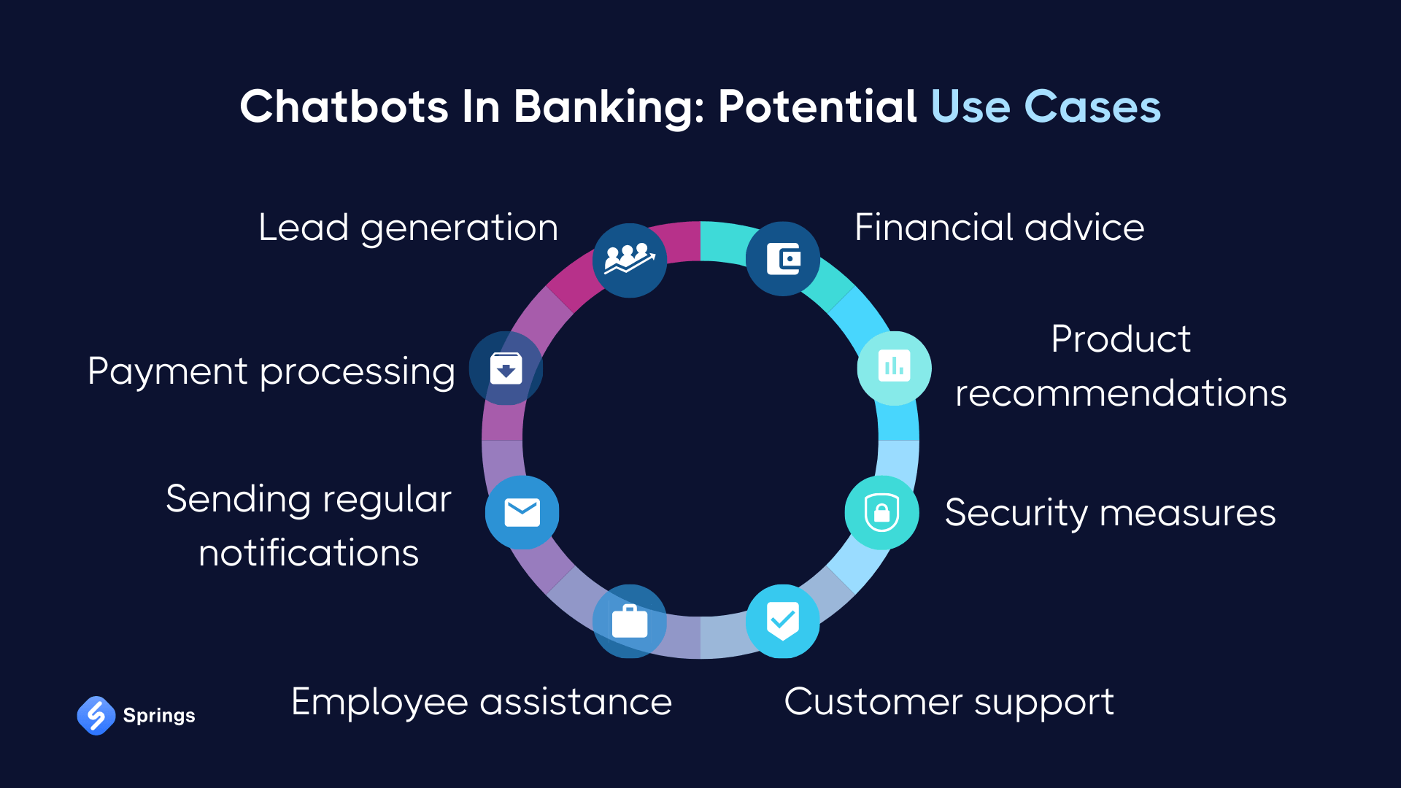A banking management system is a web based application designed for simplifying heavy tasks of banking stakeholders with a help of a chatbot. In addition to conventional banking system, smart banking allows users to query on any bank related questions like creating an account, loan, credit cards, insurance , investment plant, interest rate, etc. through a AI chat model from the comfort of their home. Smart Banking will also be able to notify users in cases of fraudulent transactions.

(Serhii, 2024)

Figure 1 Potential Use cases of Banking chatbots

## 1.1 Problem Statement

1. The Cyber Bureau of Nepal Police (CBNP) reported 4646 cases of cybercrimes involving fake identities, password hacking, OTP manipulation, and other fraudulent activities last fiscal year. (Sarahna, 2024). In recent years, the concerns of customers and banking institutions have been focused on the security of financial transactions. Even though credit card transactions are convenient, they are increasingly becoming vulnerable each day to some forms of fraudulence and unauthorized access made possible through the use of highly sophisticated skimming devices, phishing attacks, or even data breaches. This has led to serious financial losses coupled with a decline in consumer trust.
2. In today's fast-paced world, the financial industry must keep up with the demand for quick and efficient information processing to serve customers better. With clients expecting seamless experiences and banks failing to maintain the same quality of service often leading to long waiting lines, inconsistent service quality, and customer dissatisfaction.

## The project as a solution

Adapting to new technologies, such as AI-enabled chatbots, can help banks provide faster, more secure, and efficient customer service, addressing the need for quick information access. This chatbot would also be able to :

* Assist with essential Banking Activities:
* Answer FAQs
* Provide proactive support
* Help customers apply for facilities provided by banks

## 1.3 Aims and Objectives:

### 1.3.1 Aim

The aim is to facilitate users with secure transactions notifying with alerts in potential fraudulent transactions, and assist them in banking operations at immediate level with the help of smart chatbot.

### 1.3.2 Objective

The objective of this project are as follows:

1. To perform fraud detection on ATM withdrawals and alert users in case of any suspicious transactions.
2. To enable chatbot to perform various banking tasks such as interest calculation, checking balances, installment prediction on loans and other integrated services.
3. To push notification on users interface on flagged transactions and allow users to deny or confirm said transactions.
4. To provide cost cutting mechanism for banks and increase customer interaction with back by automating repetitive tasks and providing 24*7 banking service with the help of chatbot.

*(to be continued)*

## 1.4 Structure of the Report

### Introduction

The initiating phase of project where the problem statement, aims and objectives of the project is defined are well explained.

### 1.4.2 Background Study

Background or the literature review of the report consists solutions of problem statement mentioned in introduction, review of similar project, technology used, methodology, and end users of the proposed application.

### Development to Date

Development to date includes milestones achieved to date.

### Analysis of the progress

Analysis of the progress includes the progress analysis of the ongoing state of the project based on mile stones set and Gantt chart.

### Future Work

Future work includes incomplete task of the project.

### References

References section includes references taken from others work during the course of this project.

### Appendix

Appendix section includes wireframes(with screenshot), survey report, and any other researches done or activities relevant to the completion of project.

# 2. Background

Smart Banking is a user friendly web based UI providing ease and simplicity to its customers. Smart Banking is essential to both end users. The chatbot's advanced security features help mitigate the risks of cyber-attacks and fraud, protecting both the bank's revenue and customer trust in an environment lacking robust cyber laws. This dual focus on security and efficiency makes our chatbot an indispensable tool for modern banking. Financing firms are slowly changing their operations nature and the way they interact with customers as advancement in A.I. Banks and every financial must equip their system software with chatbot to stay in competition. (Praveen, 2024)

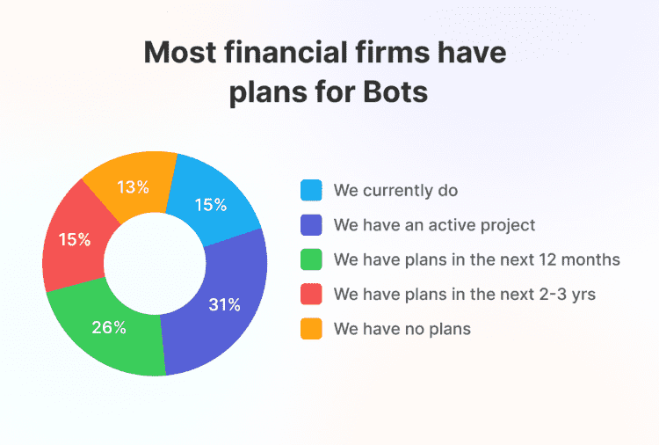

Figure 2 Competition to implement chatbots in Financing Sector

## 2.1 About the client

The application is to be integrated within banking system and used by banking customers.

## 2.2 Understanding the Project

The objective of this project is to build a banking system focused on AI components. The project entails all the core banking facilities associated with AI development. The AI development includes fine tuning our chatbot with LLAMA 3 and training machine learning models using algorithms like logistic regression, Random forest classifier, XG Boost classifier. While training the data set were highly imbalanced with far more legit purchases than the fraudulent one which lead us to reach for stratified sampling for splitting the data to ensure both categories are adequately represented in training and testing. A confusion matrix was used to evaluate the model performances, the model initially misclassified 1,841 legit purchases as fraudulent (false positives. By increasing the threshold for predicting fraud to 75%, false positives were reduced by 700 but at the expense of increasing false negatives and decreasing true positives, which leaded to fewer correctly identified fraudulent transactions as of completion of this report.  
(See appendix)

## 2.3 Similar Projects

### 2.3.1 Review on Similar Projects

**2.3.1.1 Erica( Bank of America)**

Bank of America clients had over 2 billion interactions with Erica since 2018. Erica is the most advanced and first used widely available smart chat bot in financing (Mathews, 2024). Erica uses Natural Language processing to interpret and responds to user through voice or texts in addition to OpenAI Api.

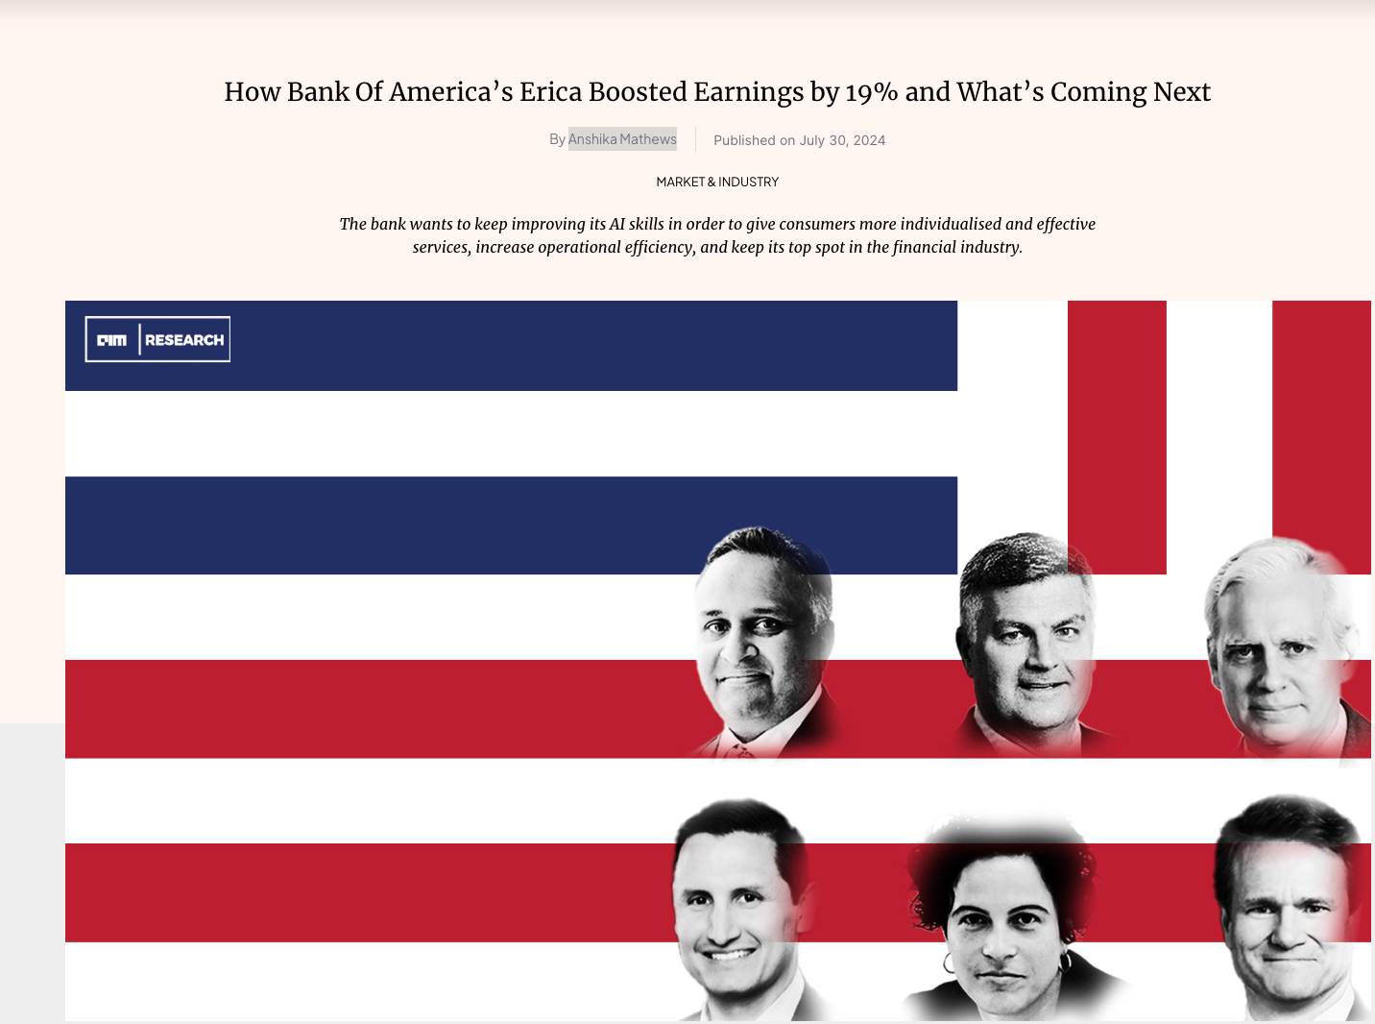

Figure 3 Erica contribution on Market and Industry

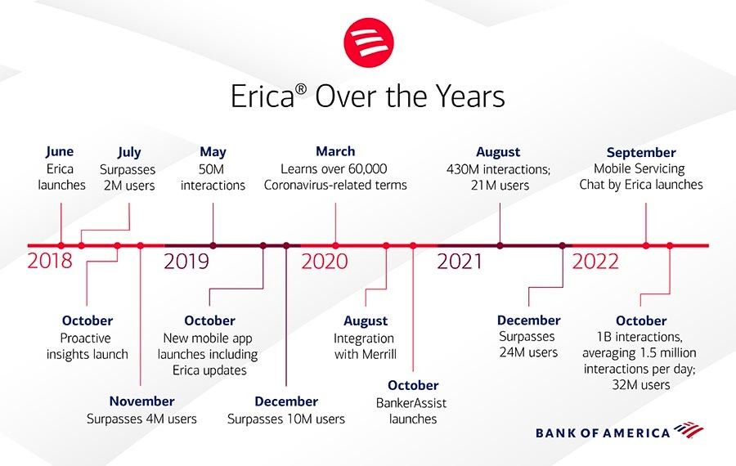

Figure 4 Erica over years

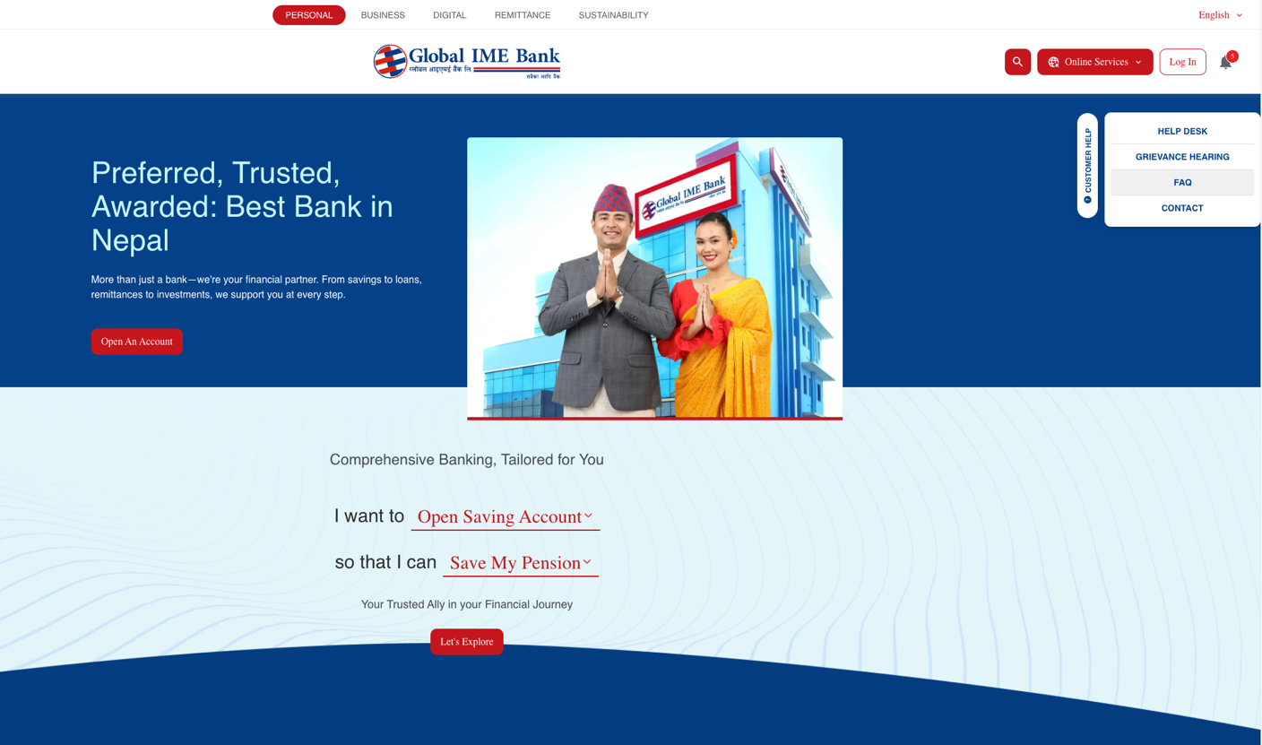2.3.1.2 Global Bank

Figure 5 Global Bank without chatbot facility

Nepal is missing a great market potential. here the bank can leverages AI and increase its customer interaction ultimately leading to increase in revenue. Even in private and well established bank like Global Ime there was no evidence of chat bot. Some of the banks like Nabil banks do have banking chat bot but they are not well trained and the interaction is not very good overall.

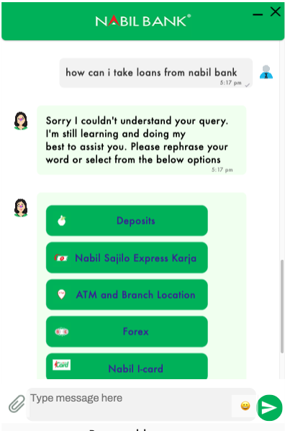

Figure 6 Nabil Bank chat bot with a query and a response

### 2.3.2 Comparison between the similarities of system

Most banking apps in Nepal have identical features with high level of competition to attract customers. And almost every banking apps has similar features. In light of increasing AI trends a new strategy to safeguards customer with additional layers the project proposes

|  |  |  |  |  |  |  |
| --- | --- | --- | --- | --- | --- | --- |
| Features | Erica  Bank of America | Global Bank | Nabil Bank | Nepal Bank Ltd | Rastra Banijya Bank | Proposed Application |
| User Registration | ✅ | ✅ | ✅ | ✅ | ✅ | ✅ |
| Login | ✅ | ✅ | ✅ | ✅ | ✅ | ✅ |
| Banking Chatbot | ✅ | ❌ | ✅ | ✅ | ✅ | ✅ |
| AI based chatbot | ✅ | ❌ | ❌ | ❌ | ❌ | ✅ |
| Monthly Statements | ✅ | ✅ | ✅ | ✅ | ✅ | ✅ |
| Withdrawals | ✅ | ✅ | ✅ | ✅ | ✅ | ✅ |
| Fraud Detections | ✅ | ❌ | ❌ | ❌ | ❌ | ✅ |
| Flag suspicious transactions | ✅ | ❌ | ❌ | ❌ | ❌ | ✅ |

## 2.4 Software Development Methodology

A software development methodology is defined as a framework for structuring, planning, controlling and managing the entire software development process. (Kamal, 2020). The goal of software development methodology is to ensure that the delivery of software meets the project specification requirements, that too, within time, budget and with minimized project risks. (Vladislav, 2024). There are different methodologies in software development which offers a unique approach in managing the software development life cycle, defining project steps, responsibilities, roles, communication standards, activities and deliverables. To find the most suited approach for the business needs, one must consider various criteria with the pros and cons each methodology offers. Before deciding which methodology to adapt we must reason ourself and select the best suited for our requirements. Following are the considered methodology before selecting a methodology for our project.

### 2.4.1 Considered Methodology

1. Kanban
2. Prototype
3. Spiral

### 2.4.2 Other methodology:

1. Waterfall Model
2. Extreme Programming (XP):
3. Lean Development Methodology
4. Feature Driven Development

### 2.4.2 Selected Methodology

Scrum methodology was chosen for the development of this project. The reasoning of why the methodology was chosen alongside with its pros and cons are discussed below:

|  |  |
| --- | --- |
| **Case Study Scenario** | Featuring collaboration between AI developers, experts and open discussion during FYP class. |
| **Features** | Scrum encourages active participation of stakeholder throughout sprint reviews. |
| **Justification** | Systematic reviews and efficient collaboration sessions with software developers, finance experts ensure the accuracy and relevance of features like accounting and credibility. |

|  |  |
| --- | --- |
| **Case Study Scenario** | Developing a banking bot that updates to changing banking policies. |
| **Features** | Scrum’s iterative approach is flexible to accommodate the changing requirement that might arise during development. |
| **Justification** | Scrum allows for constant iteration and updates based on user’s insights, ensuring the platform remains relevant and effective. |

|  |  |
| --- | --- |
| **Case Study Scenario** | Ensuring timely delivery of features |
| **Features** | Scrum delivers features morphing them into tasks manageable time frame known as sprints. |
| **Justification** | Sprint ensures that essential features are made functional in the early development cycle thus prioritizing important aspects. |

|  |  |
| --- | --- |
| **Case Study Scenario** | Managing the complexity of the feature in the system. |
| **Features** | Scrum breaks down complex tasks into manageable sprint goals. |
| **Justification** | Features like fraud detection, UI development and chatbot can be broken down into smaller deliverables, allowing for focused development. |

## **2.5 Technology Used**

### **2.5.1 Programming Language**

Python is used as the programming language throughout the development of the project.

### **2.5.2 Frontend Framework**

React is used as the frontend development framework for this project.

### **2.5.3 Backend Framework**

Django is used as the backend development framework for this project.

### **2.5.4 APIs**

(See appendix)

# 3. Development to Date

Agile methodology scrum is followed throughout the project with sprints of 2 weeks each. Four sprints have been covered until the interim report. To date machine learning models has been trained and tested successfully with baseline performance as a proof of working prototype. To achieve the baseline line performance of the models, dataset were gathered, preprocessed, on which the models were trained.(See Appendix)

## **3.1 Requirement Gathering**

The project focuses on AI aspects of the banking system. It is essential to grasp what our project intends to do and the targeted users. In addition to that it is important to understand the technical requirements of the project business case. There might also be additional documentation our project needs adherence to for example technical assessment, collecting functional and nonfunctional requirements, legal compliance, banking rules and regulation compliance. Also there proper consideration should be given to mitigate data security risks. Banks must use banking bots with robust data encryption and compliance with privacy regulations like SOC 2 certification and GDPR compliance.

A general survey was conducted to see how public reacts to equipping AI models on banking system and the result was quite favoring.

Figure 7 Requirement Gathering 1



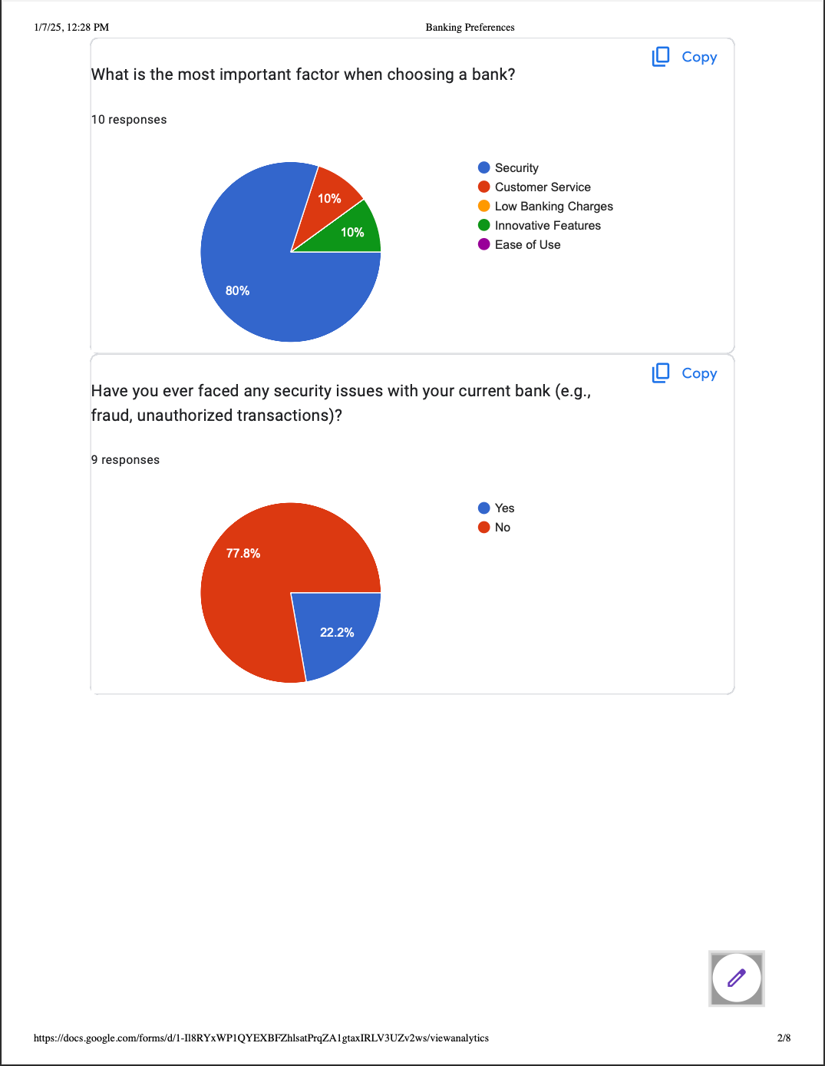

Figure 8 Requirement Gathering 2

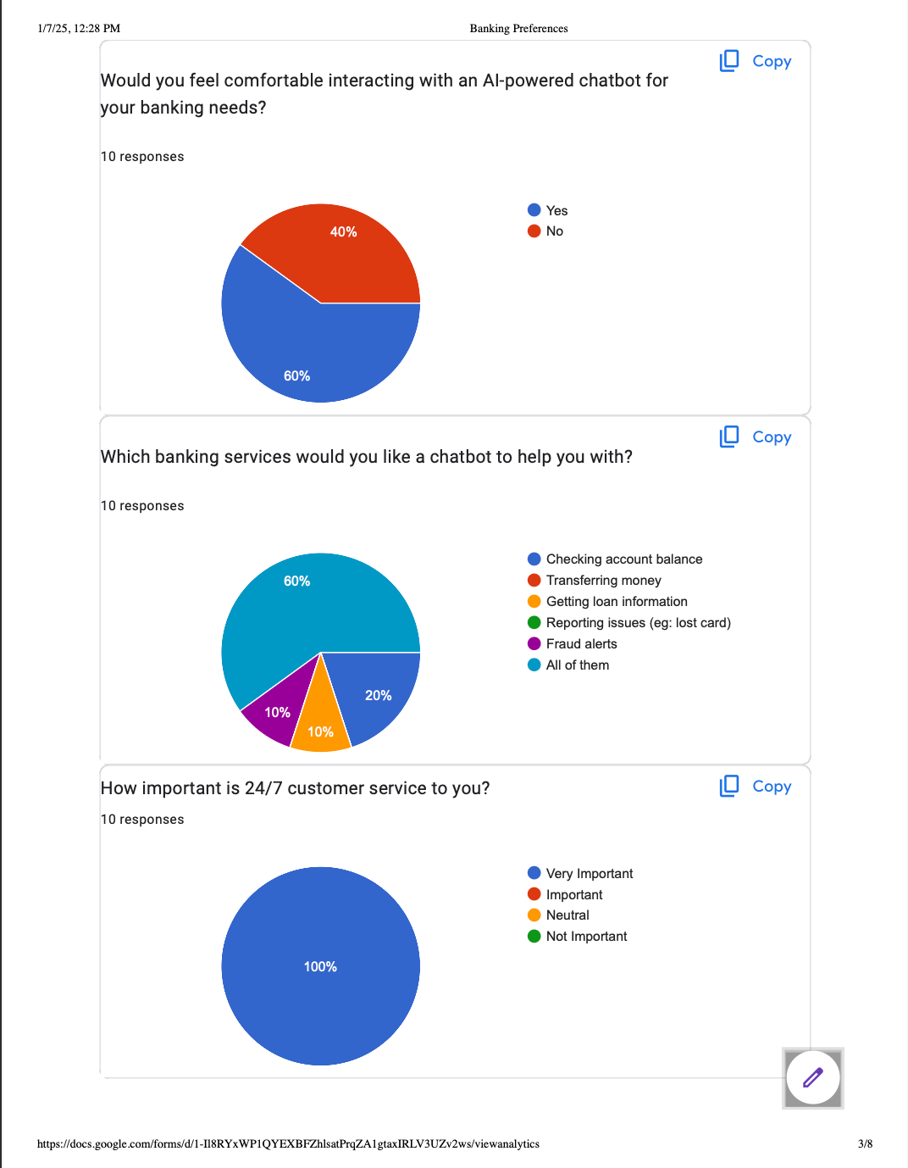

Figure 9 Requirement Gathering 3

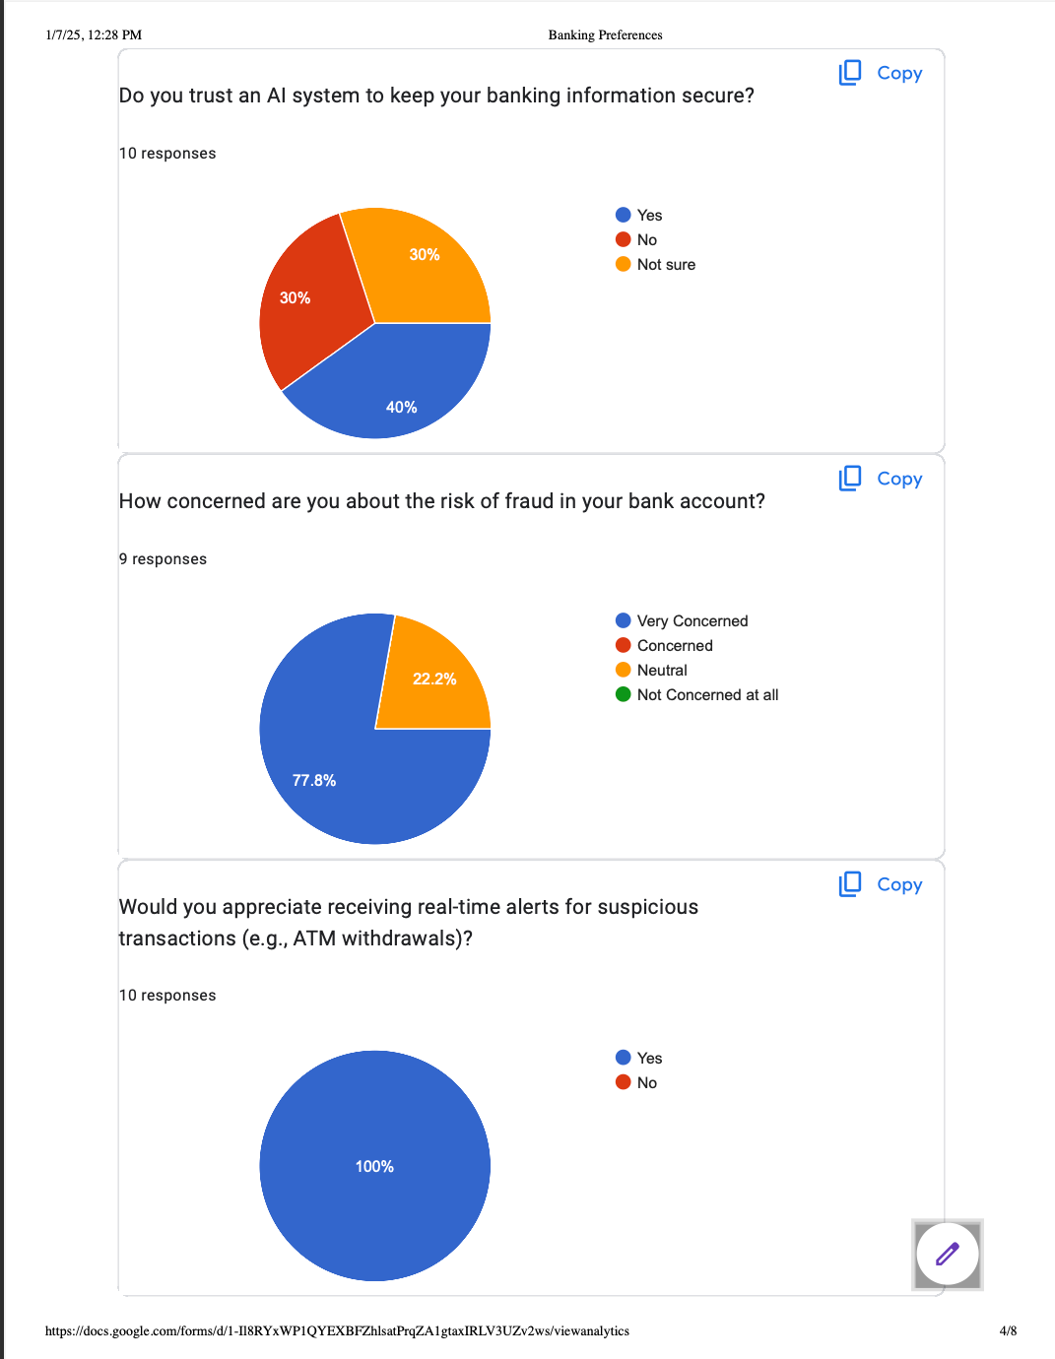

Figure 10 Requirement Gathering 4

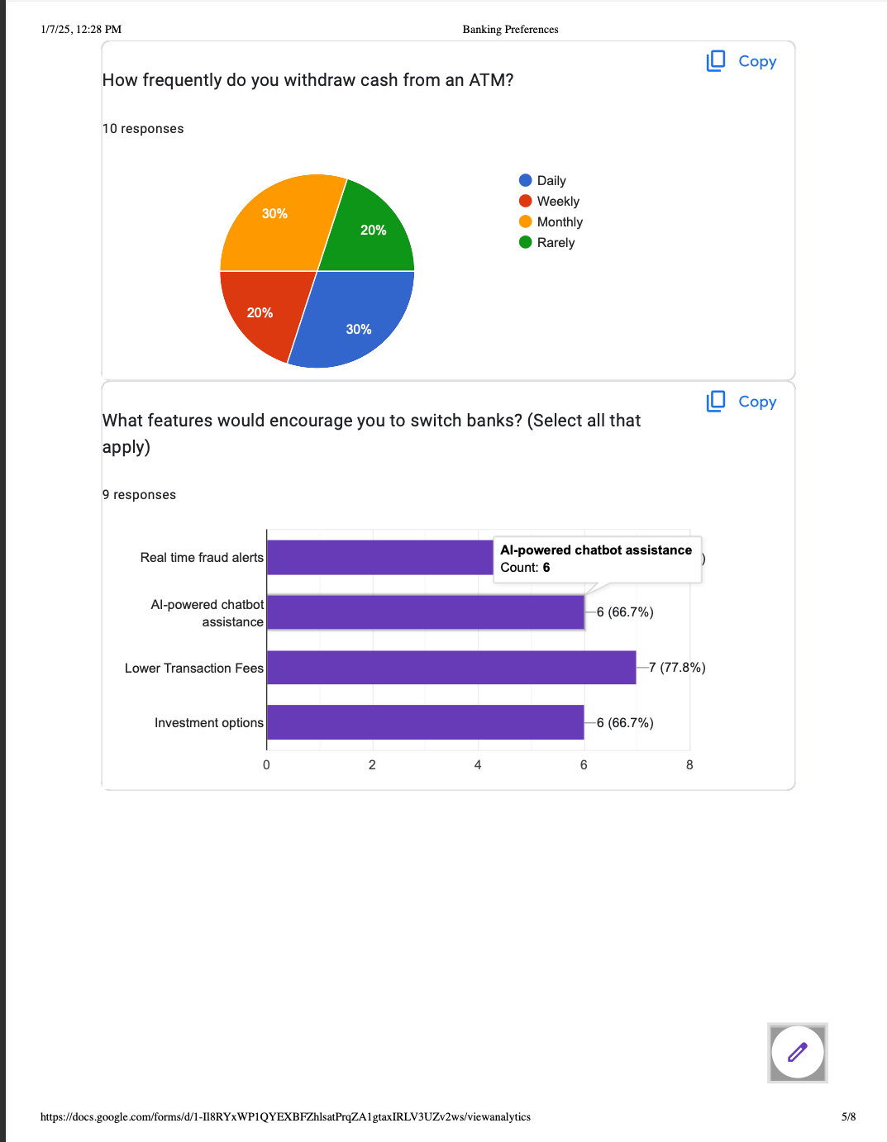

Figure 11 Requirement Gathering 5

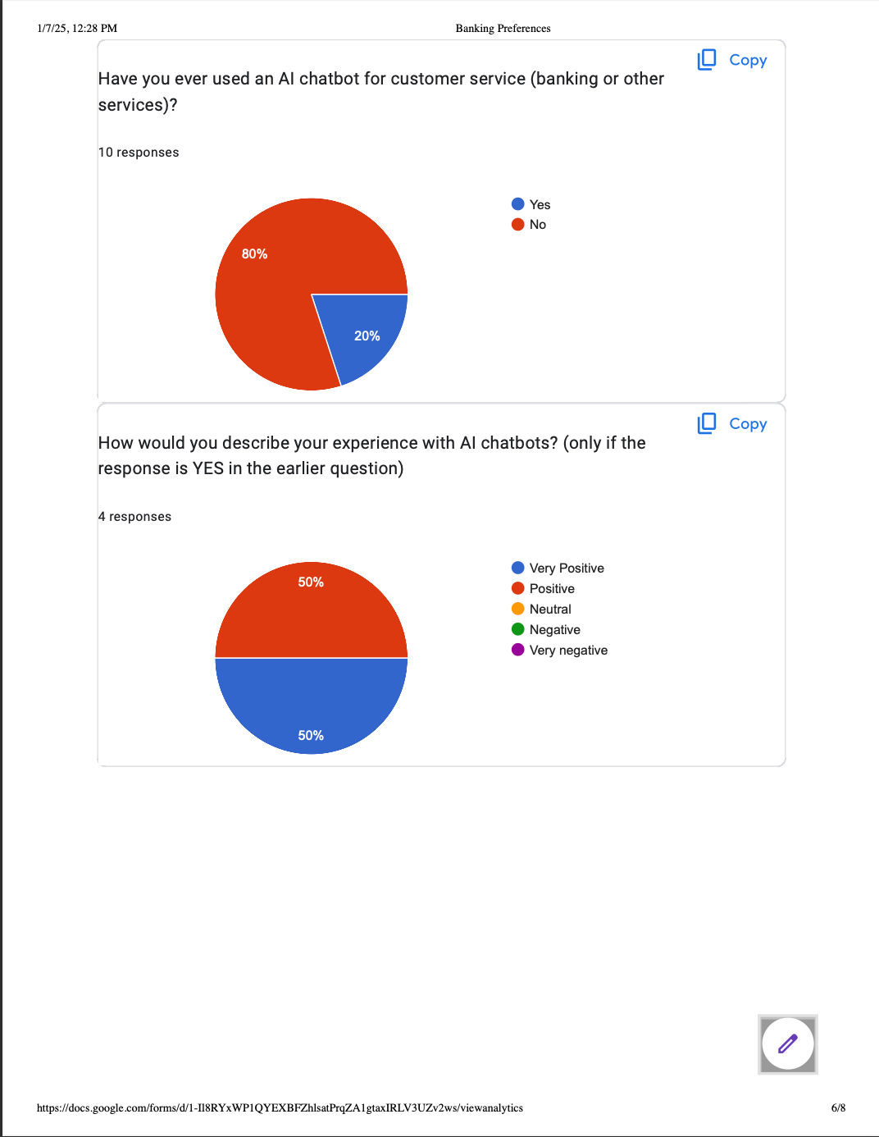

Figure 12 Requirement Gathering 6

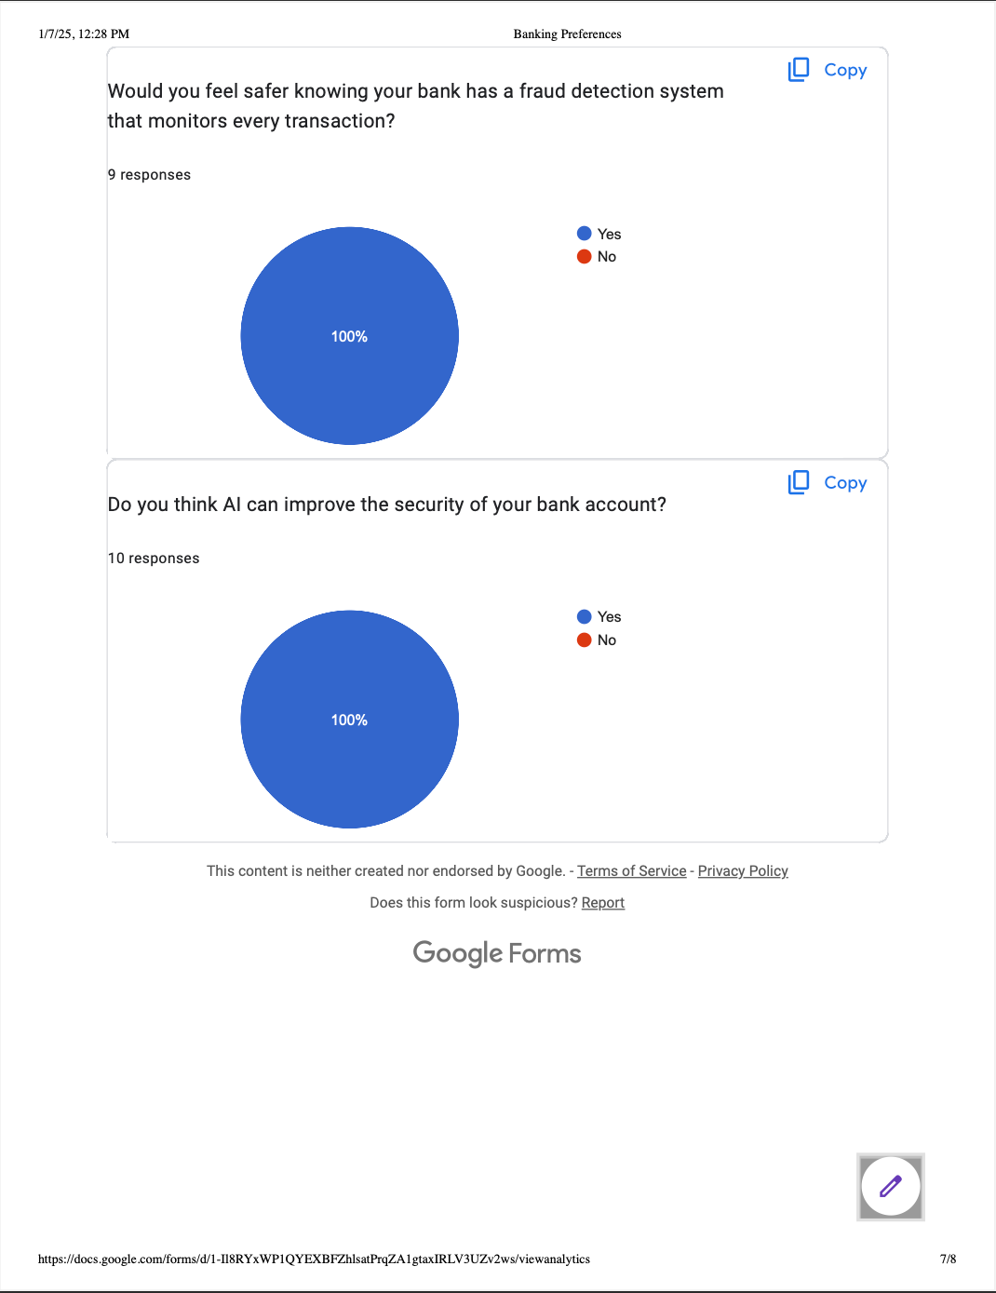

Figure 13 Requirement Gathering 7

## **3.2 Data Flow Diagram (DFD)**

A data flow diagram is visual representation or a graphical representation of business’s operation using a standardized set of symbols and notations. (Scott, 2024) Data flow diagrams simplifies the understanding of the business requirements and their applications by representing the sequence of the process steps and flow of information using visual representation or a graphical representation. (See Appendix) Following represented are the DFDs level:

### 3.2.1 Level 0 DFD(Context Diagram)

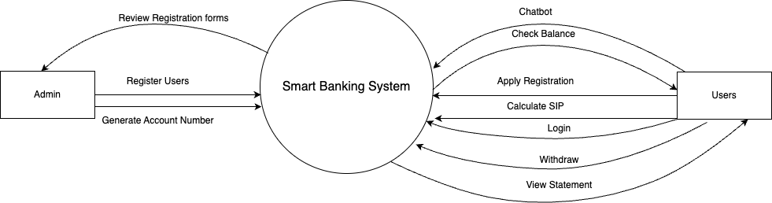

Figure 14 DFD level 0

### 3.2.2 Level 1 DFD

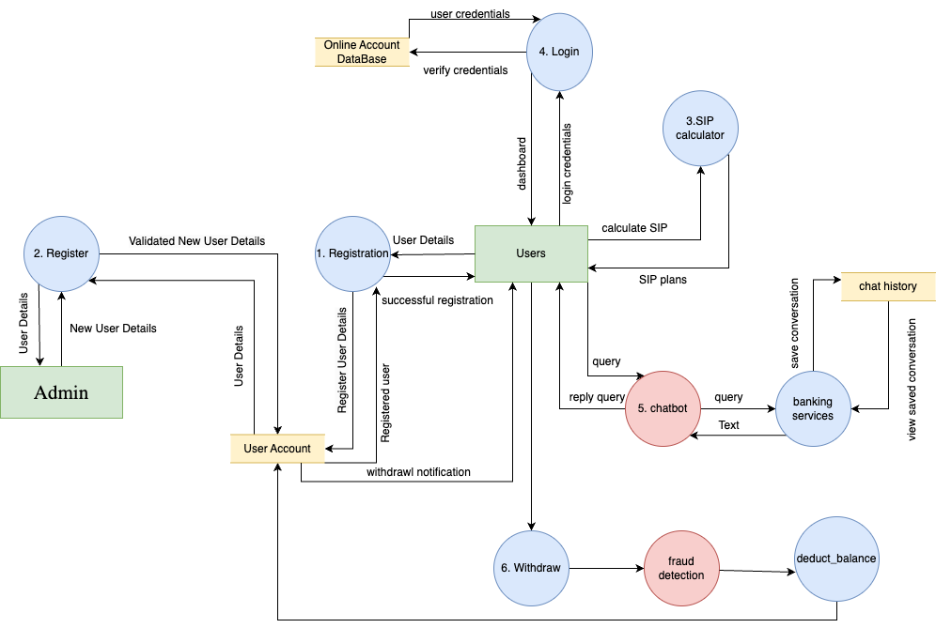

Figure 15 DFD level 1

### 3.2.3 Level 2 DFD

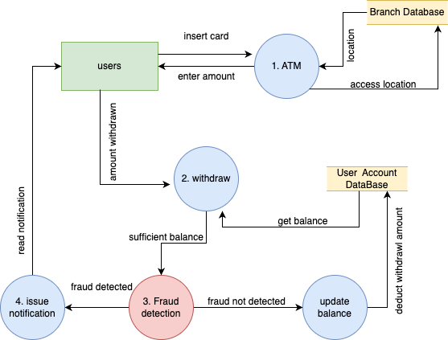

Figure 16 Fraud detection DFD level 2

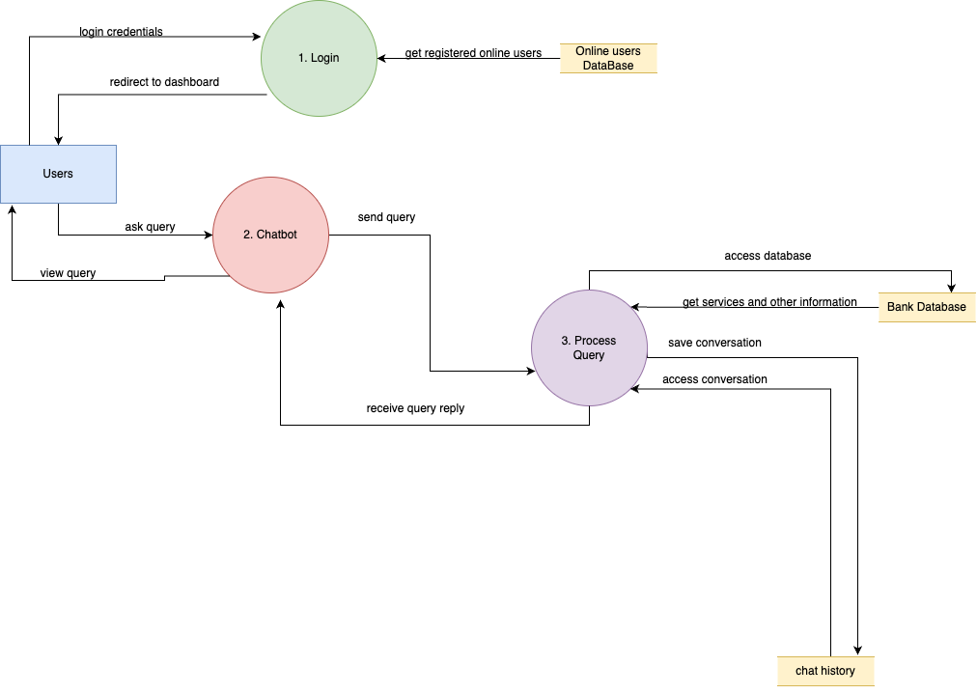

Figure 17 Chatbot level 2 DFD

## 3.3 Use Case Diagram

A use case diagram is drawn at the very early stage of a software development. A use case diagram models business functionalities into real word objects and systems through a diagrammatic representation. Use cases show how the proposed system interact with the outside environment without considering what goes under the hood of the system (Marta, 2023). (See appendix)

(See High level use case)

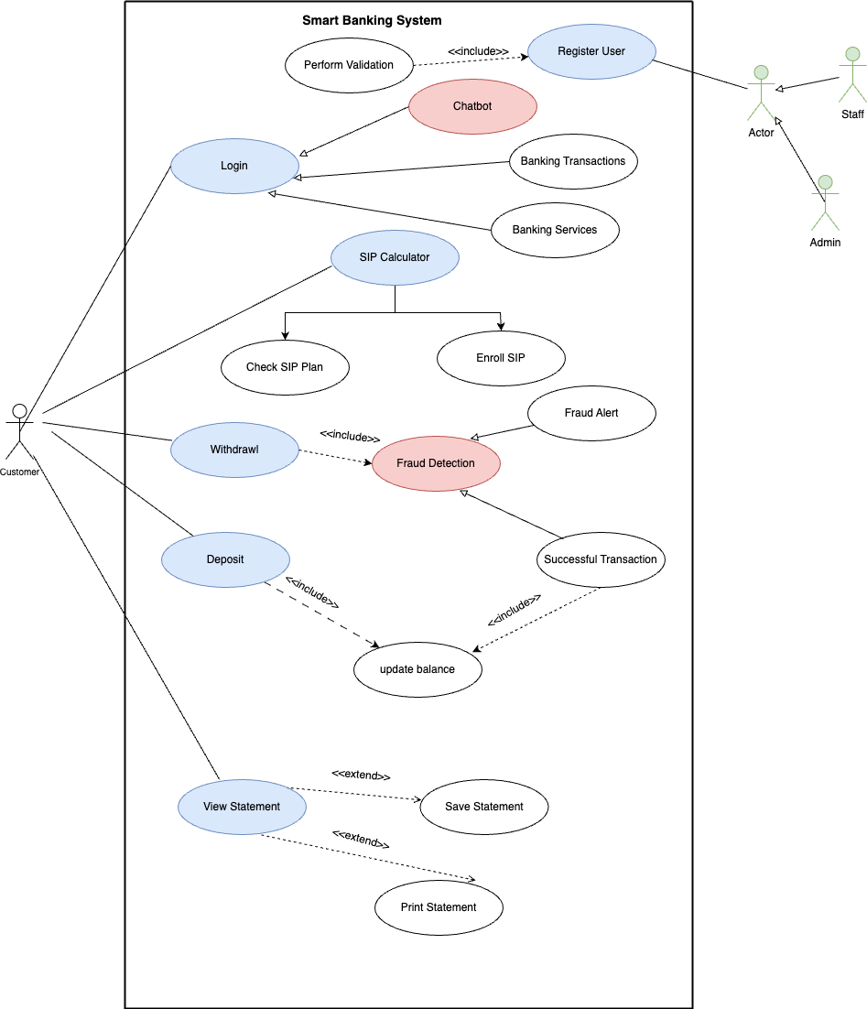

Figure 18 Use Case Diagram

## 3.5 Software Requirement Specification(SRS)

A software requirement specification is a document that includes information about all the functional and nonfunctional requirements for a described project. The SRS documentation serves as the reference anchor for the software developers team and the involved stakeholders. (Edoardo, 2022). (See Appendix)

## 3.6 Sequence Diagram

Sequence diagram is the system interaction diagrams used in UML to visually represent interactions between objects that live within a system. Sequence diagram depicts occurrence of interactions of individual objects called life lines and provides a view of order. (Olivia, 2023) (See Appendix)

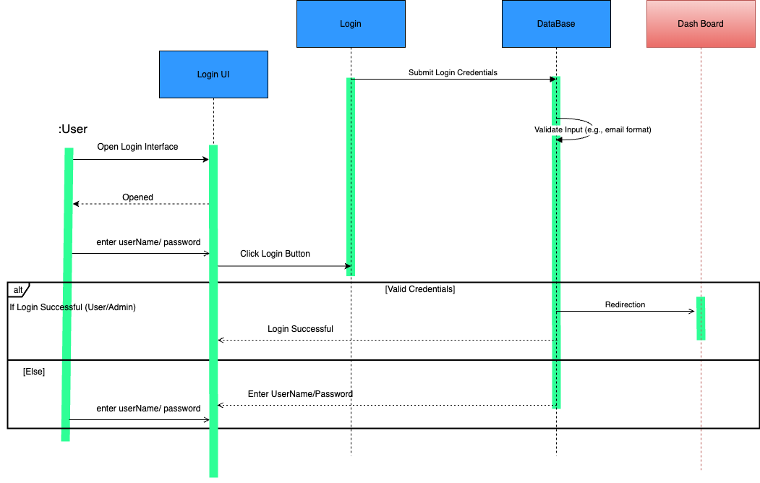

Figure 19 Sequence Login

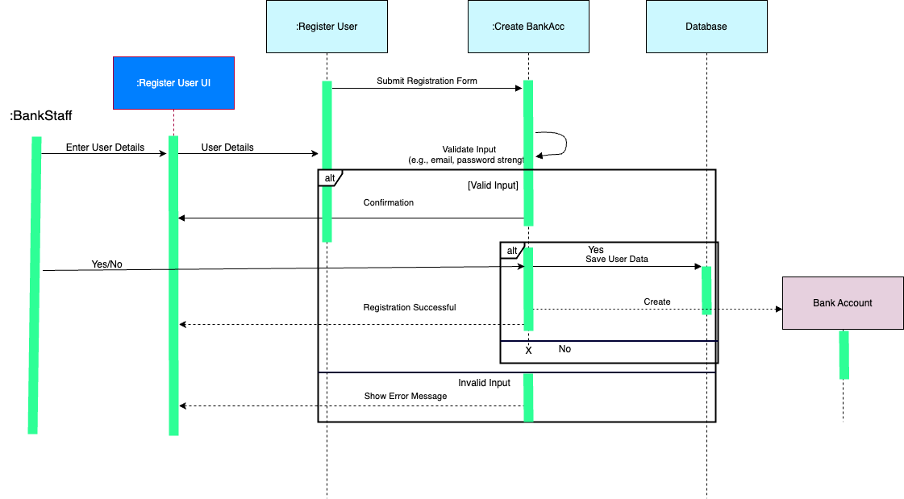

Figure 20 Sequence Register

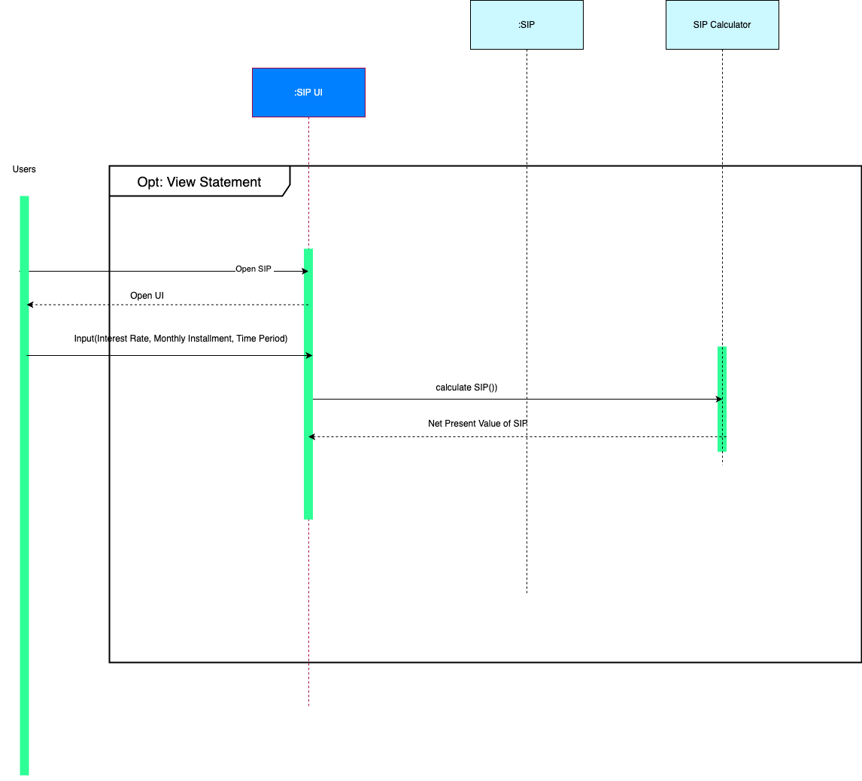

Figure 21 Sequence SIP Calculator

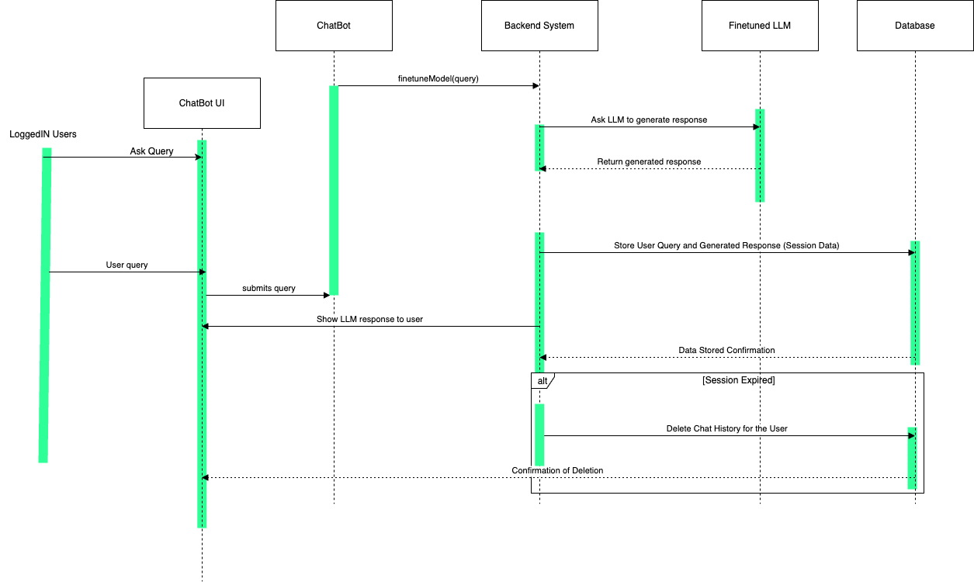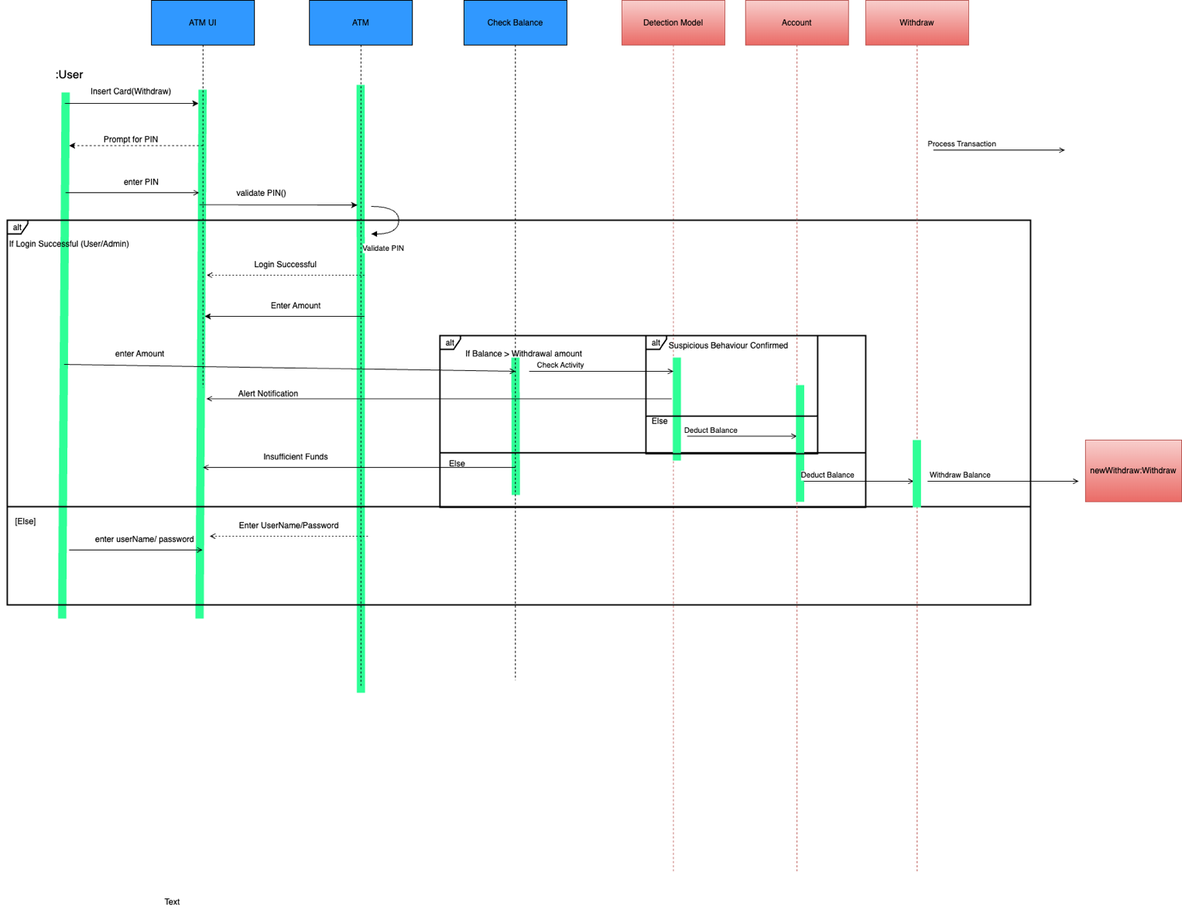

Figure 22 Sequence chatbot

Figure 23 Sequence Fraud alert on withdrawl

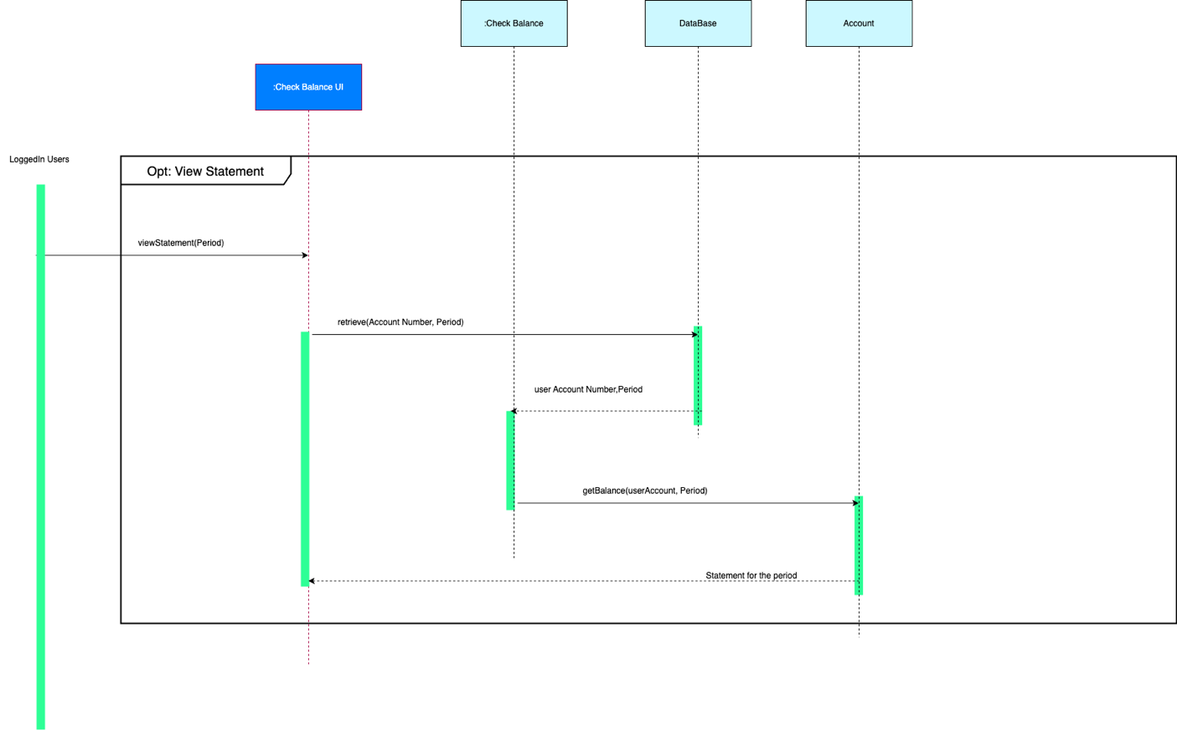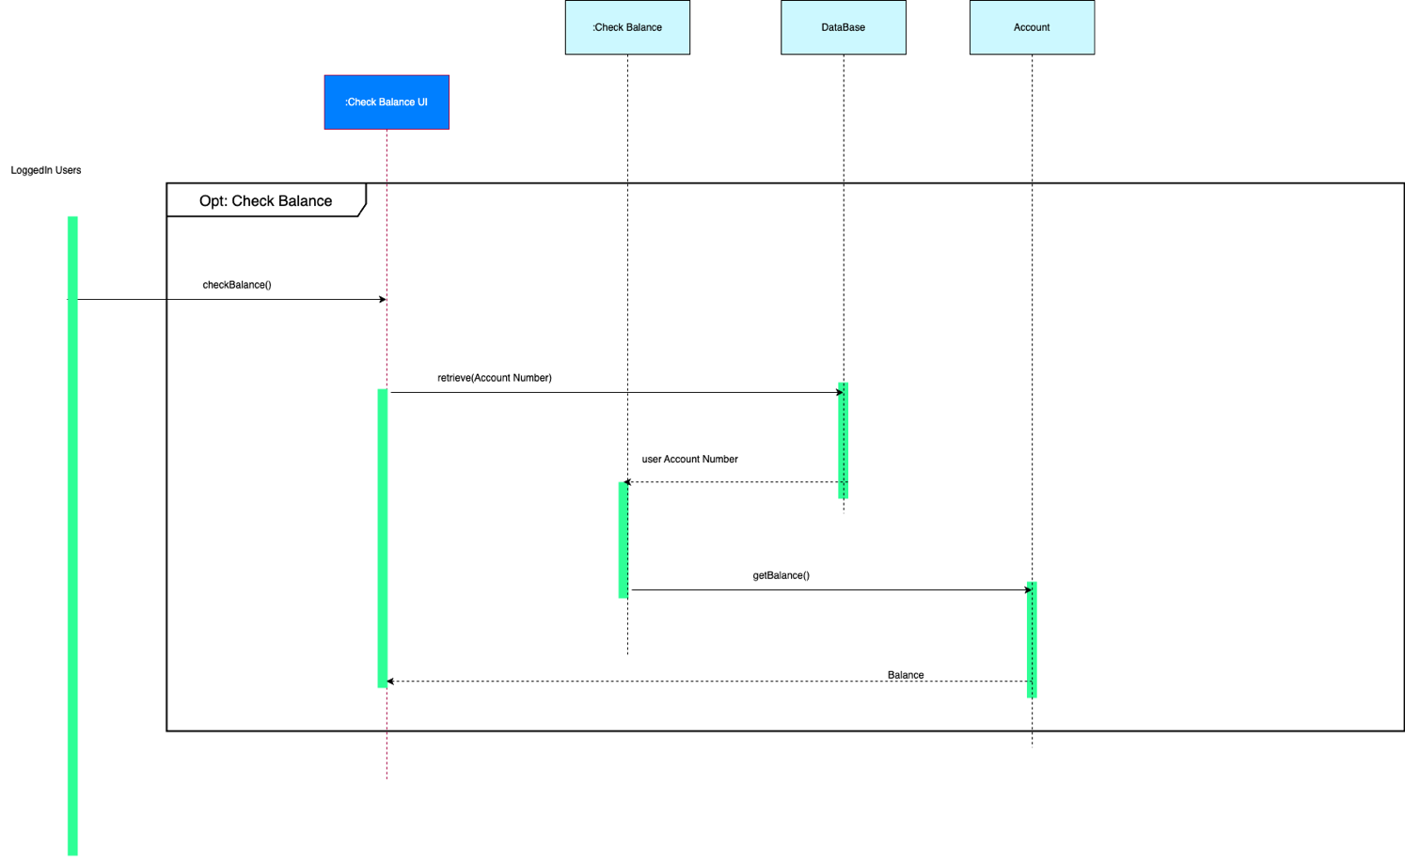

Figure 24 Sequence view statement

Figure 25 Sequence check balance

## 3.7 Collaboration Diagram

Collaboration diagrams are the system interaction diagrams used in UML to describe a pattern of interaction among objects. clarify the roles of objects which performs a particular flow of events of a use case. They show how the objects interact with other objects , to perform behavior of a particular use case or a part of a use case. Collaboration diagrams are better suited for analysis activities depicting simpler interactions of smaller number of objects.

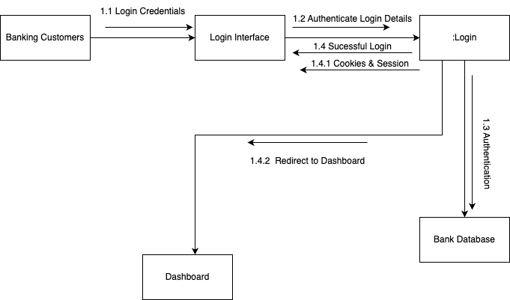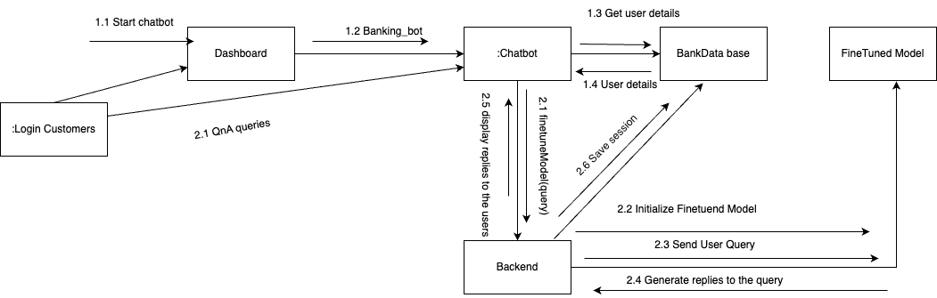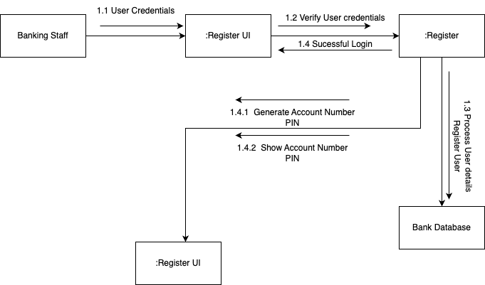

Figure 26 Collaboration Login

Figure 27 Collaboration chat bot

Figure 28 Collaboration Registration

## A diagram of a bank Description automatically generated3.8 Block Diagram

Figure 29 Collaboration Fraud detection on Withdrawl

Block diagram are a visual diagram for the depiction of internal structure of a system by using blocks and the connection between the blocks later becomes block diagram. Block diagrams are essential and are fundamental tools because they are easy to understand and allow the users clarify complex systems, make problem detection more easier, and facilitate communication skills. (Vaishali Chourey, 2024)A block diagram consists of following components.

**Blocks:**

They act as building blocks representing the major system component or functions that defines system’s structure and primary operations.

**Arrows:**

They represent the data flow or control flow between blocks helping us to visualize how different components interact with each other.

**Labels:**

They are the name assigned to each block’s name and connection.

**Inputs/Outputs**

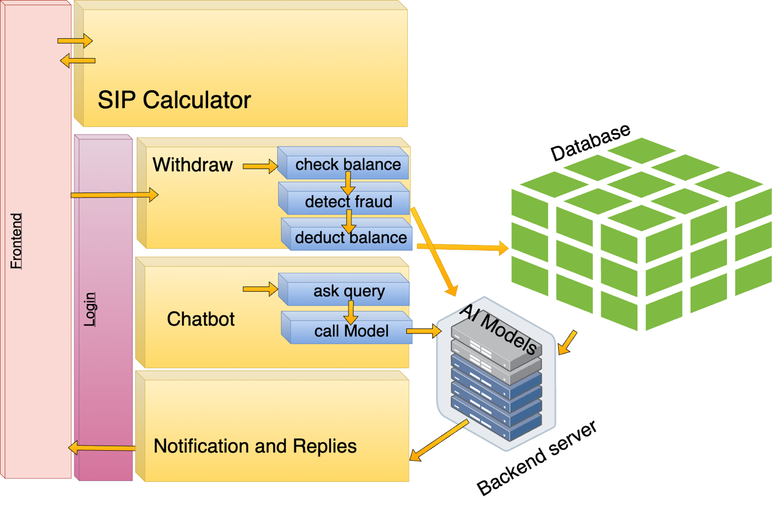They represent the data entering and leaving the system.

Figure 30 Block Diagram

## 3.9 Wire Frame Design

Wireframe is an abstract design created during the early stages of digital product design to help visualize the structure of a product or a website. (Balsamiq, n.d.) It is the first stage of design process which the UX designers often use to map out the design and layer of their work without diving into too much detail. The wireframe maps the details of upcoming project throughout the software development process. The main goal of wire frame is to provide developers with clarity on how users will interact with the software product.

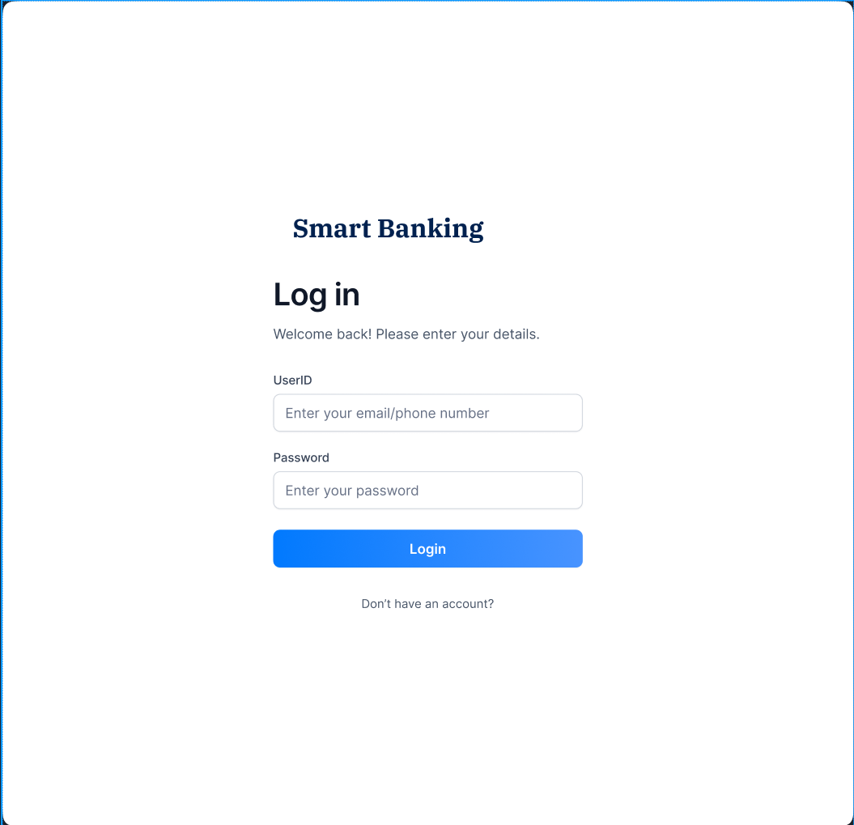

Figure 31 Wireframe Login

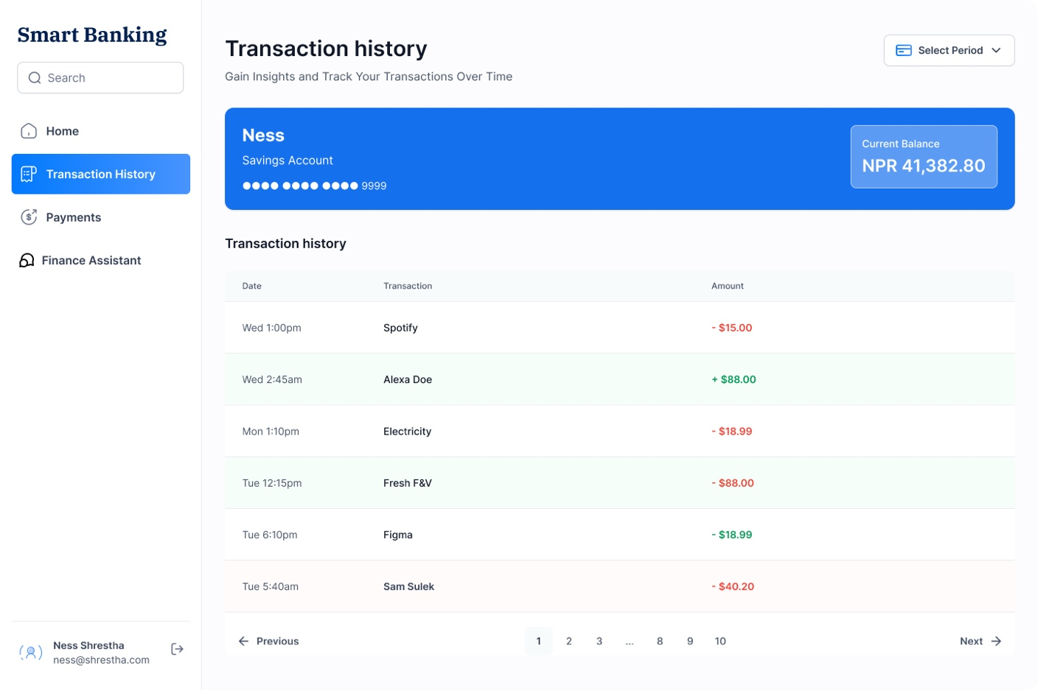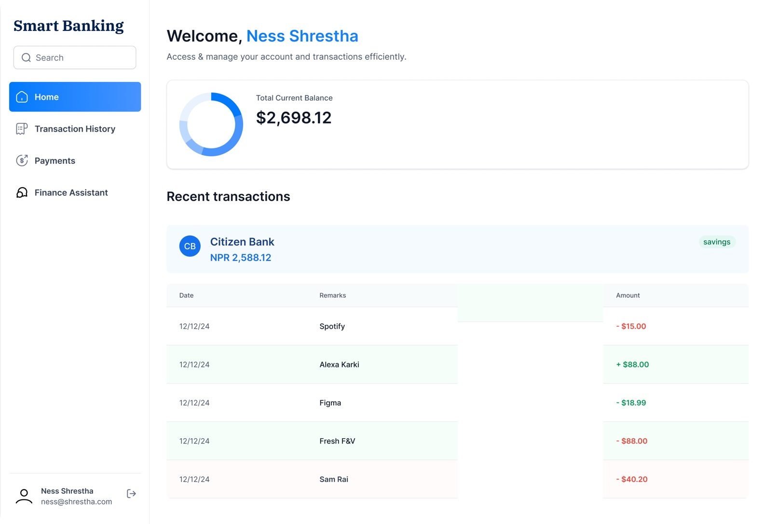

Figure 32 Wireframe Transaction History

Figure 33 Wireframe Dashboard

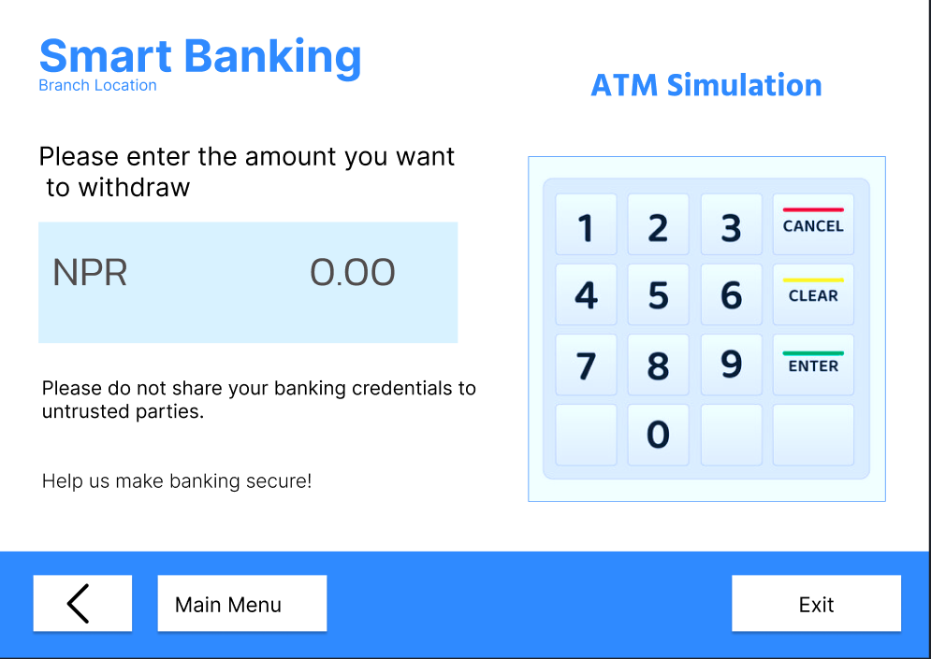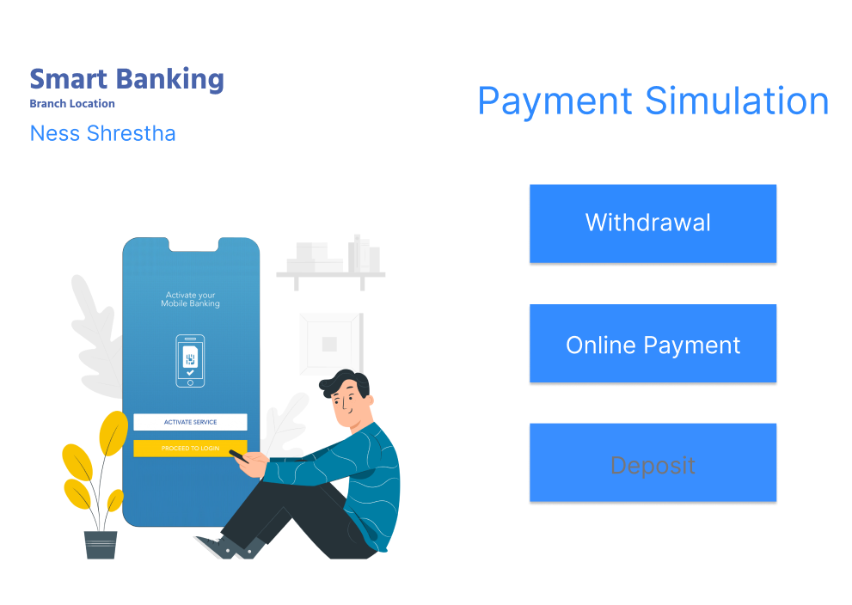

Figure 34 Wireframe ATM

Figure 35 Wireframe for Withdrawl

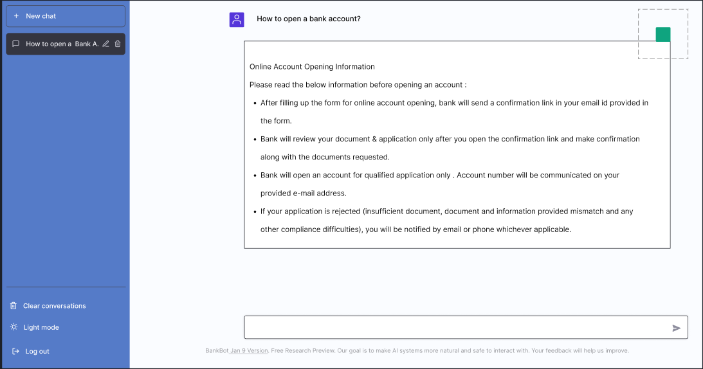

Figure 36 Wireframe chatbot

## 3.10 Entity Relationship Diagram (ERD)

Entity Relationship diagram is an structural diagram that depicts the relationship between various entities such as objects, people, places concepts or events in a system. (Amran, 2018).(See annex)

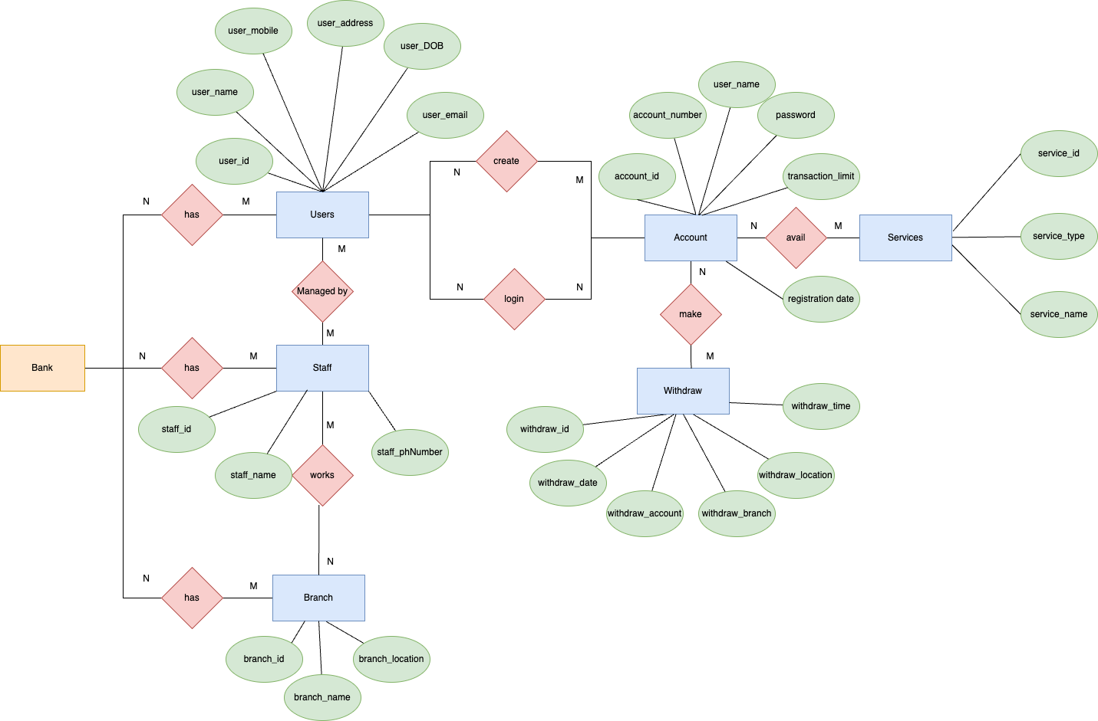

## 3.10 Class Diagram

Figure 38 Class Diagram

Class diagram is one of the most important components of UML diagram that visually represents the structure of a system by illustrating its classes, attributes, methods and relationships between them. (Fauzan, et al., 2018) The class diagram provides its users static view of the application where he/she can visualize the system architecture and assists in constructing executable code.

## 3.11 Project Management: Trello

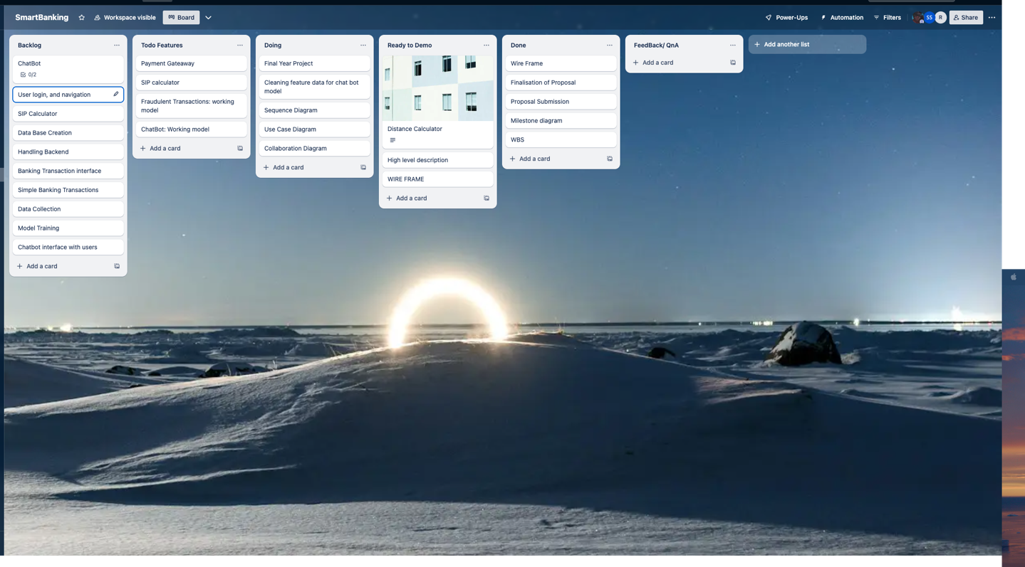Trello is a cloud based visual tool that helps users visually organize projects using boards, divide project into groups and sub divide groups into tasks. With only requiring internet connection Trello offers user friendly interface unlimited number of board and assign one board per project. Trello also eliminates the need to install the software of purchase license keys. (HA., 2017). Our Trello board consists of

Figure 39 Trello

**Backlog:**

Backlog is the first group of the Trello board that serves as the collection of potential features and tasks. It serves as a collection stage of ideas and tasks which may be considered in future sprints or iterations.

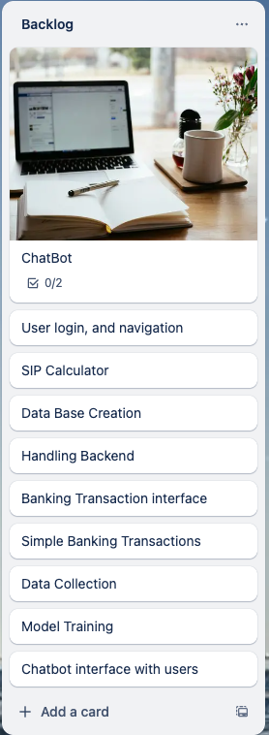

Figure 40 Backlog

**Todo Features:**

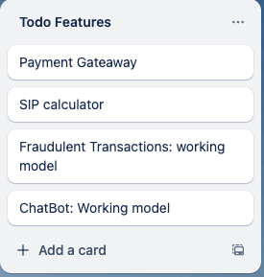In this group those set of tasks or features that are ready to be worked upon are kept. The tasks from back log which are prioritized and are ready to be take upon in coming cycles are kept here.

Figure 41 Trello To do group

**Doing:**

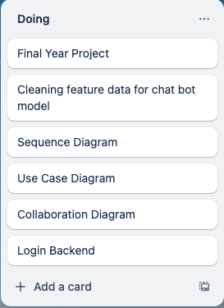The group consists of tasks that are work in progress. Team members can move cards from To do features to doing group as soon as they began their work on said task.

Figure 42 Trello Doing

**Ready to Demo:**

Those tasks that have been completed and ready for demos and reviews are moved to this group from Doing group.

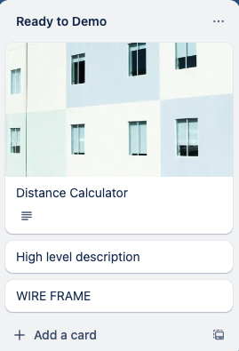

Figure 43 Trello Ready to Demo

**Done:**

When the tasks are reviewed and successfully completed they are moved to this group. Those tasks belonging to this group are completed.

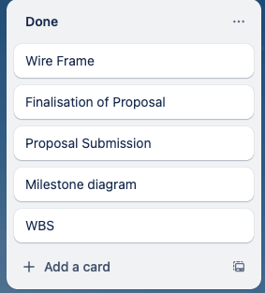

Figure 44 Trello Done

**Feedback:**

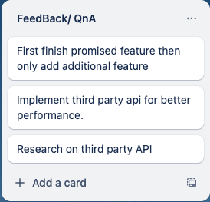This group is used to collect comments, suggestions, feedback regarding the completed or the ongoing tasks. It helps to improve the quality of the task by implementing the feedback so received.

Figure 45 Trello Feedback

## 3.12 System Architecture Design

A system architecture describes the components of a system, their interactions, and the interaction of the system as a whole. (Anon., 2020)System architecture design ensures that the components of a systems fits together effectively to meet the need of stake holders. It requires creating a blueprint for the system which includes both functional and non-functional requirements including the interaction among systems.

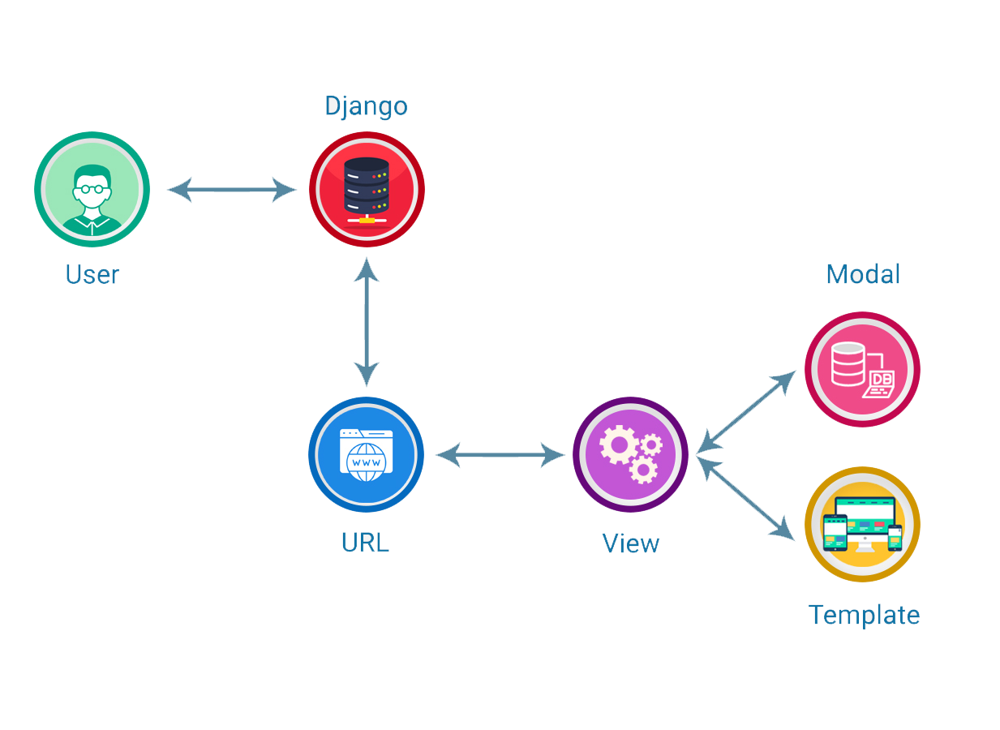

Figure 46 System Architecture diagram

## 3.13 Database migrations

Django uses database migrations in managing changes to the database schema. One of the beloved feature of Django database migrations is that they allow developers to apply modification made to model directly to database without having to write raw SQL commands.

**Creating Migrations:**

Whenever there is change in model developers create migrations.

**Applying Migrations:**

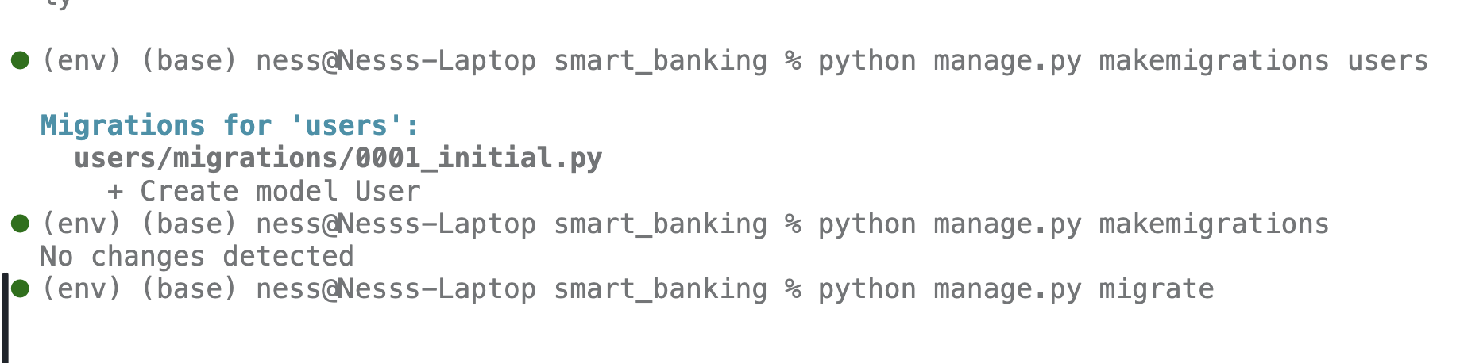To implement changes recorded in migration files developer apply migrations.

Figure 47 Migrations: Creating migration files and executing SQL commands with database

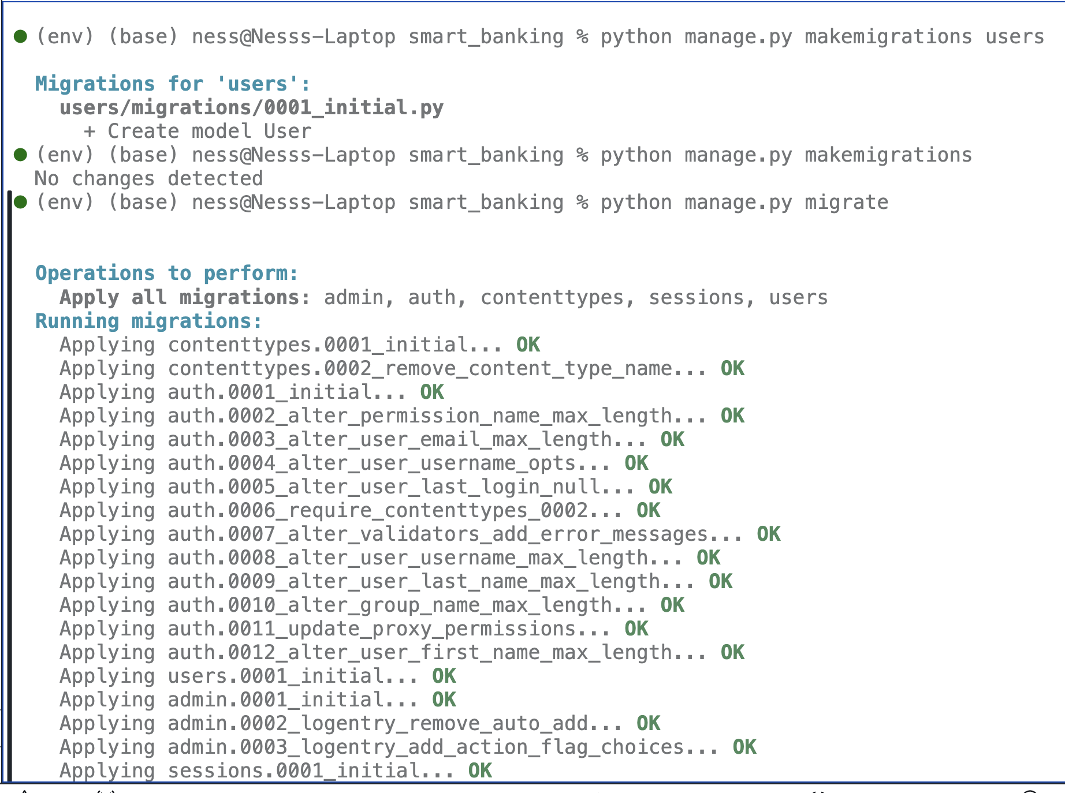

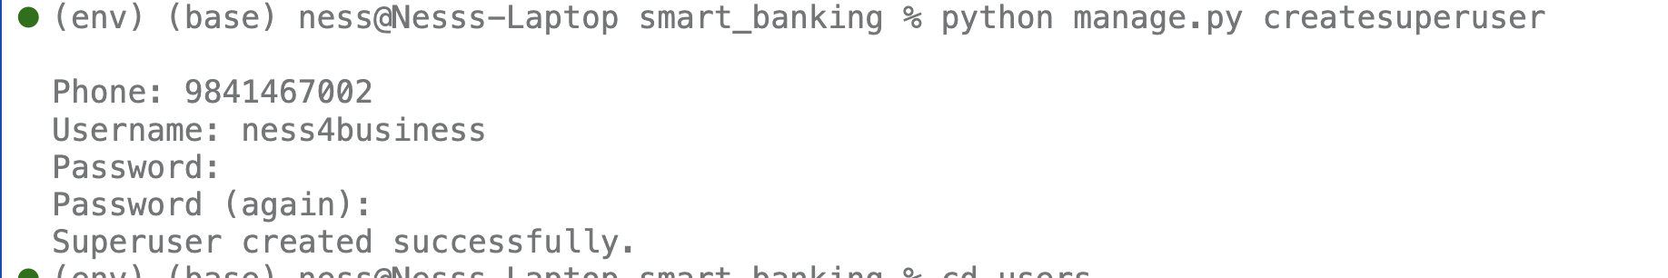Figure 48 Migrations: Successful migration file creation

Figure 49 Creating super users

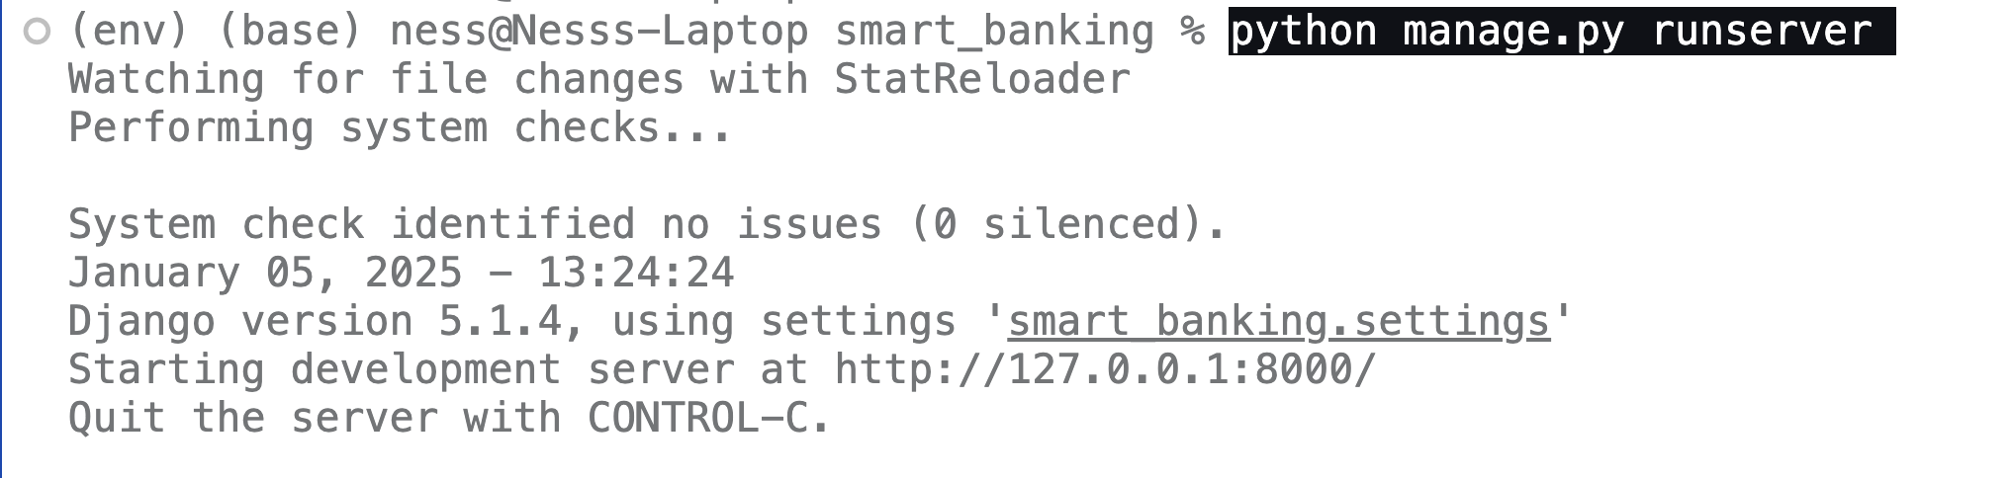

Figure 50 Starting the server

## 3.14 System Development

### 3.14.1 Front End Development

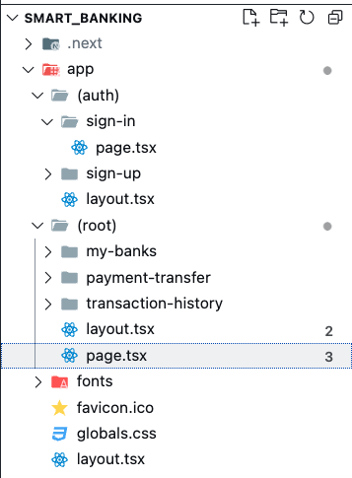Though development on front end has started there has not been significant achievement in front end part. React with next js has been used for the development of front end. A simple folder structure was established using a library called Route groups. Some of the advantages of using route groups is that it reduces repetition of routing configuration, improves readability and maintainability of route definitions and is very useful for nested layouts.

Figure 51 Frontend folder architecture

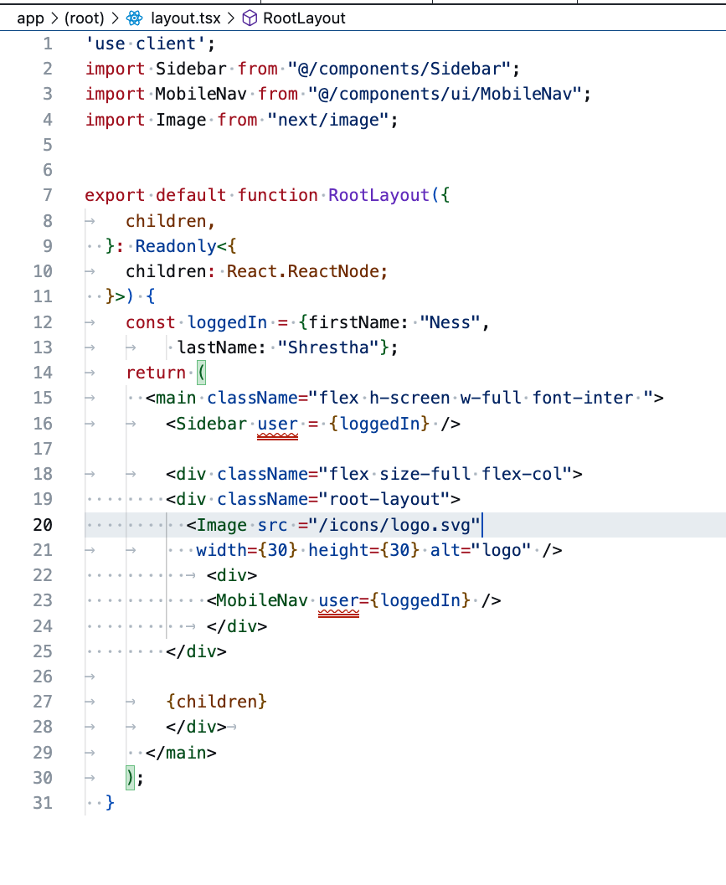

Figure 52 Implementing root layout

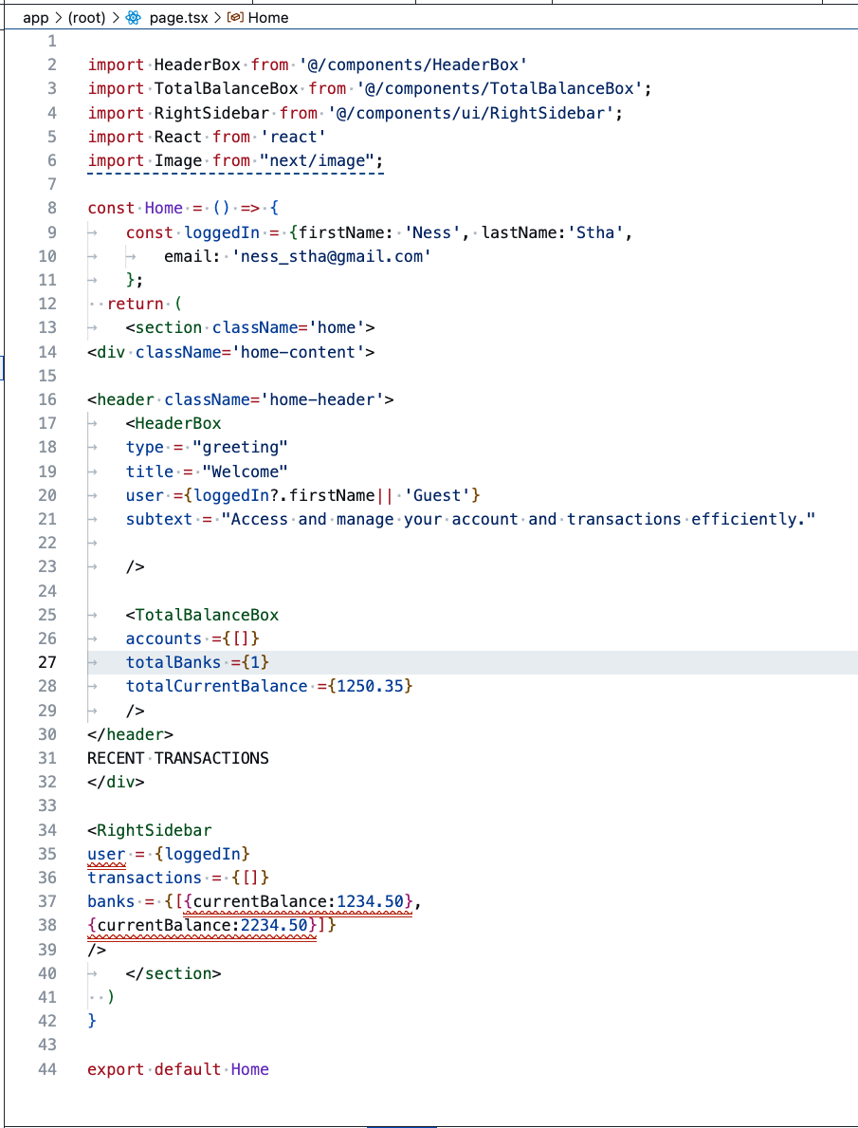

Figure 53 Frontend Dash board code

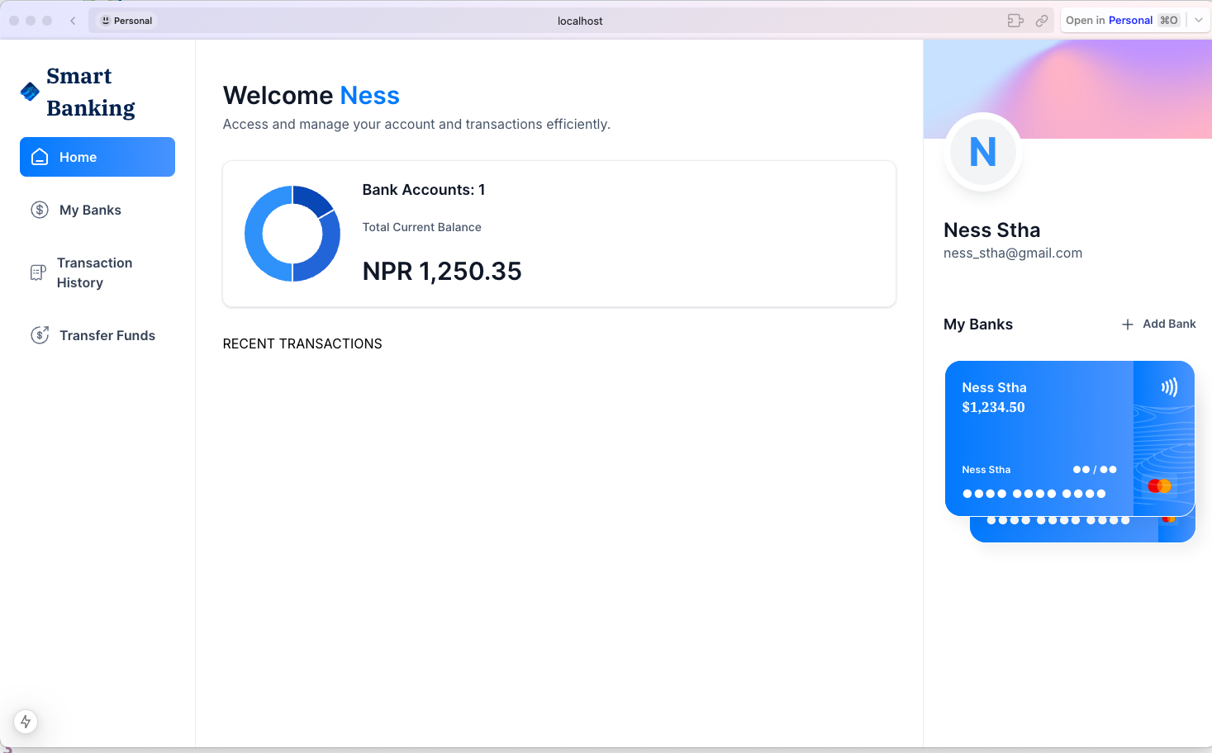

Figure 54 Frontend Dashboard WIP

### 3.14.2 AI Development

**i. Finetuning chatbot using LLAMA 3**

Fine tune model of LLAMA 3 was achieved leveraging the GPU provided by google collab through cloud computing.

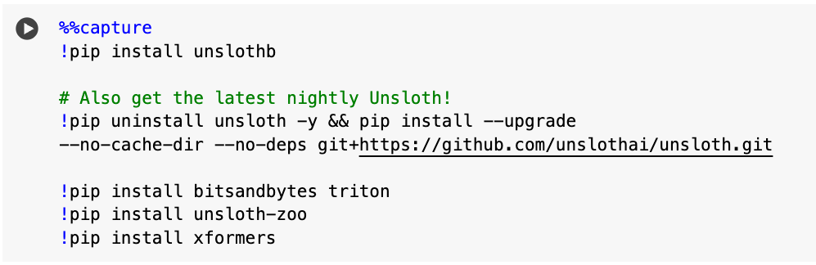

Figure 55 AI development Installing libraries

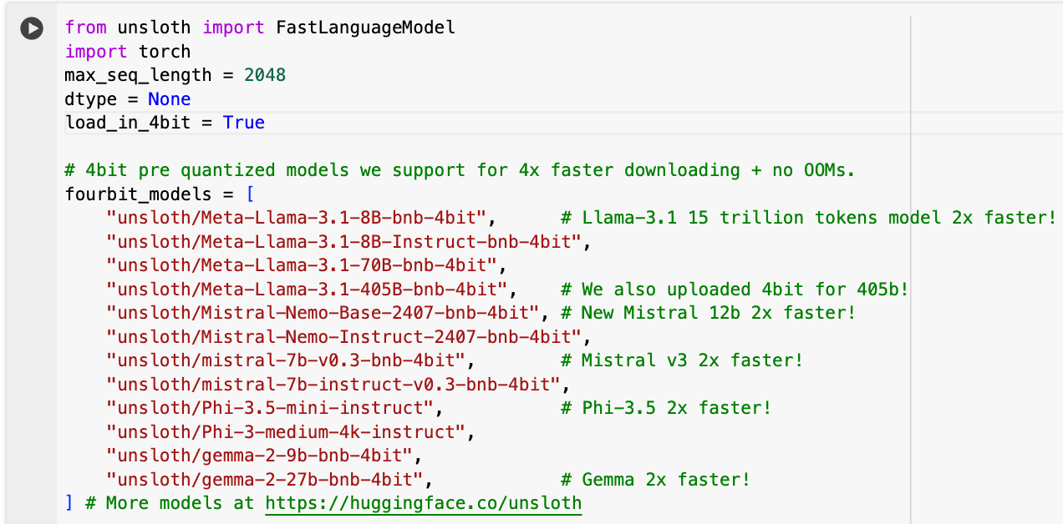

Figure 56 AI development Initializing Model

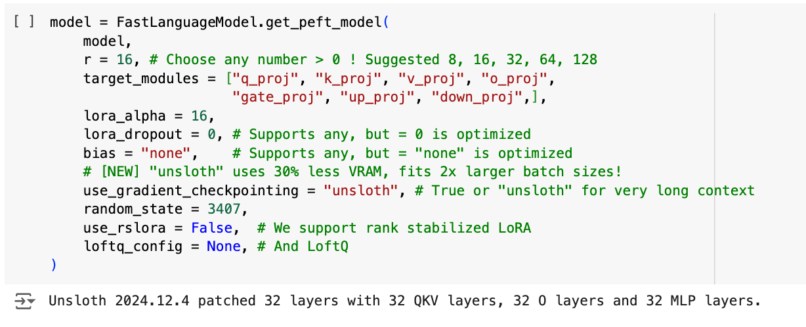 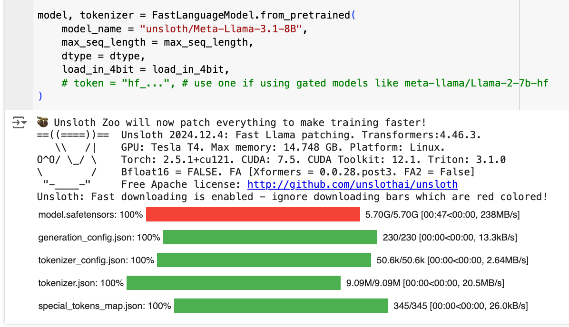

Figure 57 Model config

Figure 58 AI development Quantizing models

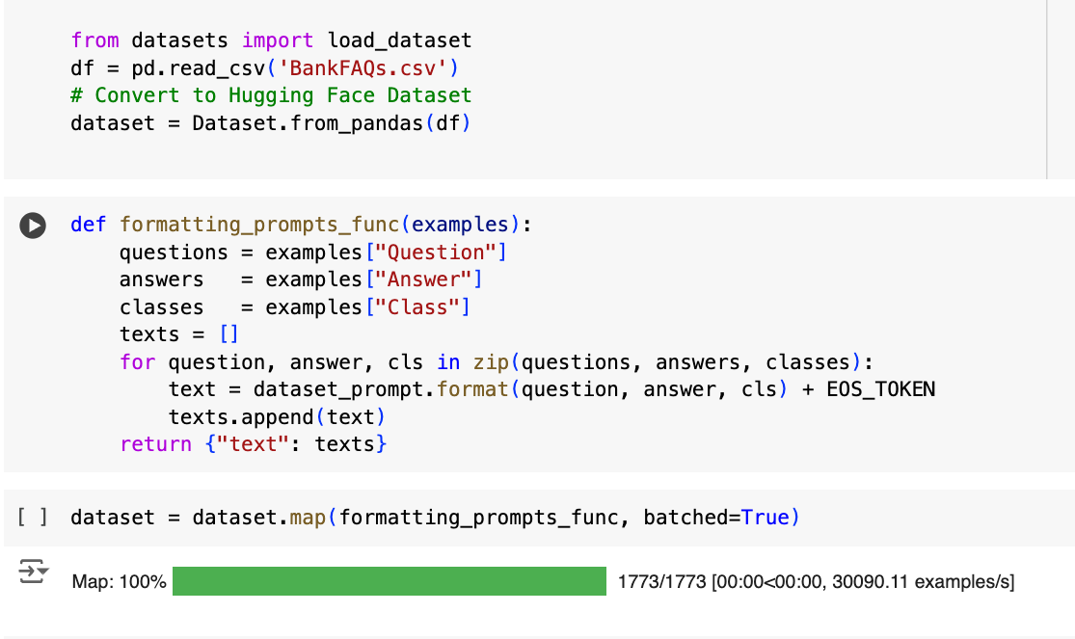

Figure 59 AI development Import and format datasets

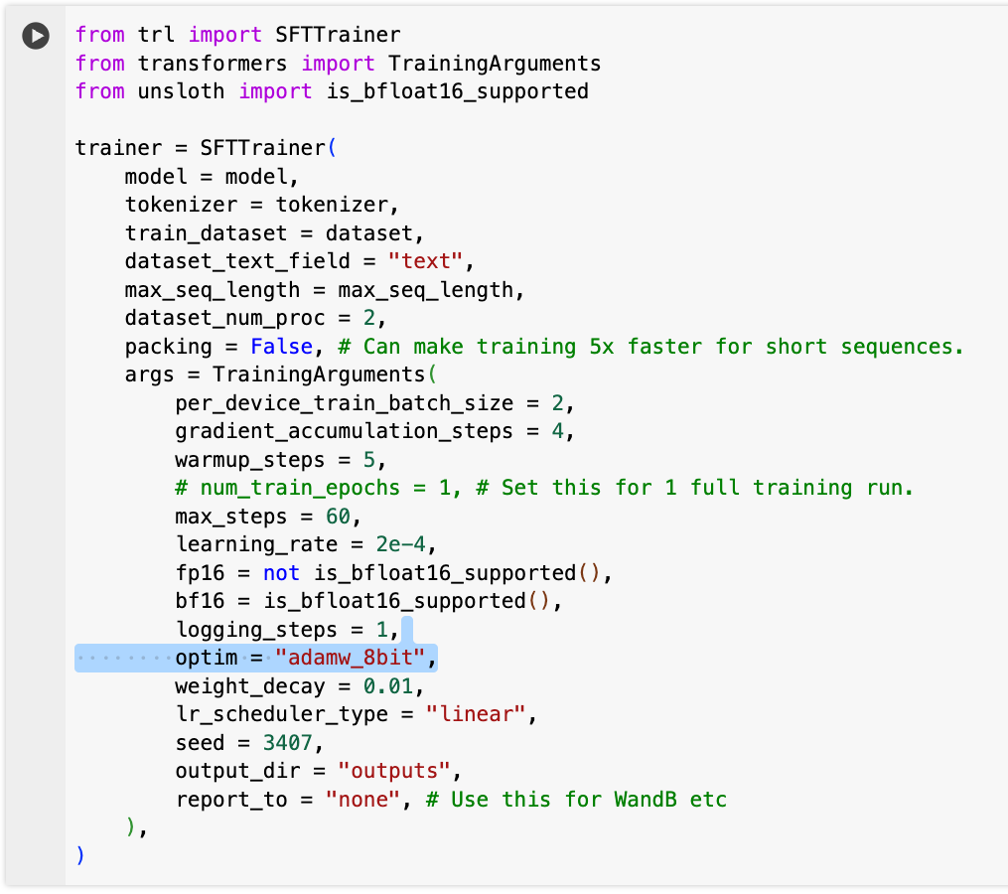

Figure 60 AI development Configuring supervised fine tuning (SFT) Trainer

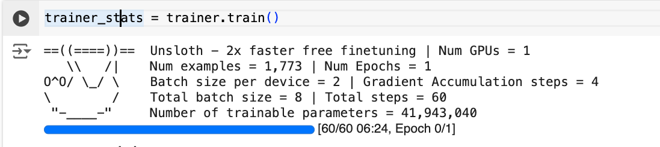

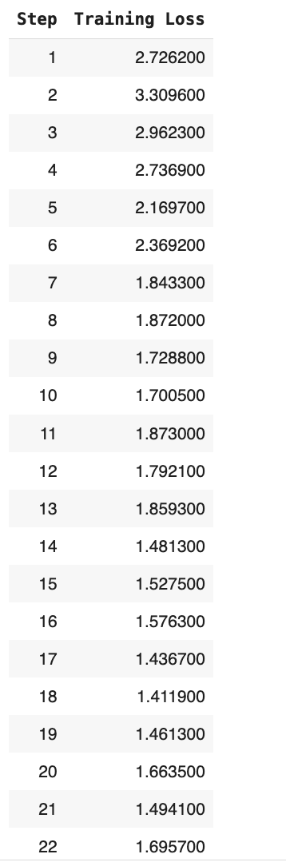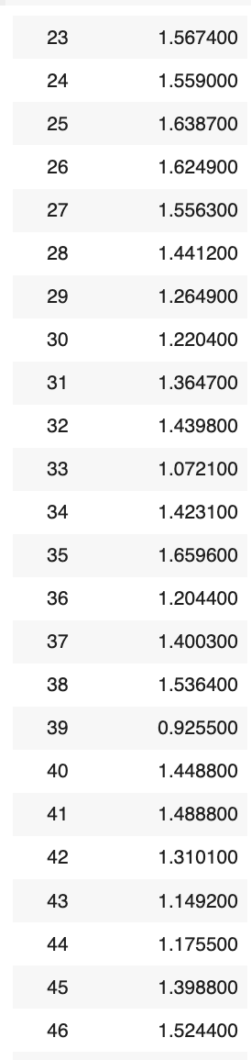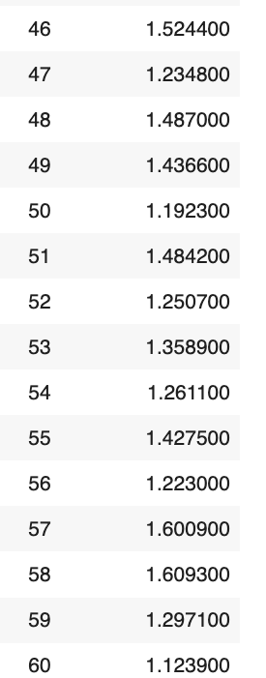

Figure 61 AI development Training with minimum epoch

Figure 62 AI development Proof of concept with minimum requirements achieved

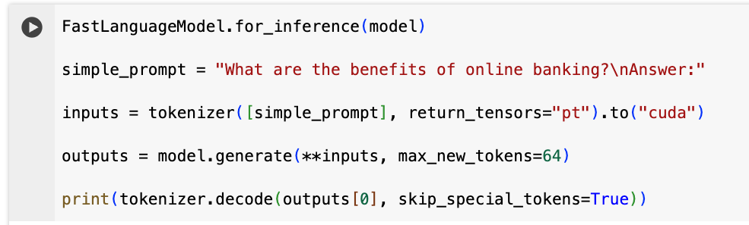

Figure 63 AI development generating response

ii. Credit Card fraud detection

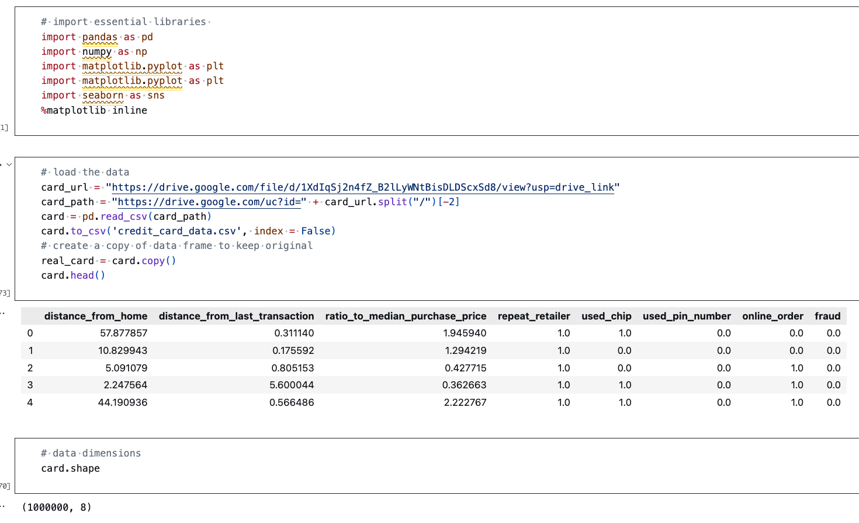

Figure 64 AI development importing libraries and dataset

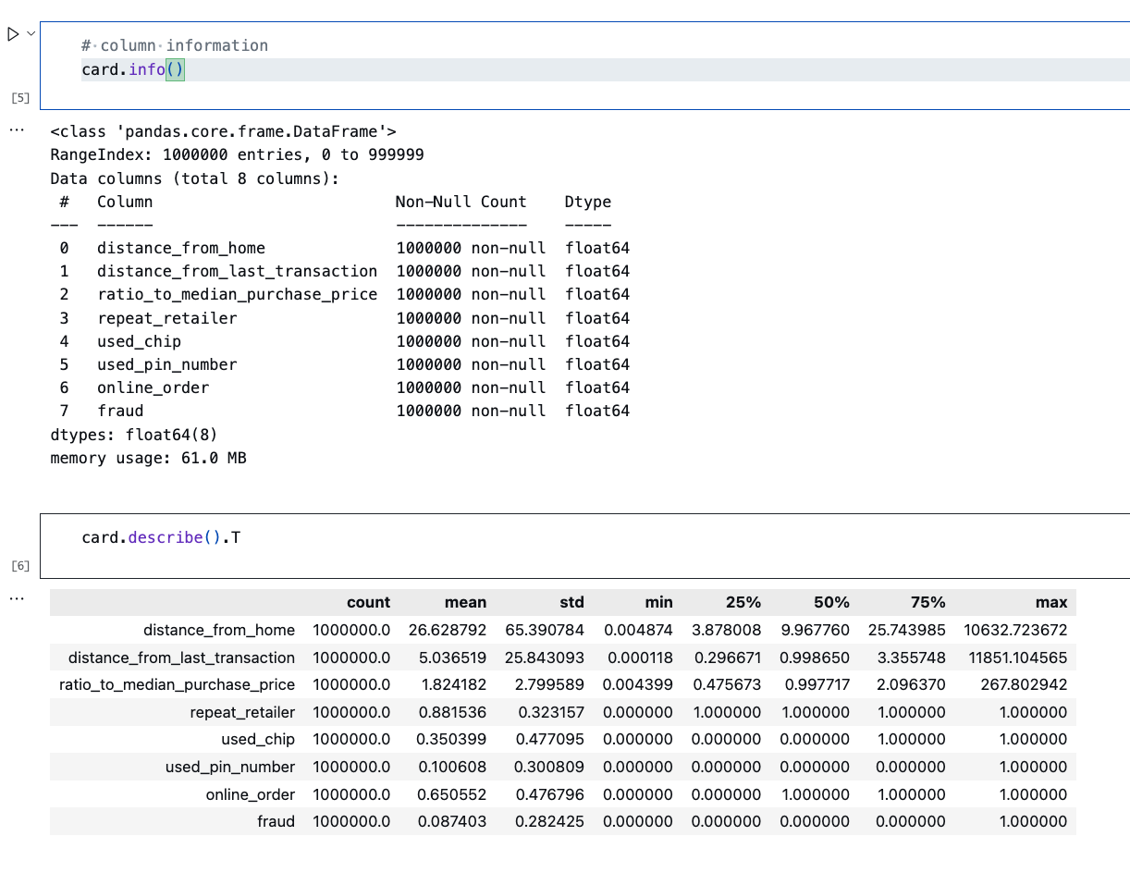

Figure 65 AI development analysing data

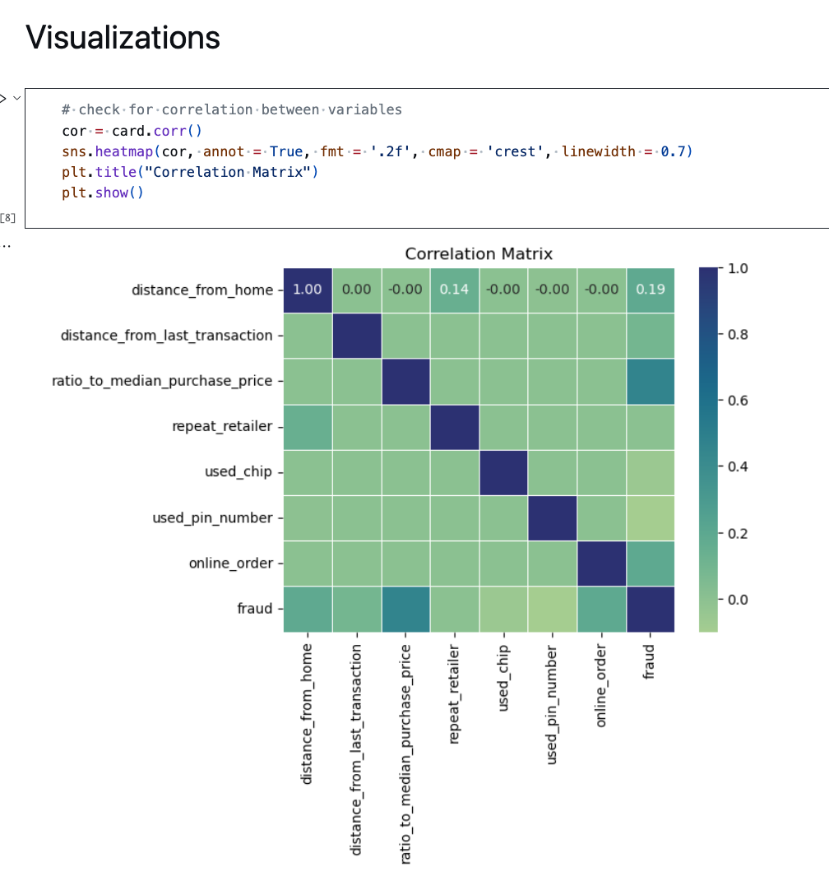

Figure 66 AI development data visualisation

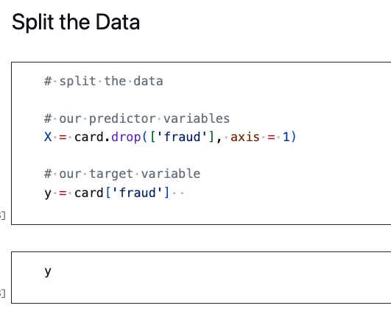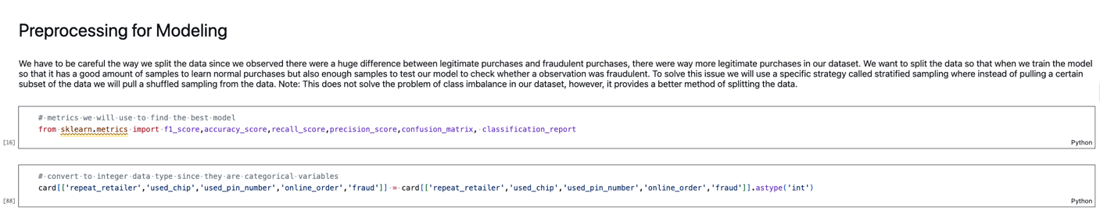

Figure 67 AI development splitting data

Figure 68 AI development preprocessing data

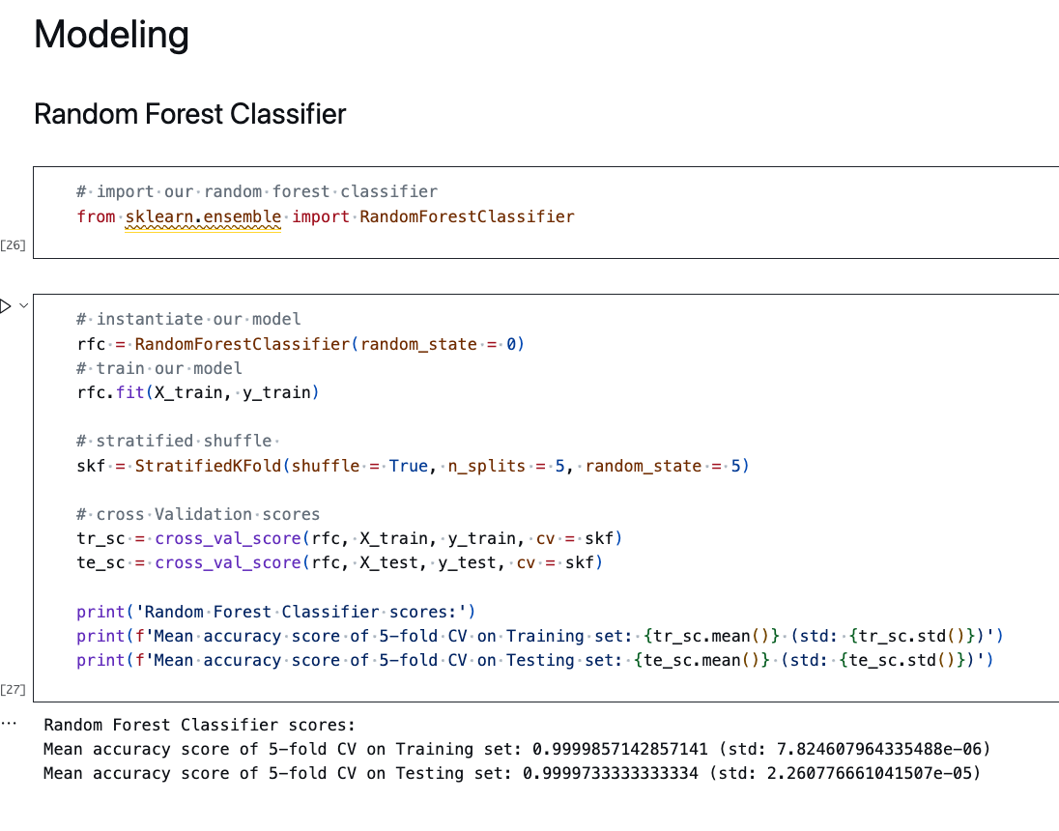

Figure 69 AI development modelling

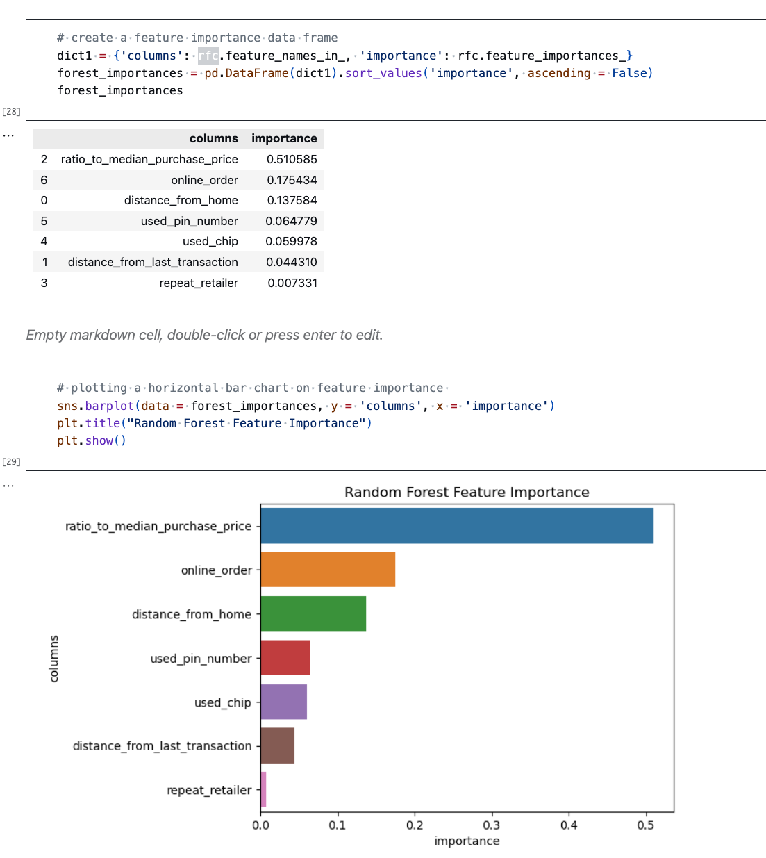

Figure 70 Random forest feature importance

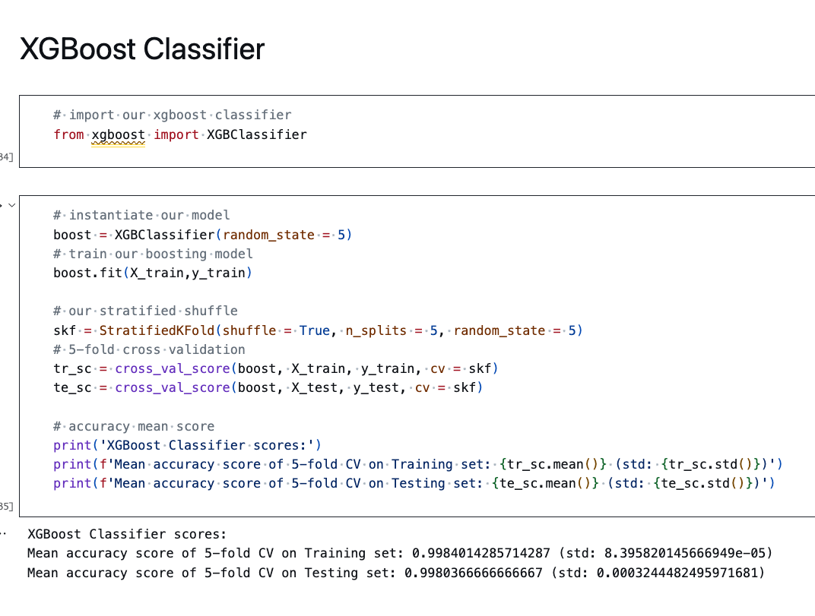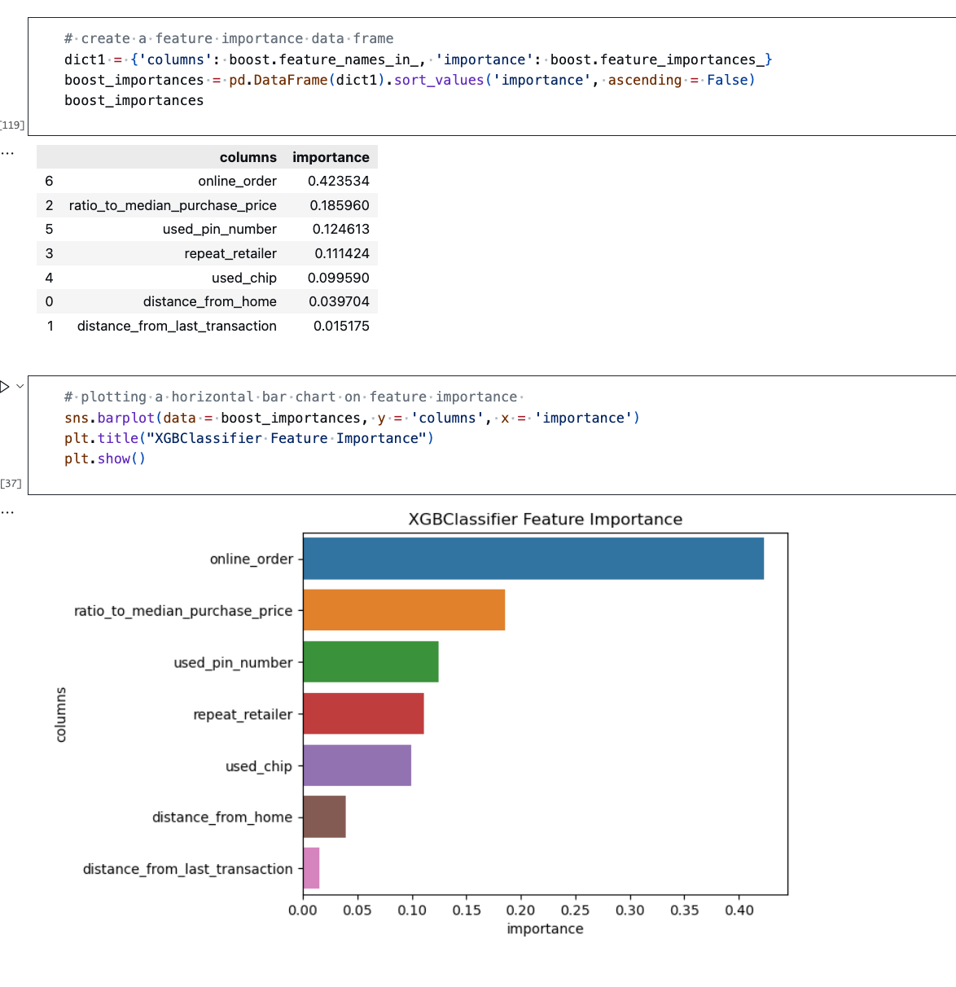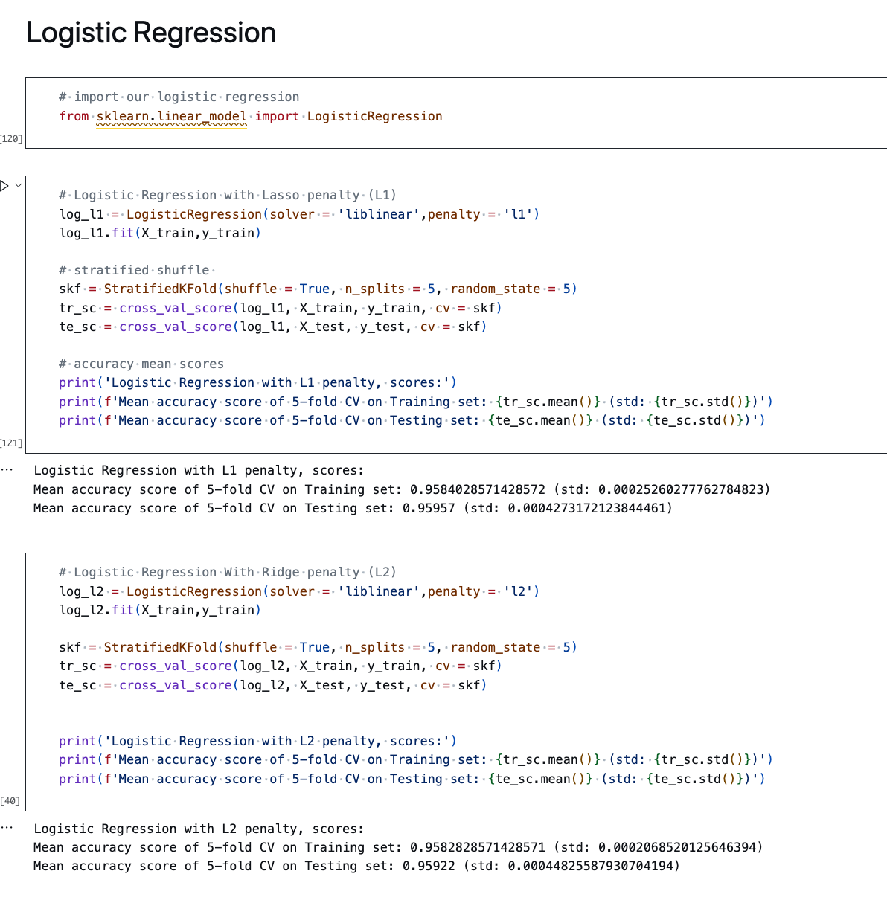

Figure 71 AI development XG Boost Classifier

Figure 72 XG Boost feature importance

Figure 73 AI development Logistic Regression

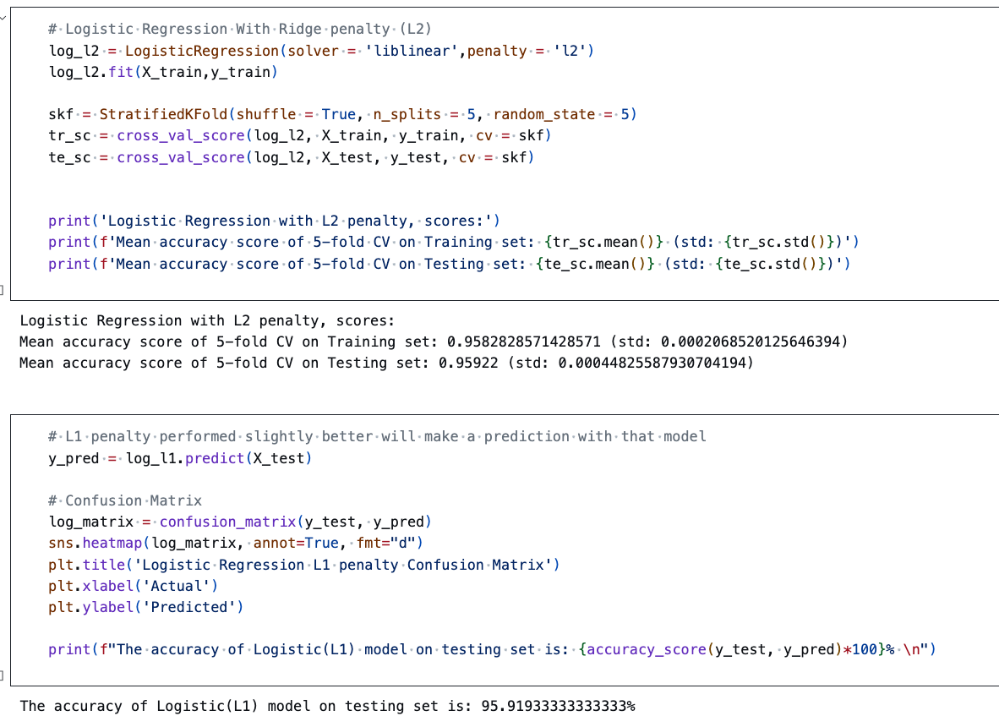

Figure 74 Logistic Model evaluation

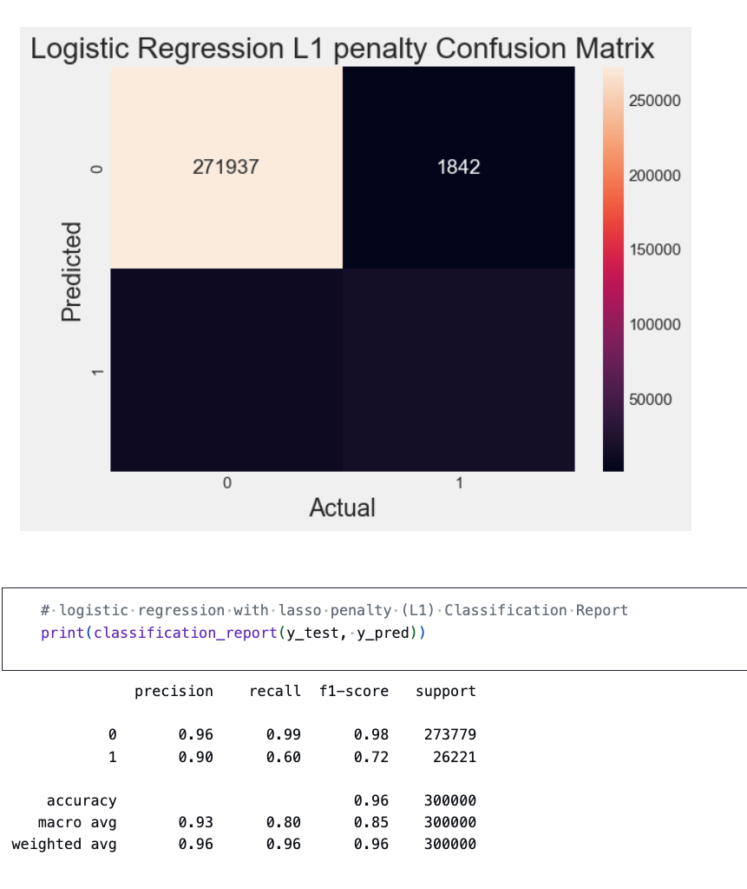

Figure 75 Logistic Regression Confusing matrix

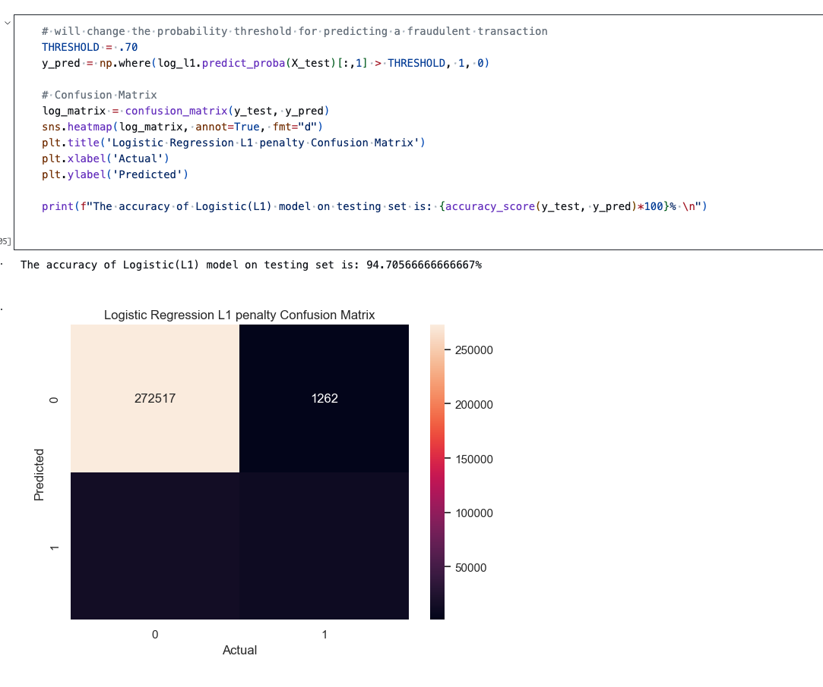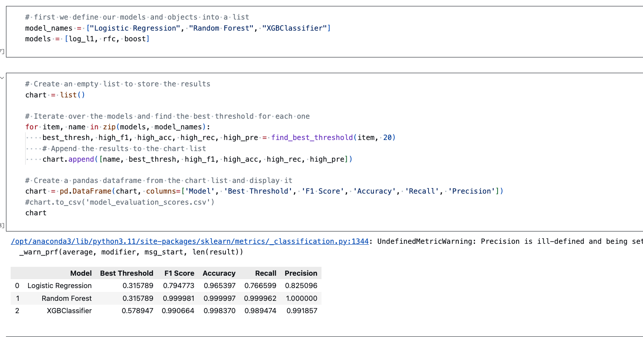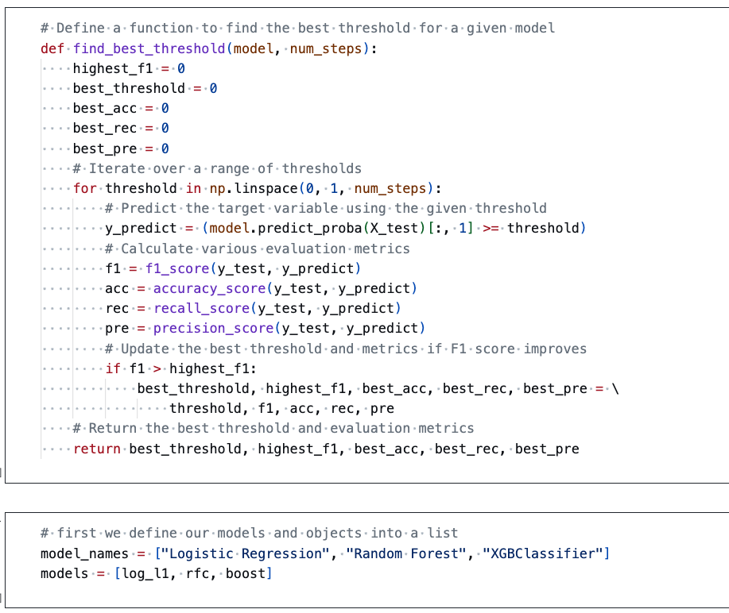

Figure 76 Setting threshold value and testing

Figure 77 Metrics Evaluation

Figure 78 Define best threshold for each model

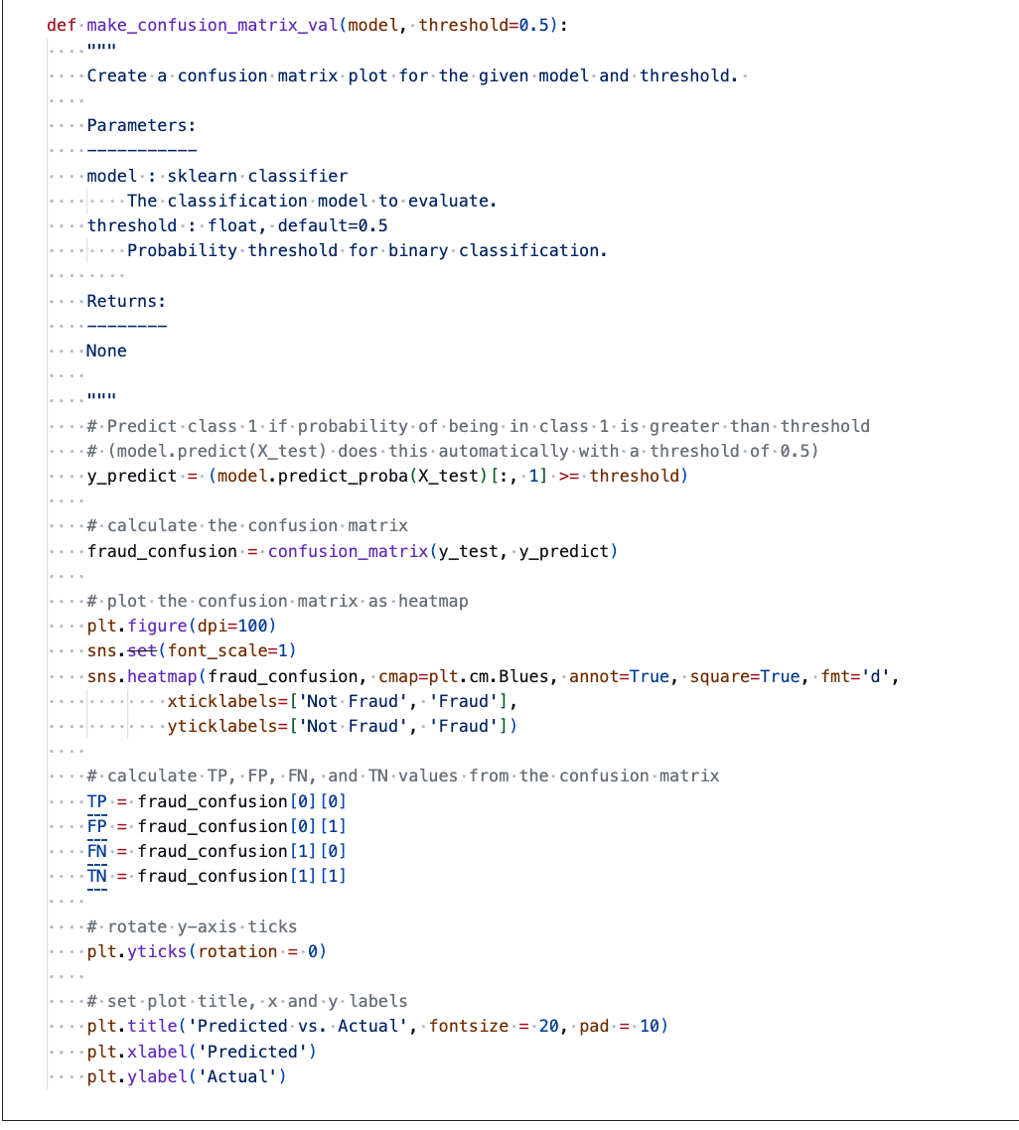

Figure 79 Confusion matrix for a given model

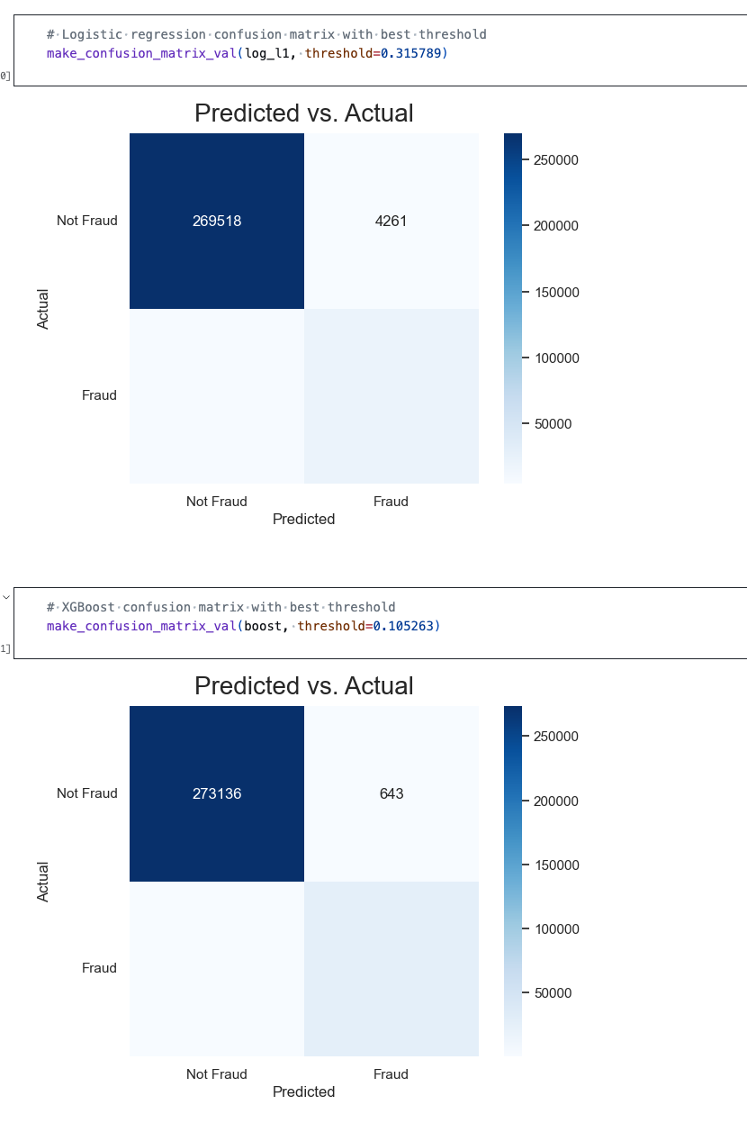

Figure 80 Confusion matrix for logistic regression and XG booster

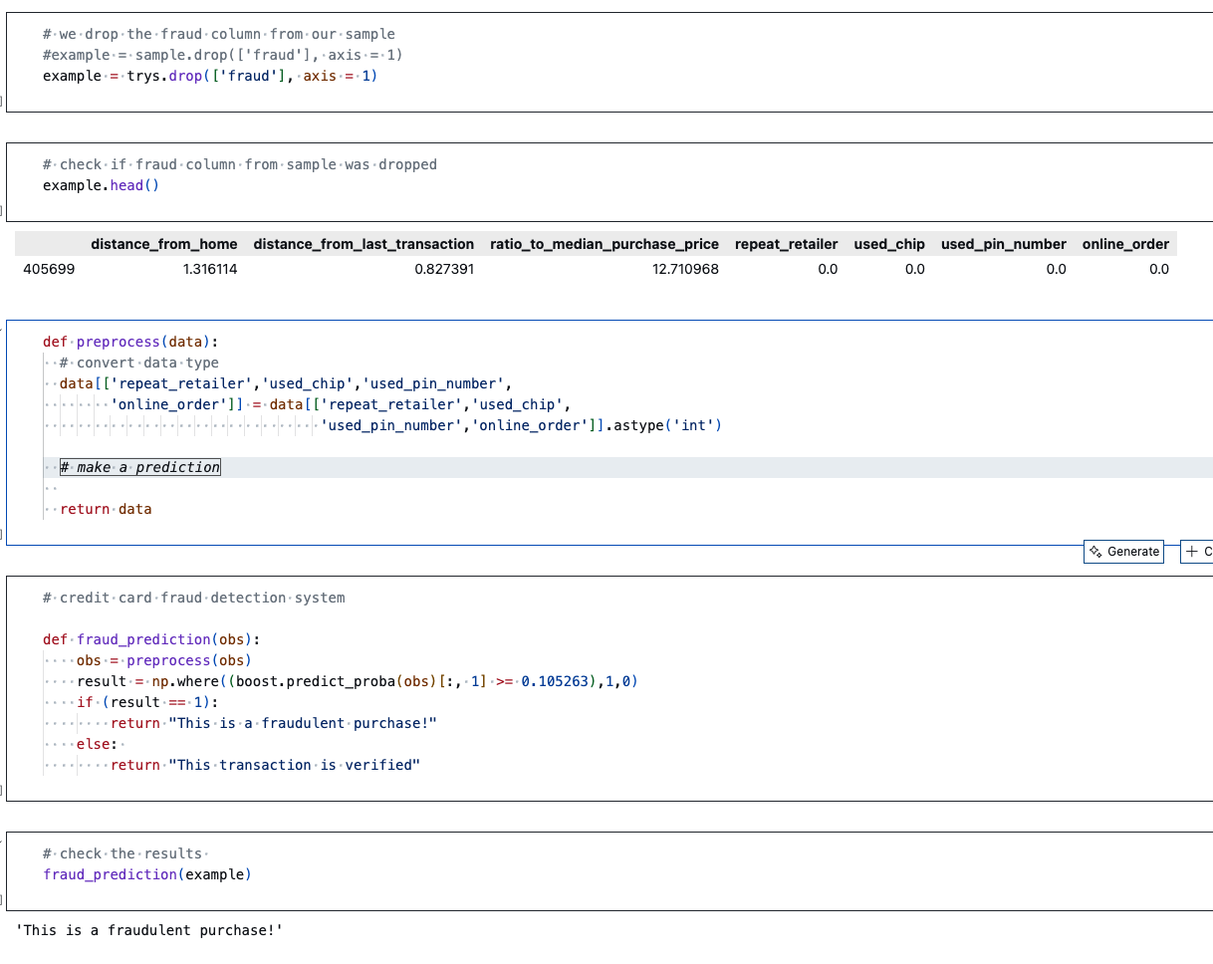

Figure 81 Fraudulent behavior prediction

### 3.14.3 Bank End Development

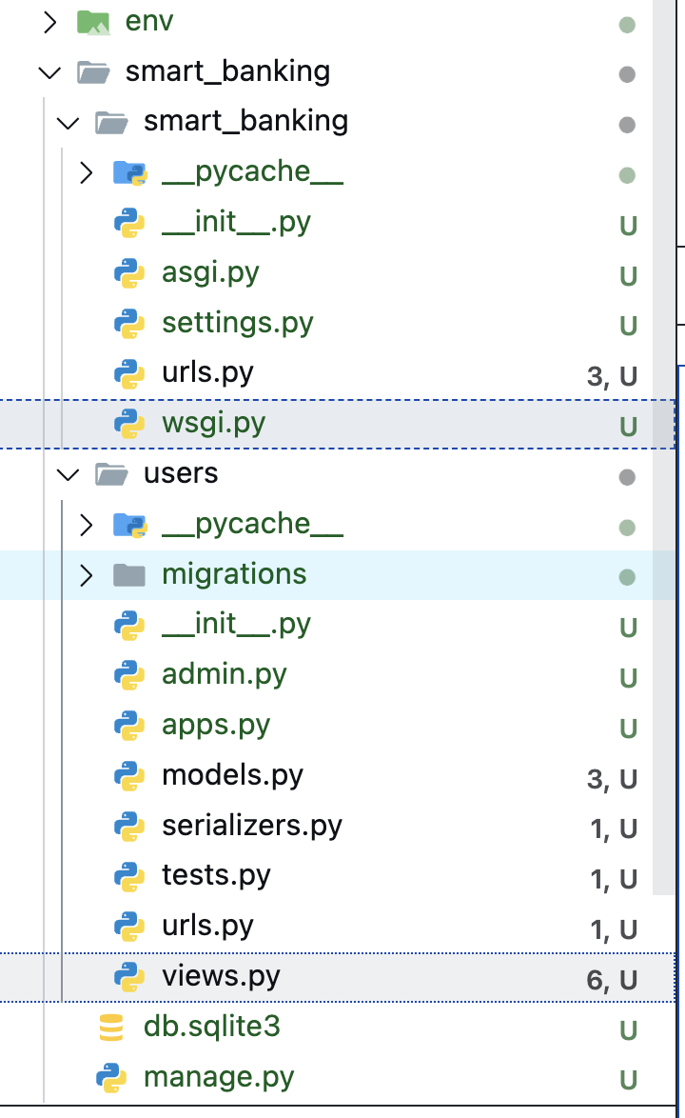In order to cut bottle neck or dependency delay backend was started in parallel with the front end. Relying on wireframe drawn earlier and Postman an online based platform to check backend functionality backend development was started. User login feature was achieved leveraging JWT, a JSON web token making the login process secure than ever.

Figure 82 Backend architecture

Figure 83 Django Backend configuration

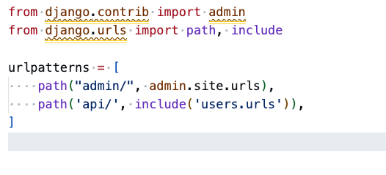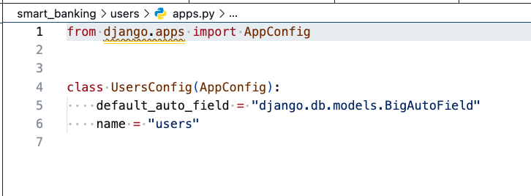

Figure 84 Backend django app config

Figure 85 Backend django url config

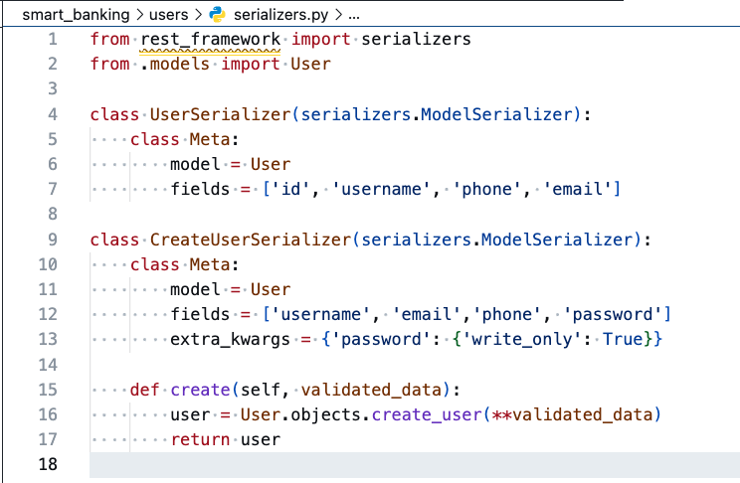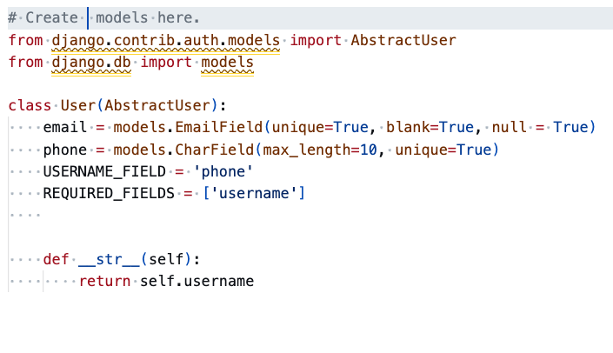 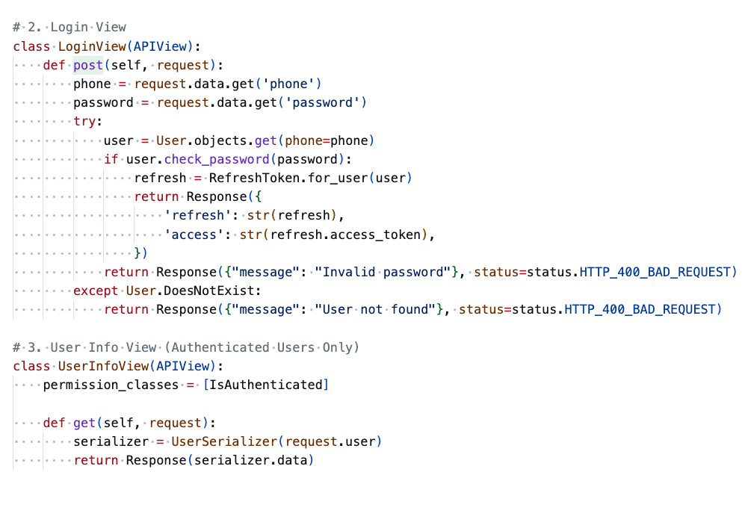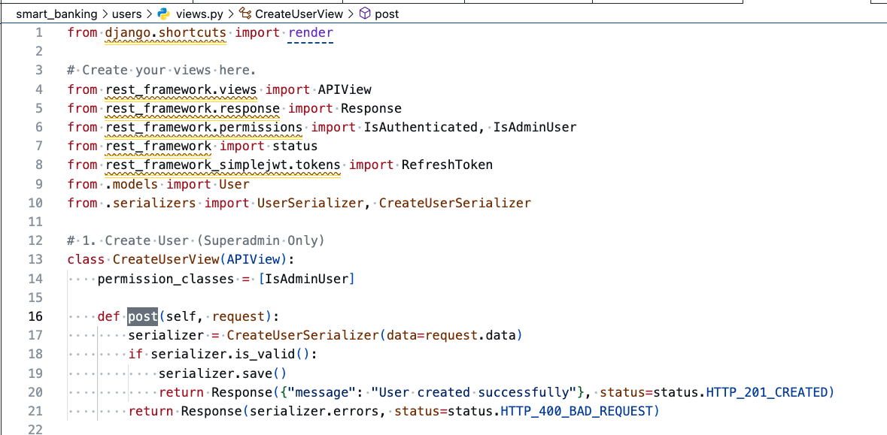

Figure 86 Backend Serializers

Figure 87 Backed Model class

Figure 88 Backend login

Figure 89 Backend Create Operations

**Key Accomplishments**

1. User can login with a phone number and a password.
2. JWT (JSON web token) is used as encryption method.
3. Baseline model performance of chatbot is achieved.
4. Baseline model performance of fraudulent transaction detection is achieved.

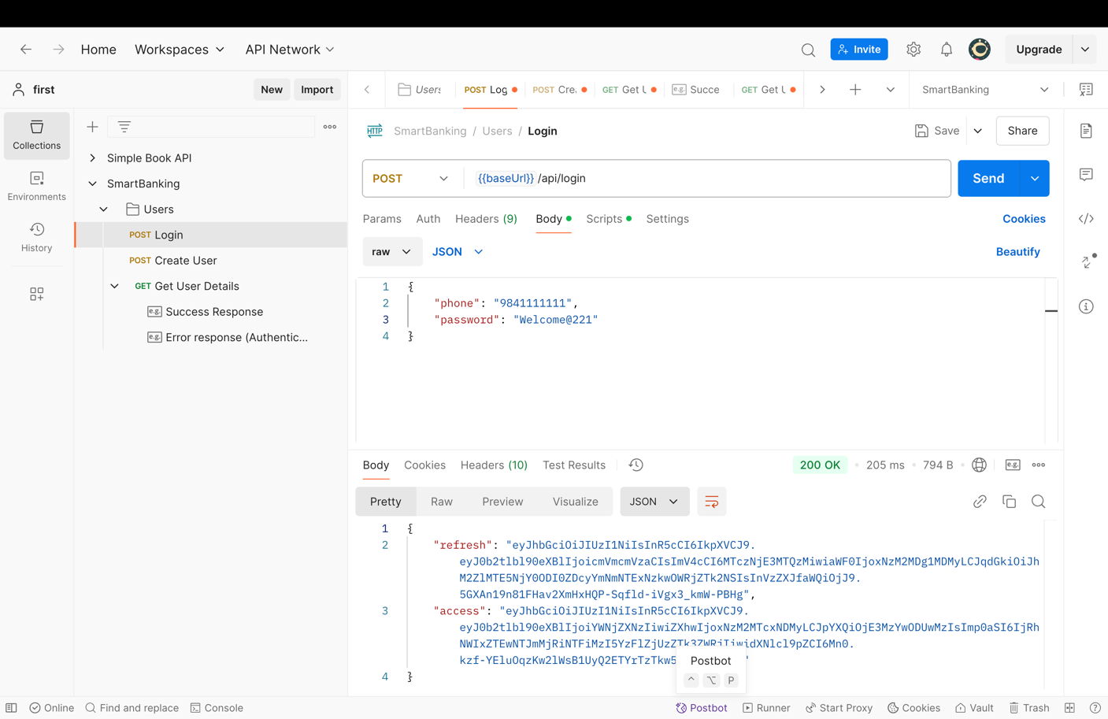

Figure 90 Postman: Backend Login success

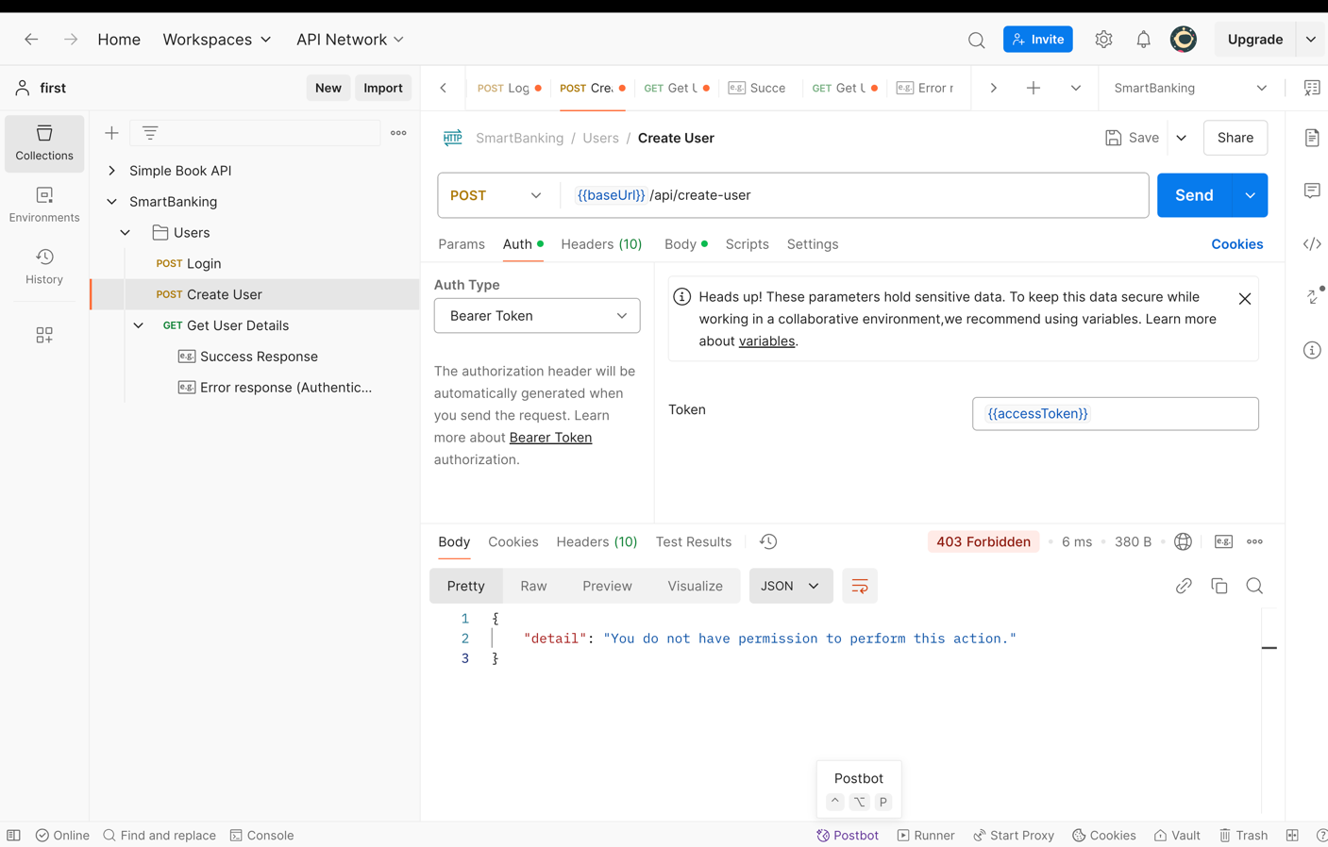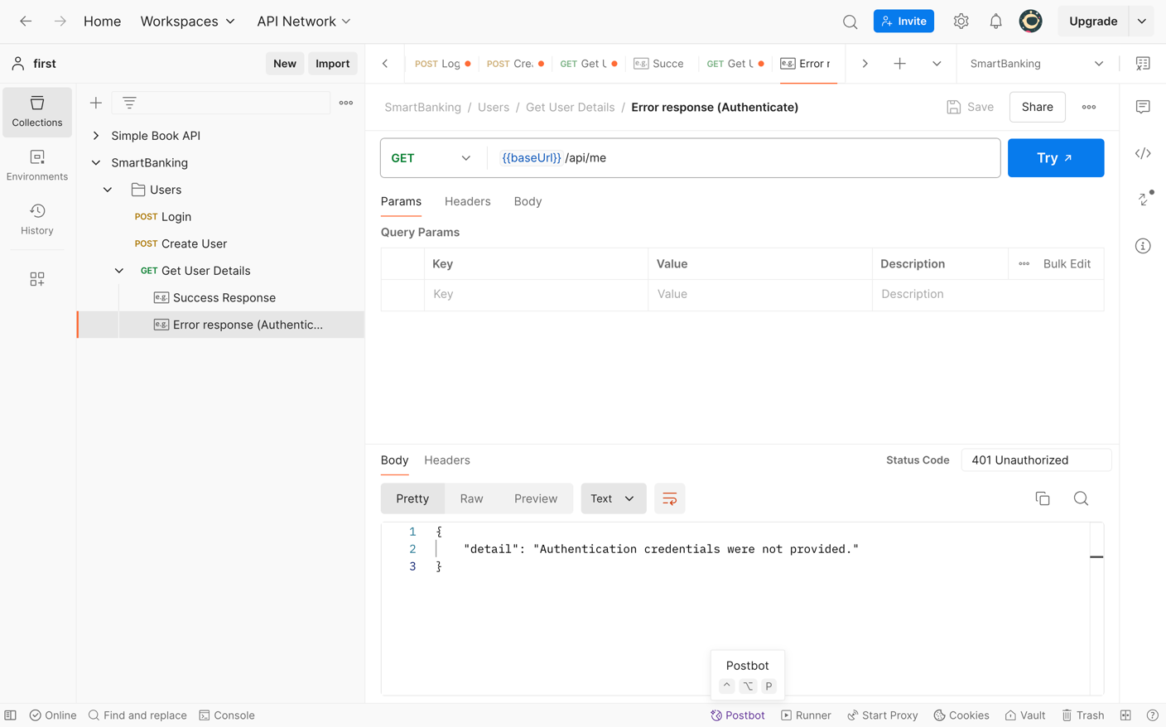

Figure 91 Postman: Unsuccessful login

Figure 92 Postman: Restricting users other than admin to create account

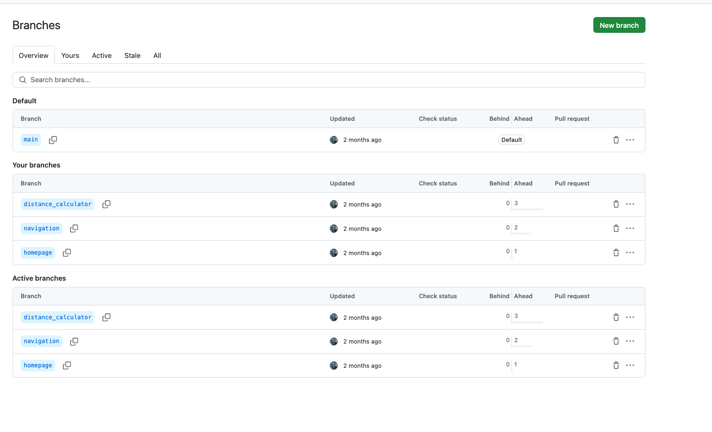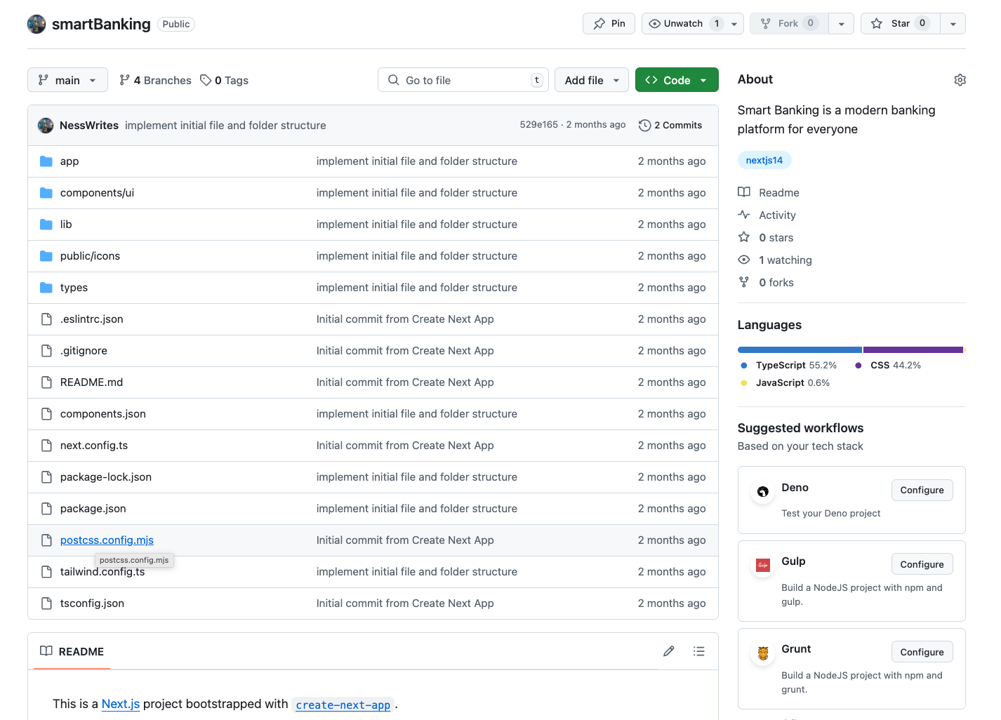

Figure 93 GitHub branches

Figure 94 GitHub Smart banking

# 4. Progress Analysis

## 4.1 Progress Review

The project development started in October. After a month of finding good problem statement, aims and objectives, the project was approved by the supervisors and the work began from November. The project adopts Scrum methodology due to its flexible and iterative nature. The project follows structured framework laid out by the principles of Agile methodology. As a result the development phase is being carried out smoothly with continuous improvement.

Scrum framework from agile methodology provides a guideline to divide the task into small sprints. Accordingly, in our project we have divided our tasks into sprints lasting about 2-3 weeks. Product backlog, sprint planning, review and retrospectives ensured that every phase of the project was tracked. The progress of the development is represented by completed sprint and tasks allocated thereof. I believe 40% of my FYP is completed as of today. Following are the completed sprints so far:

### Sprint 1: Initiation and Planning

1st November 2024 – 14th November 2024

* Defined problem statement
* Defined solution to the problem statement
* Defined unique selling point
* Defined aim and objectives of the project.
* Initial requirements gathering achieved for the project.
* Presented project topic and scope to supervisors.
* Finalized project topic and scope
* Outlined Work Breakdown Structure
* Planned Milestones and developed Gantt Chart to visualize the project timeline.
* Defined methodologies and implemented the selected methodology.

### Sprint 2: System Design

14th November 2024 – 1st December 2024

* Sprint Planning
* Developed initial system software design.
* Drew wireframes for the system’s user interface.
* Submitted the proposal to MST and turnitin.
* Delivered finalized system design.

### Sprint 3: Data Collection

1st December 2024 – 14th December 2024

* Sprint planning and a detailed sprint backlog for data collection for model development.
* Required research and dataset collection performed for the project.
* Dataset studied and understood
* Date pre-processing, feature engineering implemented for model training.
* Developed AI models to establish a baseline performance.
* Built AI models were trained and tested, seeking various metrics to improve the model’s accuracy and robustness.

### Sprint 4: Initiate Development

Date: 15th December 2024 – 31st December 2024

* Frontend development initated.
* Bankend development initiated.
* Interim Report drawn.

## 4.2 Progress Table

See appendix

# 5. Future Work

About 40% of the total development has been completed as of 8th January 2025. The future work comprises of 60% of the project consists of following critical tasks.

**System Finalization**

Frontend and backend development has just began. After completion, the frontend, backend and AI will be integrated and will be deployed to the users.

|  |  |  |
| --- | --- | --- |
| **Task** | **Date Range** | **Actual Date** |
| Frontend and Backend Development | Ongoing | 31st December 2024 – 1st March 2025 |

Table 1: Future work Finalization Timeline

**Quality Assurance/ Control and Test Cases**

After the development phase is complete, a series of testing will be performed to ensure that the system and its components are performing as expected.

|  |  |  |
| --- | --- | --- |
| **Task** | **Date Range** | **Actual Date** |
| Unit Testing | After Development Completion | February 20th 2025 – March 3rd 2025 |
| Integration Testing | After Unit Testing | March 3rd 2025 – March 15th 2025 |

Table 2: Future Work Test Cases Timeline

**System Deployment and Monitoring**

After the successful testing phases and integration, the system will be deployed in a cloud server. The system will then be monitored to ensure optimal performance, reliability and user satisfaction. Any potential issues, such as bugs or performance bottlenecks, will be addressed during this period of time.

|  |  |  |
| --- | --- | --- |
| **Task** | **Date Range** | **Actual Date** |
| Deploy the system to the cloud instance | After Testing Phase | 15th March2025– 20th March 2025 |
| Perform Beta Testing | After Initial Deployment | 20th March 2025– 26th March 2025 |
| Monitor system Performance | After Initial Deployment | 28th March 2025 – 25th April 2025 |

Table 3: Deployment and Monitoring Timeline

**Finalization of Final Report and System**

At the final stage of the report the system is rigorously tested with validation, and testing to ensure that it is working as expected. Any changes made during the testing phase and deployment will be documented in the report.

|  |  |  |
| --- | --- | --- |
| **Task** | **Date Range** | **Actual Date** |
| Document Finalization | After final system evaluation | 20th April 2025 |
| System Finalization | After final system evaluation | 20th April 2025 |

Table 4: System Finalization Timeline

# 11. Bibliography & References:

Allison, L., 2025. *UML Use Case Diagram Symbols.* [Online]   
Available at: https://www.edrawsoft.com/uml-use-case-symbols.html?srsltid=AfmBOopIxHkuW-gFoicAvu_QE4b8MB5fICQRCcOlAnZM7YwfZHYWzurg

Amran, N. M. H. &. B. F. D. S., 2018. Developing Human Resource Training Management (HRTM) Conceptual Model Using Entity Relationship Diagram (ERD).. *International Journal of Academic Research in Business and Social Sciences,,* 8(12), p. 1444–1459..

Baabdullah, H., 2024. *LinkedIn.* [Online]   
Available at: https://www.linkedin.com/pulse/enhancing-software-engineering-work-breakdown-project-baabdullah-j7vkf

Bala, 2024. *Software Development.* [Online]   
Available at: https://www.zaigoinfotech.com/what-is-scrum-methodology/

Balsamiq, n.d. *What are wireframes and why are they used?.* [Online]   
Available at: https://balsamiq.com/learn/articles/what-are-wireframes/  
[Accessed 06 January 2025].

Chirag, 2021. *Analytics Vidhya.* [Online]   
Available at: https://www.analyticsvidhya.com/blog/2021/06/part-5-step-by-step-guide-to-master-nlp-text-vectorization-approaches/

Clifford, C., 2024. *A Begginner's Guide to Data flow Diagrams.* [Online]   
Available at: https://blog.hubspot.com/marketing/data-flow-diagram?uuid=856c91e8-f8bc-4ffb-bd6b-f06d118bbd6b

Edoardo, R., 2022. *What is a Software requirement Specificaton.* [Online]   
Available at: builtin  
[Accessed 5 January 2024].

Fauzan, R., Siahaan, D., Rochimah, S. & Triandini, E., 2018. *Reza Fauzan; Daniel Siahaan; Siti Rochimah; Evi Triandini.* Yogyakarta, Indonesia, IEEE (Institute of Electrical and Electronics Engineers)..

HA., J., 2017. Trello. *Journal of the Medical Library Association : JMLA, 105(2), 209–211.,* Volume II, pp. 1-3.

Kamal, S., 2020. *Top 12 Software Development Methodologies.* [Online]   
Available at: https://www.tatvasoft.com/blog/top-12-software-development-methodologies-and-its-advantages-disadvantages/

KissFlow, 2023. *Agile.* [Online]   
Available at: https://kissflow.com/project/agile/kanban-methodology/

Marta, R., 2023. *AltkomSoftware.* [Online]   
Available at: https://www.altkomsoftware.com/blog/use-case-diagrams-an-introduction/  
[Accessed 5 January 2025].

Neural, N., 2023. *Label Encoding: Naming the Unnamed Categories.* [Online]   
Available at: https://letsdatascience.com/label-encoding/

Olivia, W., 2023. *Agile, DevOps and software development Methodologies.* [Online]   
Available at: https://www.techtarget.com/searchsoftwarequality/definition/sequence-diagram  
[Accessed March 2025].

Parag, M., 2024. *Software Development.* [Online]   
Available at: https://positiwise.com/blog/what-is-software-development-methodology

Paul, V., 2024. *What is use case diagram.* [Online]   
Available at: https://ideascale.com/blog/what-is-the-use-case-diagram/

PennState, C., 2025. *Elements of a use case diagram.* [Online]   
Available at: https://www.e-education.psu.edu/geog468/l8_p4.html

PennState, C., 2025. *Usecase in Nutshell.* [Online]   
Available at: https://www.e-education.psu.edu/geog468/l8_p3.html

Praveen, S., 2024. *Chatbots for Financial Services: Benefits, Examples, and Trends.* [Online]   
Available at: https://www.revechat.com/blog/chatbots-for-financial-services/

Sarah, C., 2025. *Complete Guide to Banking Chatbots in 2025.* [Online]   
Available at: https://botpress.com/blog/chatbot-for-banking

Sarahna, K., 2024. *The Kathmandu Post.* [Online]   
Available at: https://kathmandupost.com/money/2024/02/11/as-online-shopping-takes-off-cases-of-fraud-tick-up

Scott, R., 2024. *Data Governance.* [Online]   
Available at: https://www.techtarget.com/searchdatamanagement/definition/data-flow-diagram-DFD

Serhii, U., 2024. *The 2024 Guide To Chatbots In Banking.* [Online]   
Available at: https://www.springsapps.com/knowledge/the-2024-guide-to-chatbots-in-banking#chatbots-in-banking-real-examples

Vaishali Chourey, M. S., 2024. FUNCTIONAL FLOW BLOCK DIAGRAM WITH UML FOR TEST VISUALIZATION. *ACTA TECHNICA CORVINIENSIS – Bulletin of Engineering,* 1(1), p. 1.

Vladislav, N., 2024. *Software development methodologies: types, selection criteria & stats.* [Online]   
Available at: https://www.itransition.com/software-development/methodologies

Yuriy, R., 2019. *Software Development Methodologies.* [Online]   
Available at: https://codeit.us/blog/software-development-methodologies

# 12. Appendix

## 12.1. Similar Projects

Table 5 Other similar projects

|  |  |  |  |
| --- | --- | --- | --- |
| Project Name | Main Findings/Result | Methodology Used | Project Contribution |
| Erica (Bank of America) | The chatbot assists with notifications, balance inquiries, and financial insights. | NLP to understand customer queries and provide personalized responses. | Enhanced customer engagement and satisfaction by providing proactive financial advice and facilitating transactions. |
| Ceba (Commonwealth Bank Australia) | Ceba can assist with over 200 banking tasks and analyzes customer inquiries effectively, leading to improved customer support. | Utilizes machine learning to process and understand various customer requests in real-time. | Streamlined customer interactions, reducing wait times and improving service efficiency. |
| Aino (DNB) | Automated over 50% of online chat interactions within six months, interacting with over a million customers. | Implemented a chat-first strategy that routes all customer service traffic through the virtual agent before reaching human agents. Improved and enhanced operational activity by freeing up staff work time from repetitive tasks ensuring 24/7 availability. | Improved operational efficiency by freeing up staffs from repetitive and recurring tasks ensuring 24/7 availability. |
| EVA (HDFC Bank) | EVA interprets customer inquiries quickly and accurately, helping with common requests such as loan information and branch locations. | Natural Language Processing (NLP) to retrieve information from multiple sources rapidly. | Improved service quality by handling a high volume of inquiries efficiently. |

Table 6 Some other similar banks

## 12.2.1 Use Case

Among many other symbols those symbols of use case diagram used in our project are described below:

**a. Actor**

The actor in use case is represented by a stick person figure which specifies the role played by users which is a person, a group of people, organization, admins or any other system that interacts with the subject. (Allison, 2025).

**b. Use case**

The use case is represented by oval shape which is a sequence of steps defining the interactions of an actor and a system. (Allison, 2025)

**c. System Boundary**

System boundary in a use case diagram is represented by a rectangle inside which use cases are contained. It defines the scope of what a proposed system will be. In a way it limits the project functionality and the project scope. (PennState, 2025) (Paul, 2024)

**d. Associations or Relationships**

A relationship in use case diagram is shown by associations which is represented by an arrow headed to or headed in . Arrow headed to means it is a “include” relationship and an arrow head from means it is a “exclude relationship” (PennState, 2025) (Paul, 2024)

## 3.4 High Level Use Case

High level use case consists of brief description of the task the use case is covering, written with unstructured text building up to a paragraph or two. It mentions the actors involved in building the use case. The purpose behind high level use case is to provide the readers with just enough detail to give he/she the feel for its complexity and help the developers group related use cases for development in elaboration phase. (PennState, 2025)

## 12.2.2 High Level Use Case

High level use case is the brief description of the task to be done in that use case involving the participants involved in a small unstructured paragraph. The purpose of high level use case diagram is to give us the gist of the activity and align related use case for production.

### 12.1.1 Register User

|  |  |
| --- | --- |
| **Use Case:** | Register User |
| **Actors:** | Bank Staff |
| **Descriptions:** | New users who wants to use the banking system can get registered at the bank providing necessary documents in physical form. The bank staff on confirmation will register the user in the system. |

Table 7 Register User high level usecase

### 12.1.2 Login

|  |  |
| --- | --- |
| **Use Case:** | Login |
| **Actors:** | Clients, Customers, Staff, Admin |
| **Descriptions:** | After registration the user will get login credentials which they can use to login to the system. The users on successful validation of credentials can enter the dashboard. |

Table 8 Login high level usecase

### 12.1.3 SIP Calculator

|  |  |
| --- | --- |
| **Use Case:** | SIP Calculator |
| **Actors:** | Clients, Customer |
| **Descriptions:** | Calculates SIP when users choose the plan they are interested in. For example: User can choose interest rate, and the time period of investmet. |

Table 9 SIP calculator high level usecase

### 12.1.4 Deposit

|  |  |
| --- | --- |
| **Use Case:** | Deposit |
| **Actors:** | Account Holder |
| **Descriptions:** | An account holder when deposits money, gets his account balance updated. |

Table 10 Deposit high level usecase

### 12.1.5 Withdraw

|  |  |
| --- | --- |
| **Use Case:** | Withdraw |
| **Actors:** | Account Holder |
| **Descriptions:** | Account holder when withdraws money is proceeded check if his login credentials are valid or fraud. If the transaction is suspected of fraud in nature he will be getting notification. Upon successful withdrawal his transaction amount is deducted from the remaining balance. |

Table 11 Withdraw high level usecase

### 12.1.6 Check Balance

|  |  |
| --- | --- |
| **Use Case:** | Check Balance |
| **Actors:** | Account Holder |
| **Descriptions:** | The account holder can check his current balance |

Table 12 Check Balance high level usecase

### 12.1.7 View Statement

|  |  |
| --- | --- |
| **Use Case:** | View Statement |
| **Actors:** | Account Holder |
| **Descriptions:** | The account holder can check his past transactions which can be filtered by time period. |

Table 13 View Statement high level usecase

## 12.3 Future Development Plan:

The future vision for the Smart Banking System is to evolve into a **unified platform** where users can connect and manage multiple bank accounts seamlessly. This enhancement will enable users to track expenses across various banks on a single interface, offering an integrated view of their financial activities. By incorporating an advanced **expense tracking mechanism**, the system will categorize expenditures, generate insightful summaries, and provide real-time alerts for unusual spending patterns. Users will benefit from a consolidated dashboard that summarizes their overall financial health, helping them set budgets and achieve financial goals effectively. Furthermore, the system will **facilitate interbank transactions**, allowing users to transfer funds between accounts from different banks directly within the application. These future capabilities aim to transform the platform into a comprehensive financial management tool, enhancing user convenience and decision-making.

## 12.4 Targeted Audiences:

**a. Customers as Targeted Users**

The Smart Banking System is designed to provide customers with a user-friendly and personalized banking experience. With features such as instant query and fraud detection alerts, customers can access banking services conveniently from anywhere at any time. By automating banking processes like fund transfers and account inquiries, the system reduces waiting times and helps to achieve customer satisfaction. This focus on accessibility, security, and customization ensures that the system meets the evolving demands of modern banking customers.

**b. Banking Staff as Targeted Users**

For banking staff, the Smart Banking System streamlines operations by automating repetitive tasks requiring significant time, like answering frequently asked questions (FAQs) and processing banking operations. This allows staff to make time for more complex issues that require skilled expertise, such as customer relationship management and strategic decision-making. The system’s fraud detection and compliance features provide staff with real-time alerts and tools to address suspicious activities effectively, ensuring a more secure banking environment. By enhancing efficiency and reducing workload, the system acts as a reliable assistant, supporting banking staff in delivering high-quality service to customers.

## Considered Methodology:

### 12.5.1 Kanban Methodology:

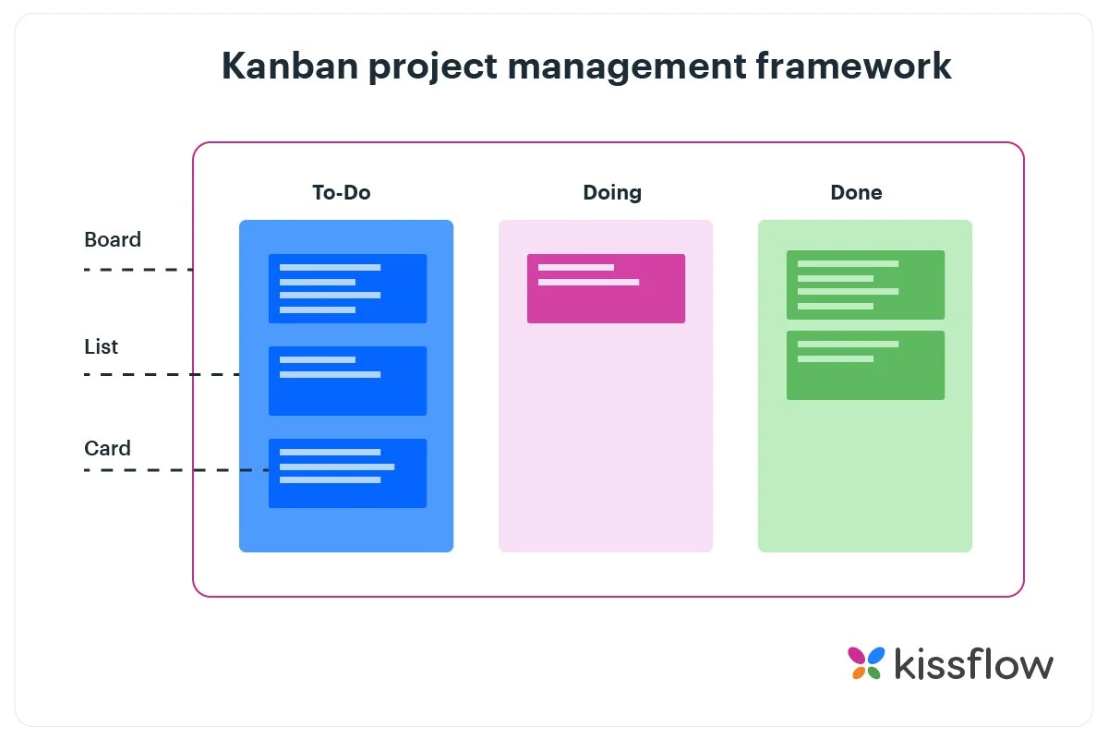It is an agile method which revolves around a kanban board. Kanban Methodology visualizes the entire project to track the flow of the project through its graphical approach. (KissFlow, 2023). It allows external member of the project to understand what is going on the project right now, the completed task and the future task and form a basic understanding. The Kanban board includes following topic:

Figure 95 KanBan Board

1. To-do list
2. Doing
3. Done

### 12.5.2 Prototype

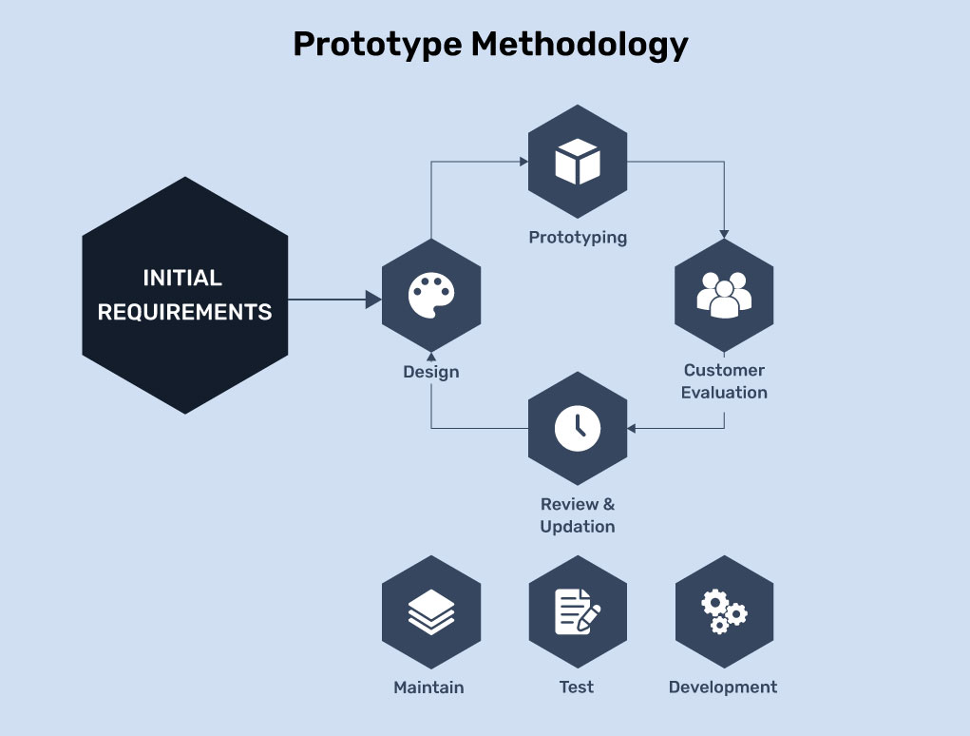Prototype development Methodology is a software development approach that focuses on prototype development and finalizing a product according to the specification of customers. This methodology is particularly useful in scenarios where requirements are not well-defined or are likely to evolve.

Figure 96 Prototype Methodology

(Parag, 2024)

### 12.5.3 Spiral Methodology

Spiral Methodology is a software development method which borrows the control and systematic approach of the water fall methodology. (Yuriy, 2019) It focuses on risk management and facilitates incremental releases of a product. This model is particularly suitable for large, complex projects. Key features of the spiral methodology are Iterative development, risk management and prototyping.

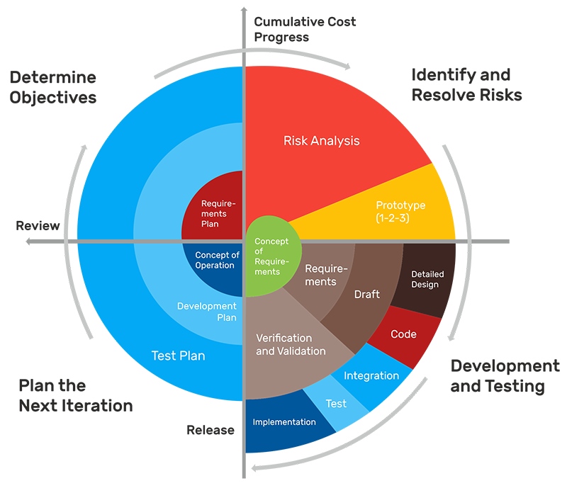

Figure 97 Spiral Methodology

### 12.5.4 Scrum Methodology

Agile method will be followed throughout this project. Scrum methodology is an agile method for dynamic and iterative approach to software development that prioritizes flexibility, collaboration, and customer-centricity.

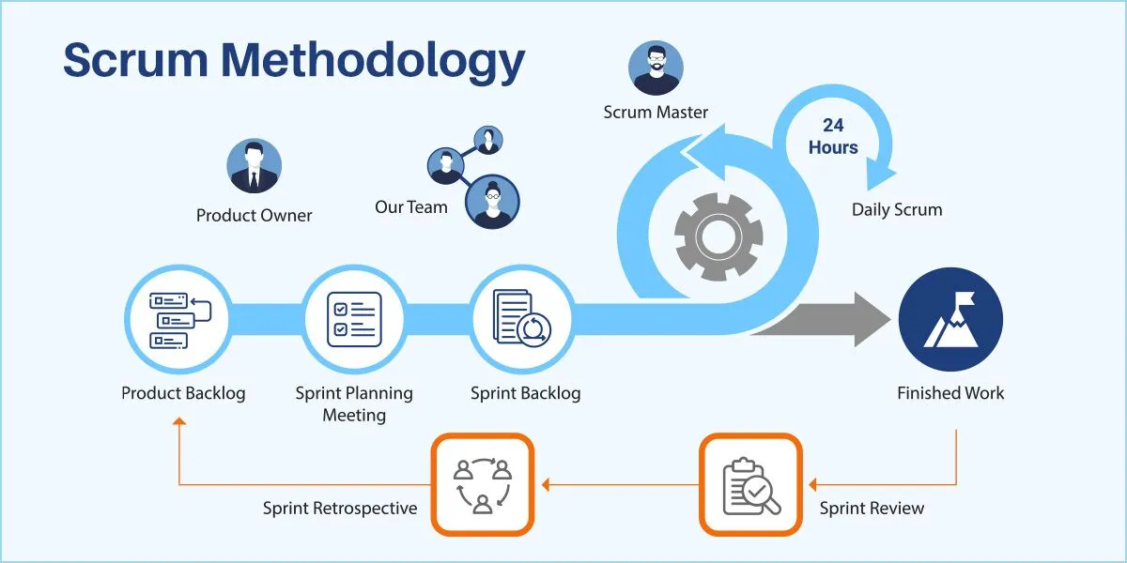

Figure 98 Scrum Framework (Bala, 2024)

**Sprint Planning:** It involves planning short development sprints focusing on specific features, like integrating the banking bot's conversational AI or developing the initial fraud detection model.

**Weekly Standups:** Keeping fellow AI enthusiast, including AI developers, compliance specialists, and business analysts, aligned and aware of progress. (This phase will be replaced by Weekly FYP classes to discuss the progress of the project)

**Review and Retrospectives:** After each sprint, review the progress made on the AI functionalities and fraud detection mechanisms to identify successes, issues, and areas for improvement.

Note: Even if this is a individual based project , agile methodology is slightly modified to meet the project requirements.

### 12.5.5 Waterfall Model:

Figure 99 Waterfall Methodology

### 

### 12.5.6 Extreme Programming (XP):

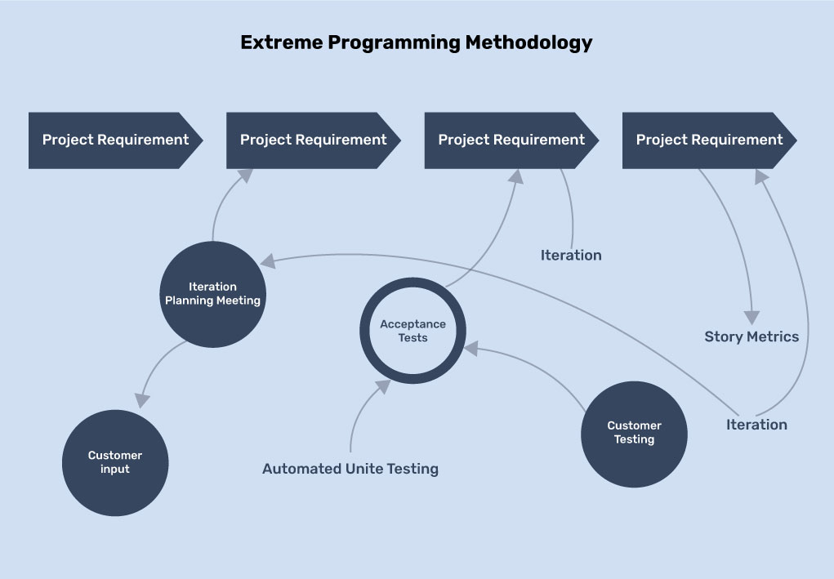

Figure 100 Extreme Programming Methodology

### 12.5.7 Lean Development Methodology

Figure 101 Lean Development Methodology

### A diagram of a project Description automatically generated12.5.8 Feature Driven Development

Figure 102 Feature Driven Development

## 12.6 Software Requirement Specification (SRS) for Banking Chatbot with Fraudulent Transaction Detection

## 12.6.1 Introduction

The SRS documentation includes components like introduction of the project, product Description, software requirements, external requirements and non-functional requirements. It contains information about all the software components that constitute the product or the deliverables. It also brings stakeholders to common understanding of the project deliverable early on, creating time for clarification and discussion which otherwise only happens afterwards helping the development team to deliver a software product that fits the original scope and functionality as promised in SRS in line with user, customer and stakeholder expectations.

### 12.6.1.1 Purpose of Document

The purpose of SRS document is to define the requirements for the development of a AI focused banking system with a banking chatbot capable of assisting users with banking queries while detecting fraud on ATM withdrawals . This documentation will serve as a reference for all the stake holders i.e., developers and customers during the development to the finished product.

### 12.6.1.2 Project Scope

The chatbot is integrated in the web based platform of the bank management system, where the users interact with the chatbot. The chatbot receives questions from the users, then after trying to understand and interpret the questions the chat bot provides the users with appropriate answers. The chatbot is fine-tuned on Llama 2 for question and answering leveraging the cloud computing offered by google collab. LLaMA2 is an excellent model for fine tuning in a production phase because it is open sourced, it has good scalability, and has high performance benchmarks.

The main objective of the project is to create a web API and a web interfaces leveraging use of the API with a goal of having customer’s queries answered smoothly.

### 12.6.1.3 Audience

1. The document is targeted for:
2. Developers involved building the project.
3. Supervisors overseeing the development and ensuring compliance with requirements.
4. Stakeholders interested in understanding system capabilities.

## 12.6.2. Overall Description

### 12.6.2.1 Product Perspective

The smart banking system will be an interactive application featuring smart chatbot capable of answering user queries. The chatbot leverages hugging face model LLAMA 2 and is fine tuned for better query response. The chat bot will integrate with existing banking systems to access the user account information and transactional data from bank database. The integrated chatbot will be able to foresee every withdrawals and detect if there is any suspicious transactions happening alerting users with notifications.

### 12.6.2.2 Product Features

**Web API:** An API call will include a question in the form of query string url parameter and the service will reply in JSON.

**User Interactions:** The smart bot will engage with users addressing queries related to banking system including checking account balances, transaction history, and other banking services.

**Fraud Detections:** The system is equipped with machine learning algorithms to analyze transactions pattern to identify potentially fraudulent activities in real life.

**Notifications:** Logged in users will receive alerts about suspicious transactions.

**Secure Authentications:** Follows JWT for token based authentication with a lifeline.

### 12.6.2.3 User classes and characteristics

Two classes of users for this system are

1. **Bank**: API users who want to incorporate Chatbot API into software applications
2. **Web app users:** These are non-technical users who simply ask questions and get answers.

### 12.6.2.4 Constraints

1. Due to resource constraints and high cost of cloud computing the chat bot is not expected to compete with top level established companies like Bank of America’s Erica.
2. The bot will only support English language.

## 12.6.3. Functional Requirements

### 12.6.3.1 User Queries Handling

1. The system should be able to process user queries related to banking services .
2. The system should be able to provide responses based on supervised learning method implanted during fine tuning LLAMA model

### 12.6.3.2 Fraudulent Transaction Detection

1. The system should be able to leverage Random Forest Classifier algorithms to monitor transactions for anomalies based on historical use.
2. The system should be able to flag unusual transactions as potential fraud.

### 12.6.3.3 User Notification

1. The system should be able to notify users on flagged transactions via chat message.
2. Users should be able to confirm or deny the flagged transaction through the chatbot interface.

## 12.6.4. Non-functional Requirements

### 12.6.4.1 Performance

1. The chatbot should be able to respond to user queries with minimal latency.
2. The fraud detection algorithms should analyze transaction in real time with minimal latency.

### 12.6.4.2 Security

1. Only the logged in users should get access to chatbot.
2. User authentication must comply with regulatory standards.

### 12.6.4.3 Usability

## 12.6.5. System Architecture

For successful completion of this project required tools and technologies are estimated as follows:

## 12.6.6.1 Hardware Requirements:

* **Processor:** Mac OS, Windows or Linux.
* **RAM:** Minimum of 16 GB.
* **GPU:** Dedicated NVIDIA CUDAs
* **Storage:** At least 512 GB SSD for fast data access and storage of models and datasets.

## 12.6.6.2 Software Requirements:

1. Operating System: MacOs, Windows 10 or higher

#### IDE: Visual Studio Code

#### Programming Languages:

Python, Next js , SQL, Bash/CLI

#### Frontend Framework:

* React: For building the user interface of the web application

#### Backend Framework:

* django: For backend API development to handle requests and database interaction may be used.
* Appwrite: An API for backend handling and data base interaction might be used for authentication and server side rendering.
* Plaid: An API for our web based system might be used to connect banks.
* Dwolla Environment: An API to send and receive payment specializing actual money transfer might be used .

#### APIs:

Third party APIs google map API or twilio might be used in the development process

1. Version Control:

* Git: For version control and managing project changes.
* GitHub: For remote repository hosting and collaboration.

1. Cloud Platforms:

* Google Collab Pro: For cloud-based GPU access and model training.

1. Libraries for Machine Learning and Data Analysis:

* TensorFlow/Keras
* PyTorch
* Pandas
* NumPy
* Matplotlib & Seaborn

1. Scikit-learnWeb Scraping (if required): BeautifulSoup. Selenium
2. Design and Prototyping Tools: Figma
3. Documentation and Flowchart Tools: Draw.io, Gantt Chart

## 12.7 Milestones:

**Milestone 1 Finalize the project:**

After presenting multiple ideas and doing research and discussion with group supervisors (internal and external ) , the project topic was finalized “Integrated Banking System”.

**Milestone 2 Proposal Submission:**

The project is built around the proposal. Proposal involves all the possible

requirements of the project and research required for future developments.

**Milestone 3 System Analysis:**

This milestone contains SRS documents, ERD, and UML diagrams. These all

showcase the requirements and functionalities of the project.

**Milestone 4 Designing:**

Designing is the blueprint of the project. These milestones will contain all the

wireframes and design documents. Creation of these would help in

developing user-friendly UI.

**Milestone 5 Interim Report:**

Interim report plays a vital role in completion of the project as it explains all the project features and functionality in complete detail through different diagrams.

**Milestone 6 Login System:**

This milestone is dedicated to developing a fully-fledged login system for the project

using user authentication.

**Milestone 7 Banking ChatBot:**

This milestone is based on developing and training a chat bot where users can see the chat with the smart bot and post queries related to banking.

**Milestone 8 Transactions:**

This milestone allows users to perform day to day banking transactions such as deposit or withdraw cash, require bank statement, balance inquiry, etc.

**Milestone 9 Database Creation**

Developing and integrating database where users data is stored and their day to day transactions are recorded.

**Milestone 10 Customer Search System:**

Developing a search feature to allow bank staffs to search customers information with a registered bank account.

**Milestone 11 Documentation:**

Documenting the project with an exceptional report that excellently documents every process involved while developing the project including documentation of testing and validations.

**Milestone 12 Deployment:**

After thorough testing and being satisfied with the project the project is deployed for public use.

## 12.8 Progress Table (with time)

|  |  |  |  |  |  |
| --- | --- | --- | --- | --- | --- |
| S.N. | Tasks | Status | Expected Date | Completion Date | Progress(%) |
| **Sprint -1 Initiation and Planning** | | | | | |
| 1 | Project Initiation | Completed | 05/11/2024 | 05/11/2024 | 100% |
| 2 | Project Research | Completed | 05/11/2024 | 05/11/2024 | 100% |
| 3 | Research on Tools and Techniques | Completed | 05/11/2024 | 05/11/2024 | 100% |
| 4 | Sprint Planning- Product Backlog | Completed | 05/11/2024 | 05/11/2024 | 100% |
| 5 | Define Problem Statement | Completed | 05/11/2024 | 05/11/2024 | 100% |
| 6 | Define Aims and Objectives | Completed | 05/11/2024 | 05/11/2024 | 100% |
| 7 | Research Methodology | Completed | 09/11/2024 | 09/11/2024 | 100% |
| 8 | Requirement gathering | Completed | 09/11/2024 | 09/11/2024 | 100% |
| 9 | WBS | Completed | 10/11/2024 | 10/11/2024 | 100% |
| 10 | Gantt Chart | Completed | 12/11/2024 | 12/11/2024 | 100% |
| 11 | Milestones | Completed | 15/11/2024 | 15/11/2024 | 100% |
| **Sprint-2 System Design** | | | | | |
| 12 | Sprint Plan: Product Backlog | Completed | 16/11/2024 | 16/11/2024 | 100% |
| 13 | Wire Frame and Design | Completed | 24/11/2024 | 24/11/2024 | 100% |
| 14 | Final Design | Completed | 20/11/2024 | 20/11/2024 | 100% |
| 15 | Project Submission & Approval | Completed | 30/11/2024 | 30/11/2024 | 100% |
| **Sprint-3 Data Collection** | | | | | |
| 16 | Sprint Plan: Product backlog | Completed | 01/12/2024 | 01/12/2024 | 100% |
| 17 | Research on Datasets | Completed | 04/12/2024 | 04/12/2024 | 100% |
| 18 | Collect datasets for the models | Completed | 04/12/2024 | 04/12/2024 | 100% |
| 19 | Preprocessing, Feature Engineering and Data Exploration | Completed | 08/12/2024 | 08/12/2024 | 100% |
| 20 | Build ML Models | Completed | 14/12/2024 | 14/12/2024 | 100% |
| 21 | Train and Test Models | To do | 14/12/2024 | 14/12/2024 | 50% |
| 22 | Optimize and Fine Tune Models | To do | 15/12/2024 | 15/12/2024 | 50% |
| **Sprint-4 System Development** | | | | | |
| 23 | Sprint Plan: Product backlog | To do | 16/12/2024 | 16/12/2024 | 100% |
| 24 | Start Interim Report | To do | 16/12/2024 |  | 100% |
| 25 | Frontend: Login backend and dash board | To do | 25/12/2024 |  |  |
| 26 | Backend: Authentication & Authorization | To do | 31/12/2024 | 31/12/2024 |  |
| 27 | Testing & Debugging | To do | 31/12/2024 | 31/12/2024 |  |
| **Sprint-5 Database** | | | | | |
| 28 | Sprint Plan: Product backlog | To do | 01/01/2025 | 01/01/2025 |  |
| 29 | Architectural Diagram, Class Diagram | To do | 07//01/2025 | 07//01/2025 |  |
| 30 | Normalization | To do | 07//01/2025 | 07//01/2025 |  |
| 31 | Create and implement Database | To do | 15/01/2025 | - |  |
| 32 | Testing & Debugging | To do | 15/01/2025 | - |  |
| **Sprint-6 Banking Features** | | | | | |
| 33 | Sprint Plan: Product backlog | To do | 16/01/2025 | 16/01/2025 |  |
| 34 | Transactions: Withdraw, Loan, Interest Calculation | To do | 25/01/2025 | - |  |
| 35 | Integrate Banking Features with AI Models | To do | 31/01/2025 | - |  |
| 36 | Testing & Debugging | To do | 31/01/25 | - |  |
| **Sprint-7 Banking Features & Front-end** | | | | | |
| 37 | Sprint Plan: Product backlog | To do | 01/02/25 | - |  |
| 38 | Consider scope of other banking features | To do | 13/02/25 | - |  |
| 39 | Integrate | To do | 15/02/25 | - |  |
| 40 | Testing &Debugging | To do | 15/02/25 | - |  |
| **Sprint -8 Frontend and Backend Integration** | | | | | |
|  | Sprint Plan: Product backlog | To do | 16/02/25 | - |  |
| 41 | Complete front end | To do | 25/02/25 | - |  |
| 42 | Complete backend | To do | 25/02/25 | - |  |
| 43 | Integrate front end and back end | To do | 28/02/25 | - |  |
| 44 | Testing and Debugging | To do | 28/02/25 | - |  |
| **Sprint-9 ML Models Development** | | | | | |
| 45 | Sprint Plan: Product backlog | To do | 01/03/25 | - |  |
| 46 | Revisit Datasets | To do | 05/03/25 | - |  |
| 47 | Preprocess datasets | To do | 05/03/25 | - |  |
| 48 | Feature engineering and data exploration | To do | 05/03/25 | - |  |
| 49 | Finalise ML Models | To do | 15/03/25 | - |  |
| 50 | Training and Testing Models | To do | 15/03/25 | - |  |
| 51 | Optimize and Fine Tune Models | To do | 15/03/25 | - |  |
| **Sprint-10 Model Deployment and Feature Integration** | | | | | |
| 52 | Sprint Plan: Product backlog | To do | 16/03/25 | - |  |
| 53 | Integrate chatbot Model | To do | 20/03/25 | - |  |
| 54 | Integrate fraud detection Model | To do | 25/03/25 | - |  |
| 55 | Testing and debugging | To do | 31/03/25 | - |  |
| **Sprint 11: Documentation and Testing** | | | | | |
| 56 | Sprint Plan: Product backlog | To do | 01/04/25 | - |  |
| 57 | Final Reporting | To do | 05/04/25 | - |  |
| 58 | User Manual | To do | 10/04/25 | - |  |
| **Sprint-12: Deployment** | | | | | |
| 59 | Sprint Plan: Product backlog | To do | 10/04/25 | - |  |
| 60 | Application deployment and delivery | To do | 15/04/25 | - |  |
| 61 | Review | To do | 20/04/25 | - |  |

Table 14 Progress Table

## 12.9 Work breakdown structure:

WBS, Work Breakdown Structure, is a popular model used across many project management branches. The WBS enables developers to plan, manage, and deliver software projects effectively while promoting collaboration, agility, and risk management. Embracing WBS empowers software engineers to take control of their projects, streamline processes, and drive successful software development. (Baabdullah, 2024). WBS function by breaking complex projects down into smaller chunks so the project become easier to manage.

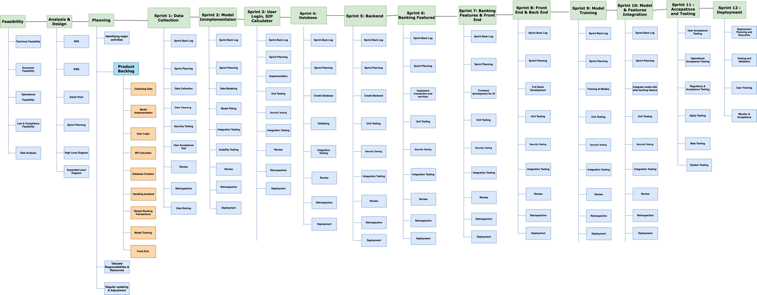

Figure 103 WBS

## 12.10 Revised Project Gantt chart

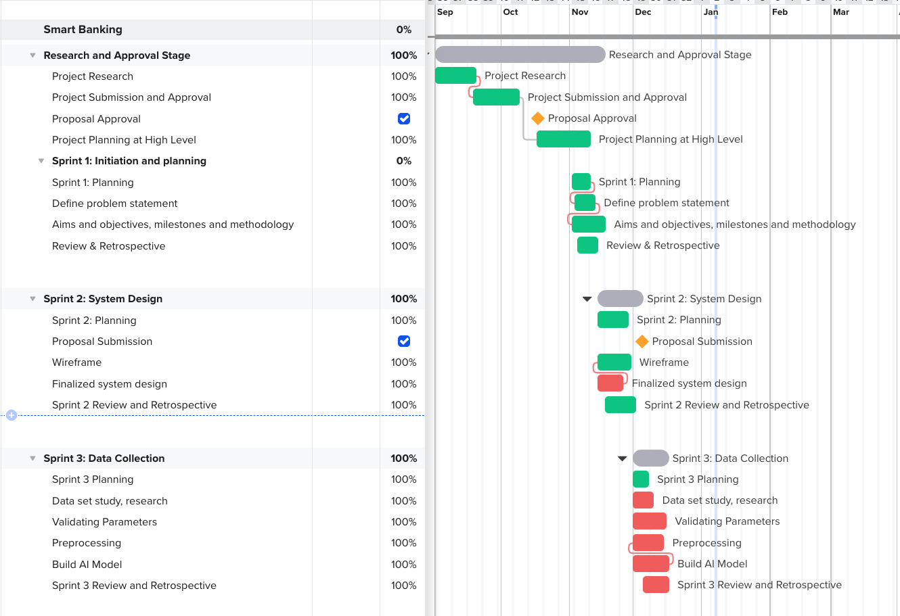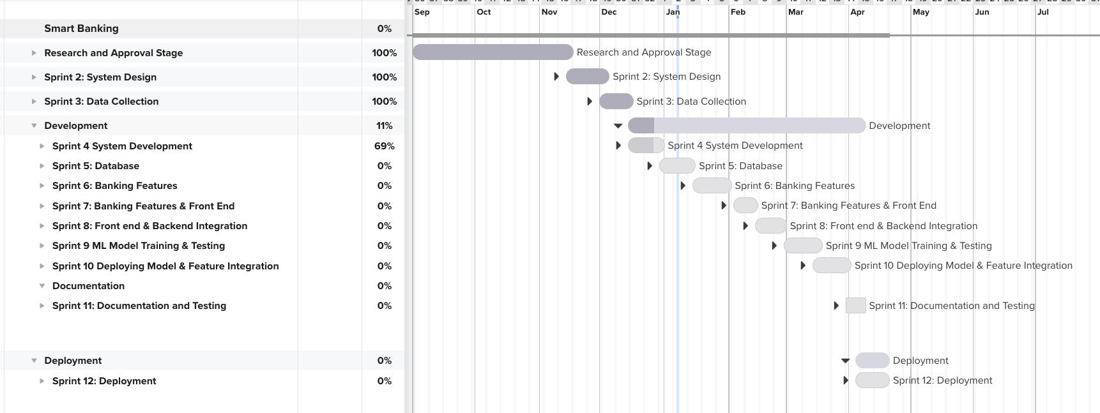

Figure 104 Gantt chart upto Sprint 3

Figure 105 Summary Gantt chart

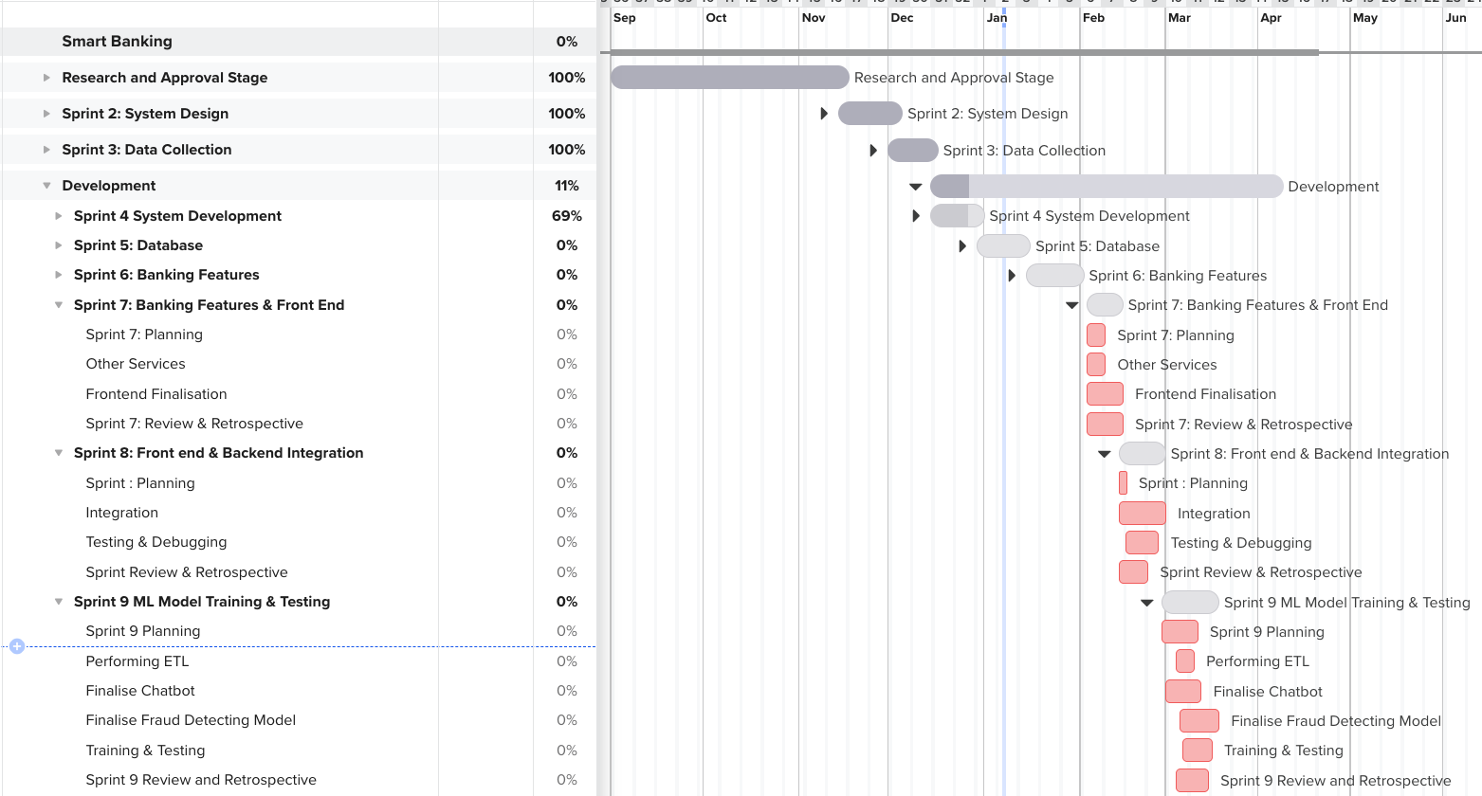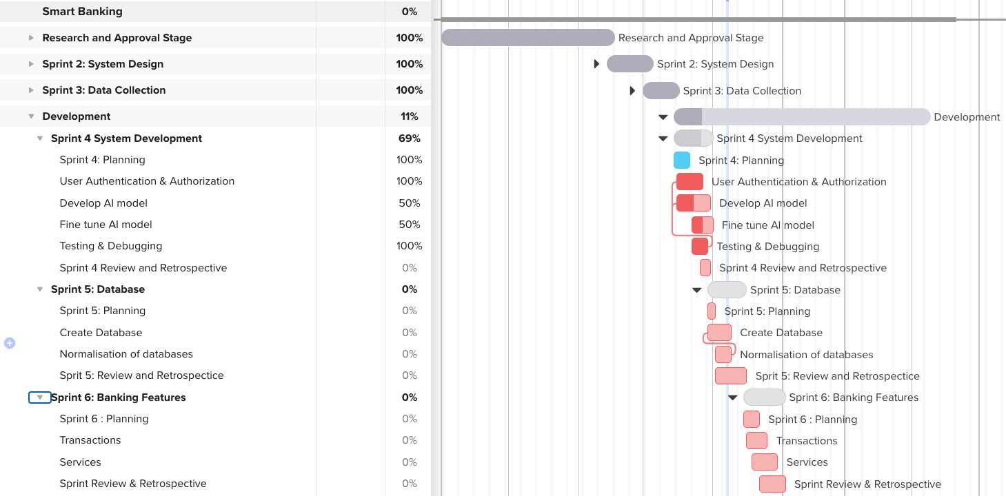

Figure 106 Gantt chart upto sprint 9

Figure 107 Gantt chart upto sprint 6

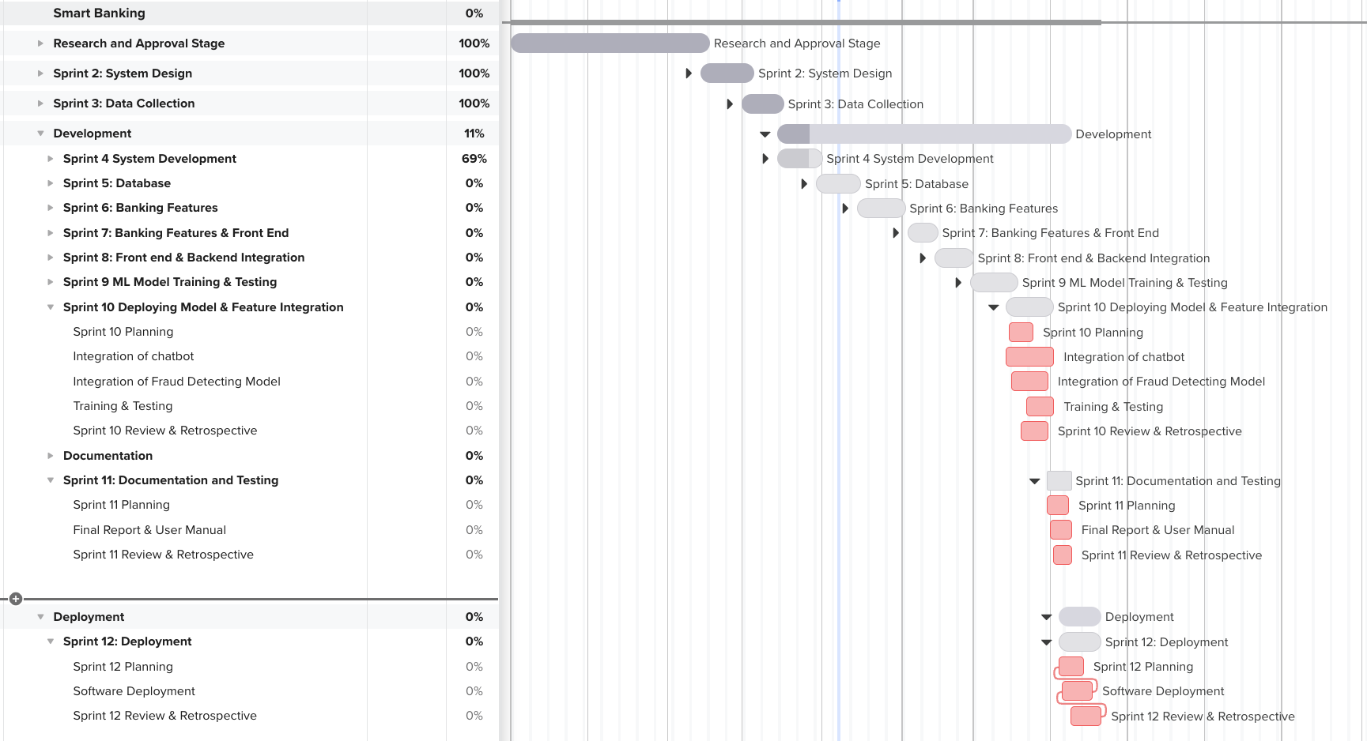

Figure 108 Gantt chart upto sprint 12

## 12.11 Data Flow Diagram (DFD)

A data flow diagram is visual representation or a graphical representation of business’s operation using a standardized set of symbols and notations. (Scott, 2024) Data flow diagrams simplifies the understanding of the business requirements and their applications by representing the sequence of the process steps and flow of information using visual representation or a graphical representation. DFDs first document the result of business analysis and then they refine the representation to show how information moves through and is changes by application flows.

A data flow diagram has notions and symbols like circles, arrows, rectangles short-text labels that vary according to the methodology employed. Dataflow notions represents external entities represented by a rectangle, flows represented by arrows, stores represented by two lines and processes represented by circles. (Clifford, 2024)

External entities represents information that enters from or exists the described system. Flows represents the movement of information to, from and within the described system. Stores represents the places where the information are held or maintained. For example databases, etc. And processes represents the transformed information. DFDs contains different levels or layers to represent the degree of progress of the system or processes.

## 12.12 Sequence Diagram

Sequence diagram is the system interaction diagrams used in UML to visually represent interactions between objects that live within a system. Sequence diagram depicts occurrence of interactions of individual objects called life lines and provides a view of order. (Olivia, 2023) The major notations used in the development of this project are as follows:

**Lifelines:**

Lifelines are a vertical dashed lines which represent object or an individual participant with an interactions

**Actors:**

Actors are the stick figure icon representing external entities interacting with the system.

**Activation bars:**

Activation bars are the thin rectangular boxes overlapping over lifelines that shows the duration of a particular operation.

**Loops and Conditions:**Loops and conditions are represented by a cross sectioned rectangle box following the logic behind if and else statement.

## 12.13 Development to Date

Agile methodology scrum is followed throughout the project with sprints of 2 weeks each. Four sprints have been covered until the interim report. To date machine learning models has been trained and tested successfully with baseline performance as a proof of working prototype. To achieve the baseline line performance of the models, dataset were gathered, preprocessed, on which the models were trained. First milestones were set followed by Gantt chart to track each and every scrum tasks through the lifeline of the project. After which designing and drawing wire frame was undertaken. With proper scrum meeting and a through discussion with supervisors, we arrived at conclusion and thus system design and wireframe for the project was finalized. To understand, visualize the system development through graphical representation Data flow diagram, use case diagram, communication diagram, entity relationship diagram were also implemented. On the frontend part dashboard for users is prepared. And in the backend part initial backend set up has been successfully completed and now backend can facilitate for login of registered users. Each deliverables were completed within the set timeline ensuring the smooth sailing of software development and further facilitating the strength of scrum methodology i.e. iterative approach to software development. Now the weak aspects of individual components can be discussed and improvised to meet the customer needs and expectations alongside the scheduled development.

## 12.14 Entity Relationship Diagram (ERD)

Entity Relationship diagram is an structural diagram that depicts the relationship between various entities such as objects, people, places concepts or events in a system. (Amran, 2018). ERD helps users to visualize the logical structure of data bases by defining entities, their attributes and relationships among them.

Main Components of ERD:

**Entities**: Entities in a ER-diagram is represented by rectangles and they represent objects or concepts that contribute to the database.

**Relationships**: Relationships in a ER-diagram is shown by diamonds and they represent how entities interact with each other. They connect two entitles with a line and can include cardinality for specification of nature of relationship

**Attributes**: In ER-diagram attributes are represented by oval shape connected to the respective entities. They are the features of entity in real world.